Section 5.1 Linear Models

1. Which graph appears to be non-linear?

A

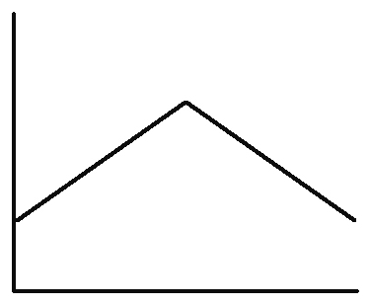
B

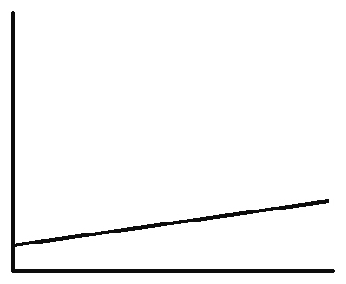
C

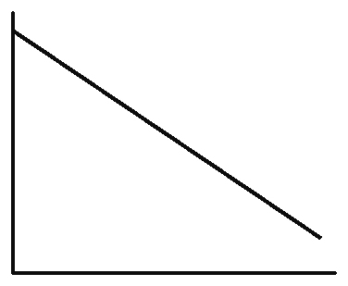
D

2. Refer to question 1.
a) Which graph shows a positive rate
of change?
b) Which graph shows a negative rate
of change?
c) Which graph shows a zero rate
of change?

3. Siddha jogged at a constant speed,
travelling around a 400-m track in 4 min.
a) What was Siddha’s rate of change of distance with respect to time, in metres
per minute?
b) If Siddha continued jogging at the same speed, how long would it take him to jog around the track five times?

4. Zoe, the manager of a home building centre, had a stock of 1600 sheets of plywood on the first day of April. She kept a graph of the number of sheets of plywood remaining for the first two weeks of April.
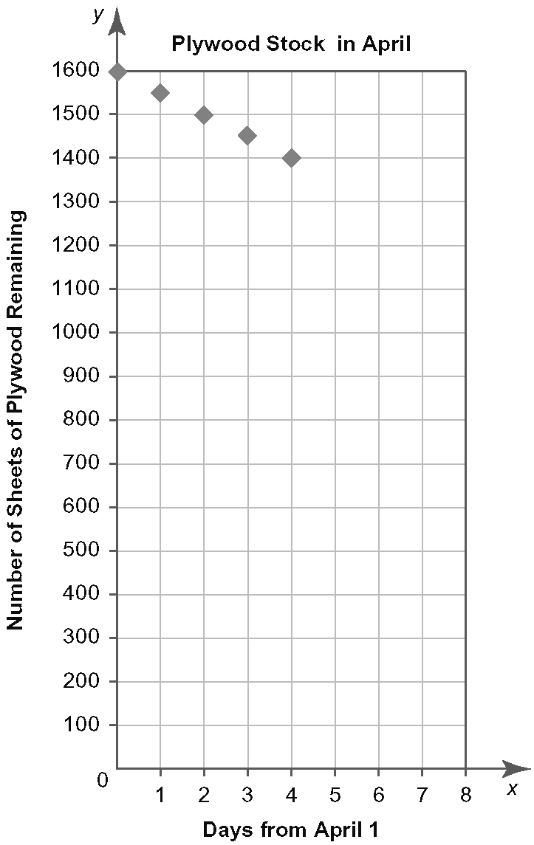
a) Describe the relationship between the number of sheets of plywood remaining and time.
b) Use the graph to estimate the number
of sheets of plywood remaining after
six days.
c) By how much does the number of sheets
of plywood remaining decrease after
seven days? after eight days?
d) By how much does the number of sheets
of plywood remaining decrease after each day in April?
e) Is the rate of change of number of sheets
of plywood remaining with respect to the number of days increasing, constant, or decreasing? Give a reason for your answer.

5. Concrete used to construct tall buildings
must be pumped vertically up to where it is needed. The table shows the time required to pump 30 m³ of concrete to different heights.
Height (m) | Time (min)
100 | 60
120 | 67
140 | 73
160 | 79
180 | 86
a) Does the relationship between height
and time appear to be linear or
non-linear? Justify your answer.
b) Draw a graph with height on the
horizontal axis and time on the
vertical axis. Does the graph match your answer to part a)? Explain how you know.
c) What is the rate of change of time with respect to height? Remember to include
the units.
d) Predict the time required to pump
30 m³ of concrete to a height of 200 m.

6. As an airplane rises, the surrounding air temperature decreases by approximately
3.25 ºC for every 500 m in vertical height.
a) Complete the table.
Height (m) | Temperature (°C)
0 | 15.00
500
1000
1500
2000
2500
3000
b) Is the relationship between height
and surrounding air temperature linear
or non-linear? Explain how you know.
c) This model is considered to be accurate
up to a height of 11 000 m. Determine
the surrounding air temperature for an
airplane flying at this height.
7. The table shows Canada’s gross domestic spending on research and development
(R&D) from 1998 to 2005.
Year | Gross Domestic Spending on R&D  ($, billions)
1998 | 16.1
1999 | 17.6
2000 | 20.6
2001 | 23.1
2002 | 23.5
2003 | 24.7
2004 | 26.8
2005 | 28.1
Adapted from: Statistics Canada. http://www40.statcan.ca/l01/cst01/scte03-eng.htm,
Dec 10, 2008
a) Does the table show an increasing, constant, or decreasing trend in Canada’s gross domestic spending on research and development? Does the rate of change appear to be constant? Explain.
b) Let 1998 be year 0. Use technology to draw a graph with the year on the horizontal axis and the gross domestic spending on research and development on the vertical axis.
c) Use linear regression to add a line of
best fit to your graph. Write the equation for the line.
d) Does the line of best fit support your prediction in part a)?
e) Use the line of best fit to determine the average rate of change of the gross domestic spending on research and development with respect to time.
What are the units for this rate of change?
f) Predict Canada’s gross domestic spending on research and development in 2015.

