Section 5.1 Example 2 Use Technology

Tools
● TI-Nspire™ CAS Graphing Calculator
Time (h) | Fuel Remaining (gal)
0.00 | 19.5
0.25 | 18.7
0.50 | 17.9
0.75 | 17.1
1.00 | 16.3
1.25 | 15.4
1.50 | 14.6
1.75 | 13.8
2.00 | 13.0
2.25 | 12.2
2.50 | 11.4
2.75 | 10.6
3.00 | 9.8

Example 2 Fuel Consumption in an Aircraft
The Diamond Katana is a popular training aircraft manufactured in London, Ontario. The capacity of the fuel tank is 19.5 gal. The table shows the amount of fuel remaining in the tank during a flight.
a) Draw a graph, with time on the horizontal axis and fuel remaining on the vertical axis.
b) Describe the shape of the graph.
c) How much fuel was consumed during the first hour of flight? the second hour? the third hour? Does the rate of change appear to be increasing, constant, or decreasing?
d) What is a reasonable estimate for the rate of change of fuel remaining in the tank? Include suitable units for this rate of change.
e) Determine the length of time that the aircraft can be flown on one tank of fuel.

Solution
a) Follow these steps to draw the graph.
1. Open a Lists & Spreadsheets page.
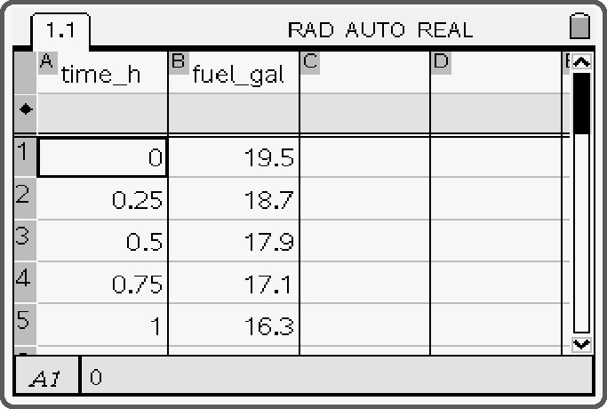
2. Enter the time data in column A.
Enter the fuel remaining data in column B.
To type an underscore, press   .
3. Create a new Graphs & Geometry page.
Press  and change the graph type to Scatter Plot.
4. Select time from the x-axis dropdown menu.
Select fuel from the y-axis dropdown menu.

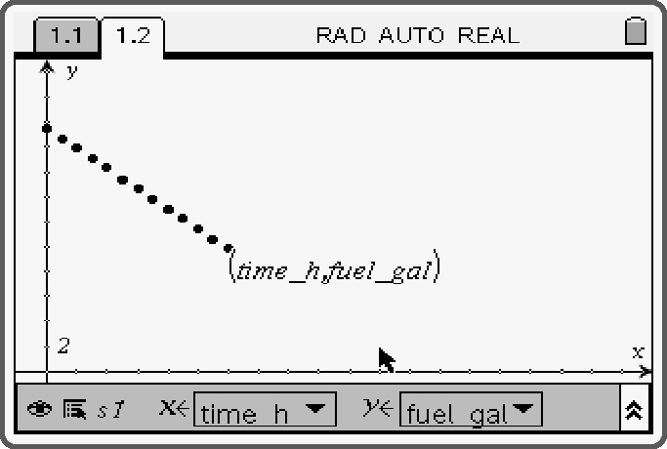
5. Press . Adjust the Window settings
from –0.5 to 10.0 for the x-axis
and from –5 to 25 for the y-axis.

b) The data points fall along a straight line. The line slopes down from left to right.
c) Subtract the fuel remaining at the end of the first hour from the fuel remaining at the beginning of the first hour.
19.5 − 16.3 = 3.2 The aircraft consumed 3.2 gal of fuel during the first hour.
16.3 − 13.0 = 3.3 The aircraft consumed 3.3 gal of fuel during the second hour.
13.0 − 9.8 = 3.2 The aircraft consumed 3.2 gal of fuel during the third hour.
The rate of change appears to be constant.
d) Determine the fuel burned during the 3 h of flight.
19.5 − 9.8 = 9.7
Divide by three to obtain the rate of change.
The units for the rate of change are gallons per hour (gal/h). The fuel remaining decreased by 3.2 gal/h during the flight.
e) Method 1: Use the graph.
Return to the Lists & Spreadsheets page and press .
• Select 4: Statistics, and then, 1: Stat Calculations. Select 3: Linear Regression (mx + b).
• Select time_h for the X List, and fuel_gal for the Y List.
• Tab down and select OK. The linear equation of best fit will be displayed.
• Return to the Graphs & Geometry page.
• Set the graph type back to 1: Function. Press , and select 6: Points & Lines.
Select 2: Point On.
• Move the cursor to the line. Press  to plot a point on f1.
• Press  to deselect the point plotting tool. Move the cursor over the point until
the hand appears.
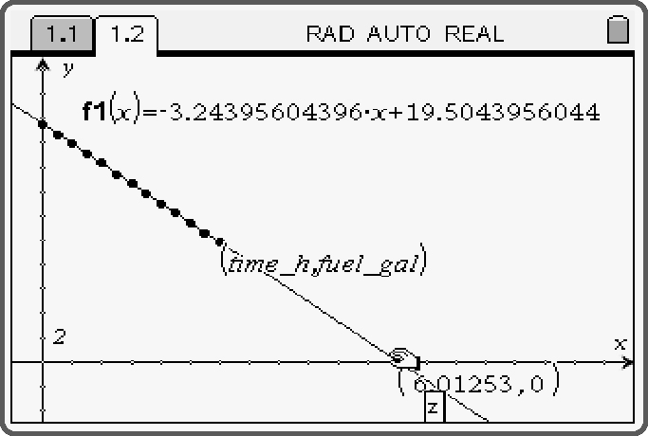
• Press and hold  until the hand closes to grab the point.
• Drag the point to determine where the line crosses the
horizontal axis. The text zero or a “z” in a
box will appear, along with coordinates,
when the point intersects the x-axis.
The fuel remaining will be 0 gal at a time
of approximately 6.01 h.
Method 2: Use a calculation.
Divide 19.5 gal by 3.2 gal/h.
The aircraft can fly 6.1 h on one tank of fuel.

