Section 5.2 Example 3 Use Technology

Tools
• TI-Nspire™ CAS Graphing Calculator

Example 3 Maximize Revenue
Trevor sells hot dogs for $2.00 each from his cart at the beach. He currently sells an average of 120 hot dogs per day. If he increases the price, he will earn more per hot dog but may lose sales due to the increased price. He decides to gradually increase the price in steps of 10¢, and keep track of the effect on sales. Trevor’s records are shown.
Price ($) | Average Daily Sales (hot dogs)
2.0 | 120
2.10 | 117
2.20 | 114
2.30 | 111
2.40 | 108
2.50 | 105
2.60 | 102
2.70 | 99

a) Calculate the average daily revenue from hot dog sales.
b) Calculate the first and second differences for the daily revenue. What do the first differences tell you? What do the second differences tell you?
c) Use technology to fit a quadratic relation to the price and revenue data. What is the equation that models the data?
d) Determine if the revenue will continue to increase as the price increases or if it will reach a maximum and then decrease. If the revenue does reach a maximum, determine the price that results in this maximum.

Solution
a) The revenue is determined by multiplying the price of each hot dog by the number of
hot dogs sold.
Price ($) | Average Daily Sales (hot dogs) | Revenue ($)
2.00 | 120 | 240.00
2.10 | 117 | 245.70
2.20 | 114 | 250.80
2.30 | 111 | 255.30
2.40 | 108 | 259.20
2.50 | 105 | 262.50
2.60 | 102 | 265.20
2.70 | 99 | 267.30

b)
Price ($) | Revenue ($) | First  Differences | Second  Differences
2.00 | 240.00 | First  Differences | Second  Differences
2.00 | 240.00 | 5.70 | Second  Differences
2.10 | 245.70 | 5.70 | –0.60
2.10 | 245.70 | 5.10 | –0.60
2.20 | 250.80 | 5.10 | –0.60
2.20 | 250.80 | 4.50 | –0.60
2.30 | 255.30 | 4.50 | –0.60
2.30 | 255.30 | 3.90 | –0.60
2.40 | 259.20 | 3.90 | –0.60
2.40 | 259.20 | 3.30 | –0.60
2.50 | 262.50 | 3.30 | –0.60
2.50 | 262.50 | 2.70 | –0.60
2.60 | 265.20 | 2.70 | –0.60
2.60 | 265.20 | 1.90 | –0.60
2.70 | 267.30 | 1.90

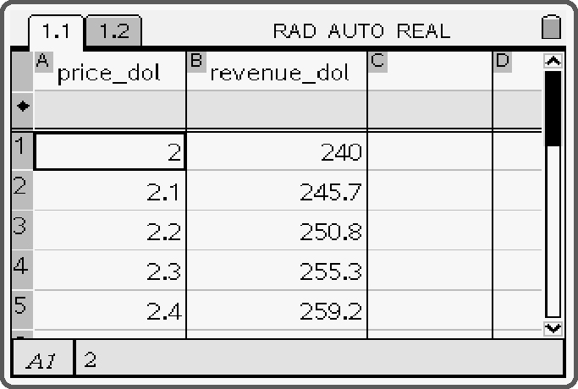
c) Open a Lists & Spreadsheet page.
• Enter the price and revenue data from the table.
• Open a Graphs & Geometry page.
Plot the price and revenue data as a scatter plot.
• Return to the Lists & Spreadsheet page and press .
• Select 4: Statistics, and then, 1: Stat Calculations.
• Select 6: Quadratic Regression.
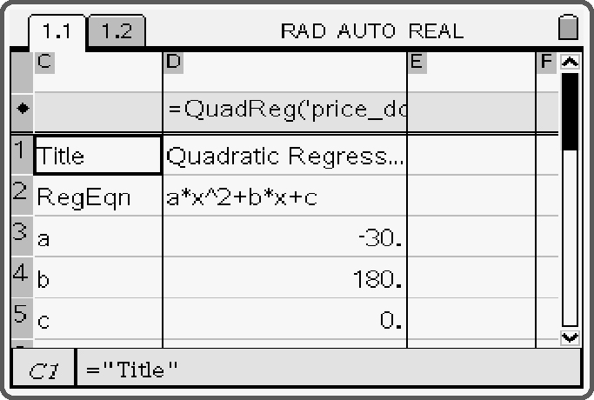
• Select price_dol for the X List, and revenue_dol
for the Y List.
• Tab down and select OK.
The quadratic equation of best fit will be displayed.
The equation of best fit is y = −30x² + 180x.

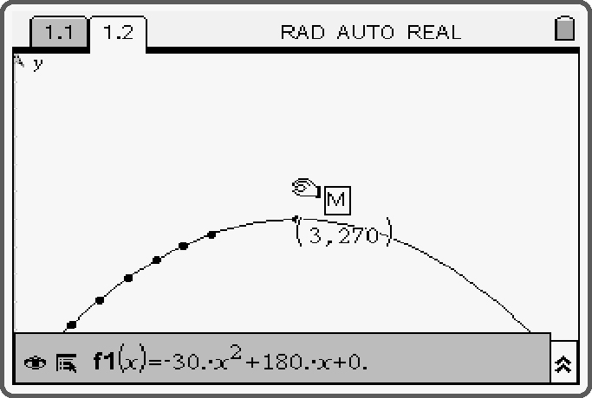
d) Return to the Graphs & Geometry page.
• Set the graph type back to 1:Function.
The regression equation will be displayed as f1.
This graph reaches a maximum, and then, decreases.
• Press , and select 6: Points & Lines. Select 2: Point On.
• Move the cursor to the curve. Press  to plot a point on f1.
• Press  to deselect the point plotting tool.
• Move the cursor over the point until the hand appears.
Press and hold  until the hand closes to grab the point.
• Drag the point to determine where the line crosses the horizontal axis.
The text maximum or an “M” in a box will appear, along with coordinates, when the point reaches the maximum on the curve.
The maximum revenue of $270.00 occurs at a price of $3.00 per hot dog.

