Section 5.3 Exponential Models

1. The population of Negliville has been decreasing by 10% per year. If the
population of Negliville is 11 000 now,
what will it be after one year?
after two years?

2. Refer to question 1. Explain why the decreasing population can be modelled
with an exponential relation.

3. Determine if each number sequence
represents exponential growth. Justify
your answer.
a) 12, 24, 36, 48
b) 3, 9, 27, 81
c) 6, 13, 21, 30

4. A weather balloon was launched and monitored by a meteorologist. He
compared the atmospheric pressure at different heights with the standard
atmosphere (atm), the atmospheric
pressure at the Earth’s surface. Then, he plotted the points and drew a curve of
best fit to show the trend in the atmospheric pressure as the weather balloon rose.
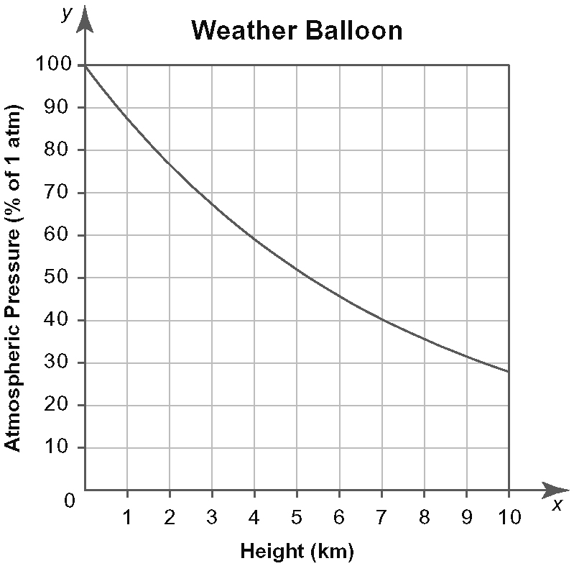
a) Describe the relationship between the atmospheric pressure and the height.
b) Use the graph to estimate the atmospheric pressure at a height of
i) 2 km
ii) 4 km
iii) 6 km
c) Use your answers to part b) to calculate
the ratios.
- What happens to the atmospheric pressure after every 2-km increase in height?
- Consider the rate of change of the atmospheric pressure with respect to
the height. What are suitable units for
this rate of change?
- Is the rate of change of atmospheric pressure with respect to the height increasing, constant, or decreasing?
Justify your answer.

5. Lacey bought a high-end camcorder five years ago. The yearly resale value of the camcorder is shown in the table.
Year | Resale Value of Camcorder ($)
0 | 4800.00
1 | 3840.00
2 | 3072.00
3 | 2457.60
4 | 1966.08
5 | 1572.86
a) Calculate the first and second differences. Is the relationship between resale value
and time linear? quadratic? Explain how you know.
b) Calculate the ratios. Is the relation exponential? Explain how you know.
c) Draw a graph of the data. Can the graph
be used to determine if the relation is linear? quadratic? Justify your answer.
- Compare the table and the graph. Does the rate of change of resale value with respect to time appear to be increasing, constant, or decreasing? Justify your answer.
- What are suitable units for the rate of change of resale value with respect
to year?

6. Tyson plans to buy a new condominium.
His real estate agent predicts the value of
the condominium will increase over time.
She made a table relating the value of the condominium to its age.
Age (years) | Value of Condominium ($)
0 | 320 000
1 | 328 000
2 | 336 200
3 | 344 605
4 | 353 220
5 | 362 051
a) Calculate the first and second differences. Does the relationship between value and time appear to be linear? quadratic? Explain how you know.
b) Calculate the ratios. Can the data be modelled using an exponential relation? Justify your answer.
- Use technology to find the equation of best fit for an exponential model.
- Use the equation from part c) to predict the value of the condominium when it is ten years old.
- Sketch a graph of the data.

7. Radon-222 (Rn-222) is an element that
results from the decay of Radium-226. It is a dangerous radioactive gas that sometimes accumulates in basements. A sample of
500 micrograms (μg) of Rn-222 is collected
in a lab for study. The table shows the mass
of Rn-222 remaining, in micrograms, over
five days.
Days | Mass Remaining (μg)
0 | 500
1 | 417
2 | 347
3 | 289
4 | 241
5 | 201
a) Calculate the first and second differences. Does the relationship between mass remaining and time appear to be linear? quadratic? Explain how you know.
b) Calculate the ratios. Can the data be modelled using an exponential relation? Give a reason for your answer.
c) Use technology to find the equation of
best fit for an exponential model.
d) Use the equation from part c) to predict
the mass of Rn-222 remaining after
seven days.
e) Sketch a graph of the data.

