Section 5.4 Example 2 Use Technology

Tools
● TI-Nspire™ CAS Graphing Calculator

Example 2 Leaky Compressor
Time (h) | Pressure (psi)
0 | 3000
1 | 2950
2 | 2900
3 | 2850
4 | 2800
5 | 2750

Dwight owns a construction business. He uses a compressor attached to a storage tank to maintain a supply of compressed air for power tools. He suspects a leak either in the tank itself or in the valve assemblies between the compressor and the tank. If the leak is in the tank, the pressure should drop according to an exponential relation. If the leak is in the valve, the pressure should drop according to a linear relation. Dwight measured the pressure in pounds per square inch (psi) every hour for 5 h.
a) Use the table to determine whether a linear or exponential model is more appropriate. What do you notice? Why does this happen?
b) Use technology to determine a linear and an exponential model for the data. Record the regression equations.
c) Display the graphs of both models. How long does it take before the graphs show a visible difference?
d) Dwight left the tank overnight. The next morning, after 14 h, the pressure was 2300 psi. Which model predicts this pressure most accurately?
e) Compare the rate of change of the linear model to that of the exponential model. Which predicts that the pressure will decrease more slowly?

Solution
a) Determine the first differences and ratios from the table.
Time (h) | Pressure (psi) | First  Differences | Ratios
0 | 3000 | First  Differences | Ratios
0 | 3000 | –50 | 0.98
1 | 2950 | –50 | 0.98
1 | 2950 | –50 | 0.98
2 | 2900 | –50 | 0.98
2 | 2900 | –50 | 0.98
3 | 2850 | –50 | 0.98
3 | 2850 | –50 | 0.98
4 | 2800 | –50 | 0.98
4 | 2800 | –50 | 0.98
5 | 2750 | –50 | 0.98
The first differences are constant. This implies that a linear model may be appropriate.
The ratios are also constant. This implies that an exponential model may be appropriate.
Both models can be used for the data so far. Dwight has not waited long enough for a difference between the models to be noticeable.

b) • Open a Lists & Spreadsheets page. Enter the data for the time and the pressure.
• Open a Graphs & Geometry page. Plot the data as a scatter plot. Adjust the window as required.
• Perform a linear regression, and an exponential regression.
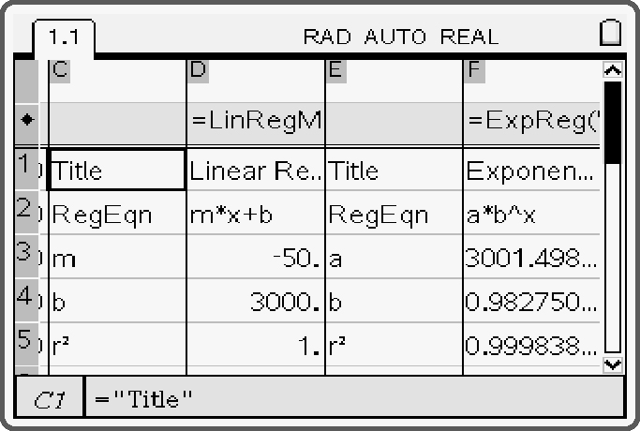
The linear regression models the relation as y = −50x + 3000.
The exponential regression models the relation as y = 3001 (0.983^{x}).

c) Adjust the window settings to emphasize the differences between the two graphs.
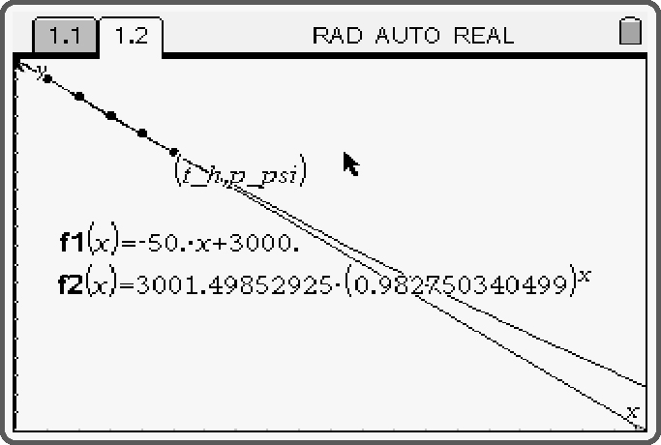
With the y-axis set to display from 2000 psi to 3000 psi, the graphs start to show a visible difference after approximately 7 h.

d) Plot a point on each of the models. Drag the point until the horizontal coordinate is closest to 14 h. The exponential model predicts the pressure will be approximately 2350 psi. The linear model predicts the pressure will be approximately 2300 psi.
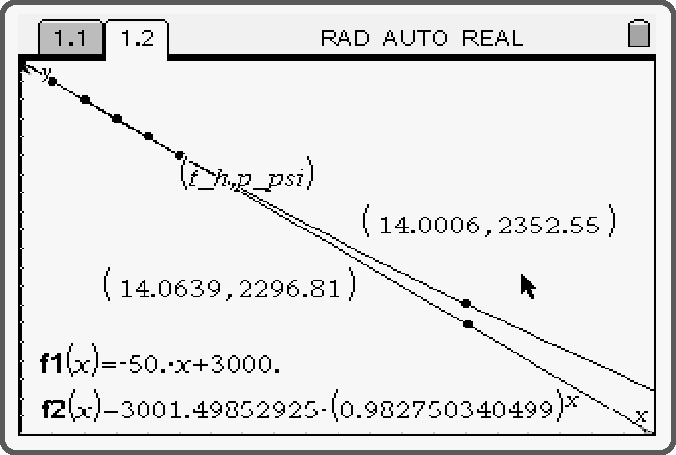
e) The linear model predicts a constant rate of change of –50 psi/h. The exponential model predicts a rate of change that increases, starting from –50 psi/h. The exponential model predicts that the pressure will decrease more slowly than the linear model.

