Section 5.5 Select a Mathematical Model

1. If the second differences of a set of data
are nearly constant, which model—linear, quadratic, or exponential—would be most appropriate to represent the data?

2. Which model—linear, quadratic, or exponential—seems most appropriate
for this scatter plot?
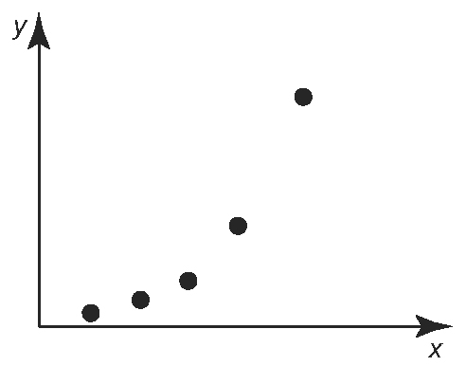

3. The table shows the total operating revenue for golf courses and country clubs in Canada each year from 1998 to 2004.
Year | Operating Revenue  ($, billions)
1998 | 1.625
1999 | 1.607
2000 | 1.716
2001 | 1.805
2002 | 1.881
2003 | 2.048
2004 | 2.224
Source: Statistics Canada, CANSIM Table 361-0002 Database: E-STAT
a) Create a scatter plot of the data. Let
1998 be year 0.
b) From the scatter plot, which model
appears most appropriate: linear,
quadratic, or exponential? Give a reason for your answer.
c) Generate a model for the data. Represent the model using a graph and an equation.
d) Use the model to predict the operating revenue in 2005.

4. A telecommunications company recently launched a year long advertising campaign
to promote their brand of cellular telephones. The monthly number of new cellular telephone subscribers is shown in the table.
Month | Number of New Subscribers
1 | 6 500
2 | 7 150
3 | 7 870
4 | 8 650
5 | 9 520
6 | 10 470
7 | 11 520
8 | 12 670
a) Calculate the first and second differences, and the ratios.
b) Which model appears most suitable
for the data: linear, quadratic, or exponential? Justify your answer.
c ) Sketch a scatter plot of the data.
d) Generate a suitable model for the
data. Represent the model using a graph and an equation.
e) Use the graph to predict the month in which there will be approximately
15 000 new subscribers.
f) Use the equation to predict the number
of new subscribers in month 12.
5. Examine each pattern. Which relation does each pattern model? Explain.
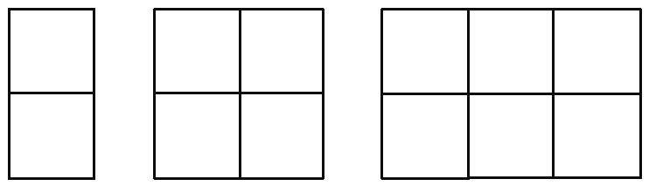
a)

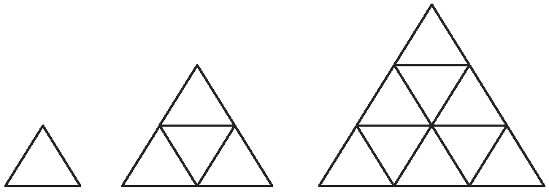
b)

