Section 5.5 Example 2 Use Technology

Tools
● TI-Nspire™ CAS Graphing Calculator

Example 2 Movie Soundtrack
Key Number | Frequency (Hz)
1 | 261.626
5 | 329.628
9 | 415.305
13 | 523.251

Where is the mathematics in a movie? Films that seek to stir their audiences make use of unusual musical chord structures as part of the soundtrack. One of these chord structures is the augmented fifth chord. On a keyboard, such a chord can be demonstrated by simultaneously pressing the keys marked in grey. What is the relation among these notes? The key numbers and frequencies, in hertz (Hz), are shown in the table.
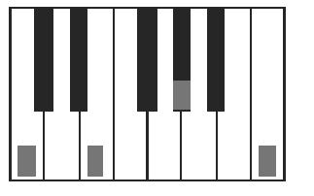
a) Are the key number intervals constant?
b) Calculate first differences, second differences, and ratios.
c) Which model appears most suitable for the data: linear, quadratic, or exponential?
Justify your answer.
d) Create a scatter plot of the data.
e) Generate a suitable model for the data. Represent the model graphically and algebraically.
f) A more powerful effect can be created by adding more notes in the same augmented fifth pattern. Use the model to predict the next three key numbers and frequencies.

Solution
a) Yes; the key intervals increase by a constant value of 4.
b) The first differences, second differences, and ratios are shown.
Key Number | Frequency (Hz) | First Differences | Second Differences  Ratios  1.260  1.260  1.260
1 | 261.626 | First Differences | Second Differences  Ratios  1.260  1.260  1.260
1 | 261.626 | 68.002 | Second Differences  Ratios  1.260  1.260  1.260
5 | 329.628 | 68.002 | 17.675
5 | 329.628 | 85.677 | 17.675
9 | 415.305 | 85.677 | 22.269
9 | 415.305 | 107.946 | 22.269
13 | 523.251 | 107.946

c) The first differences are not constant so a linear model is not suitable. The second differences are not constant so a quadratic model is not suitable. The ratios are constant, so an exponential model is suitable.

d) The scatter plot is shown.
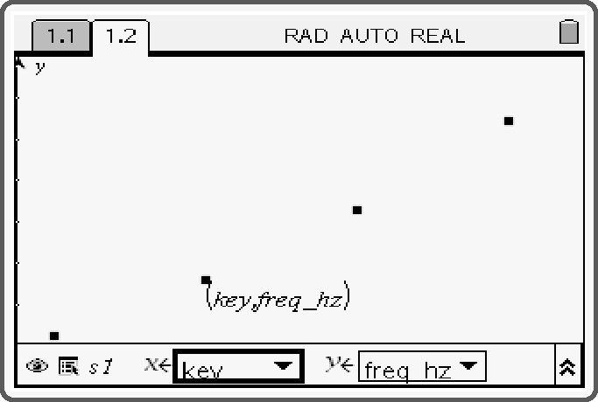
e) The equation for the model is y = 246.942(1.059^{x}).
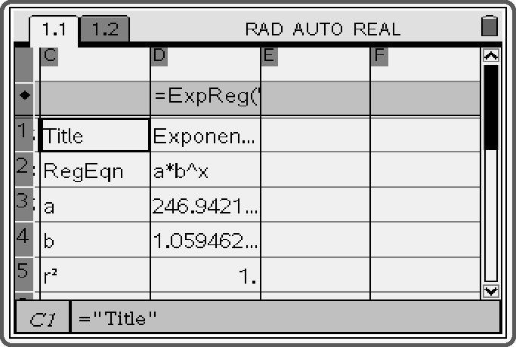
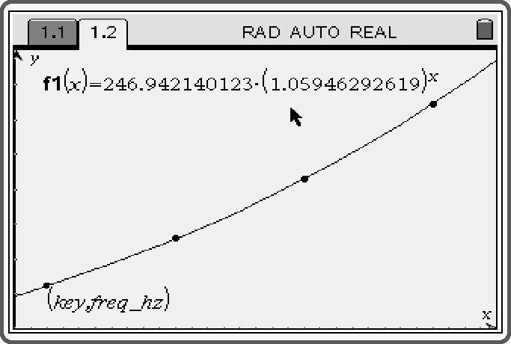
Key Number | Frequency (Hz)
1 | 261.626
5 | 329.628
9 | 415.305
13 | 523.251
17 | 654.374
21 | 823.019
25 | 1035.128

f) The next three key numbers are 17, 21, and 25. Use the modelling equation to calculate the corresponding frequencies.
Sample calculation:

