Chapter 5 Practice Test

For questions 1 to 4, choose the best answer.
1. Which model appears most suitable for the scatter plot?
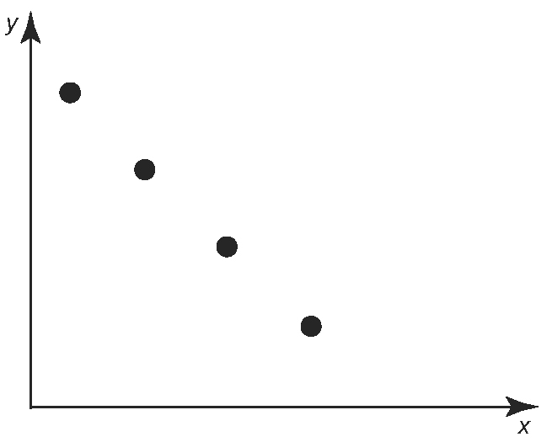
A linear model
B quadratic model, leading to a
minimum
C quadratic model, leading to a
maximum
D exponential model

2. Which best describes the rate of change
in the relation in question 1?
A constant and positive
B constant and negative
C increasing
D decreasing

3. Which indicates that a quadratic model
is the best fit for a set of data?
A first differences are constant
B second differences are constant
C second differences are increasing
D ratios are constant
4. Jamal bought a $500 GIC that pays 15% per year, compounded annually. Britney bought a $600 GIC that pays 5% per year, compounded annually. Which statement is true?
A The difference between the values of the GICs will always be constant.
B One GIC will always have a lower value than the other.
C The values of the GICs can be accurately represented by linear models.
D The GICs will be equal in value after approximately two years.

5. Which model appears most suitable for the data in the table: linear, quadratic, or exponential? Justify your answer.
x | y
0 | 2
1 | 6
2 | 18
3 | 54
4 | 162

6. The town of Esterville has a population
of 1000 and is growing at a rate of
150 people/year. The neighbouring town Malthos has a population of 500 and is growing at a rate of 25%/year. Use modelling methods to determine how long it will be before both towns have the same population.

7. Priyam started giving fitness classes at
her local community centre. She recorded
the number of participants each month for
the first seven months in the table.
Month | Participants
1 | 480
2 | 576
3 | 691
4 | 829
5 | 995
6 | 1194
7 | 1433
a) Calculate the first and second
differences, and the ratios.
b) Which model appears most suitable
for the data: linear, quadratic, or exponential? Justify your answer.
c) Sketch a scatter plot of the data.
d) Generate a suitable model for the
data. Represent the model using a graph and an equation.
e) Use the graph to predict when the
number of participants in one month
will reach 2000.
f) Use the equation to predict the number
of participants in the tenth month.
8. The table shows the total operating revenue of private FM radio broadcasters in Canada from 1999 to 2006.
Year | Operating Revenue ($)
1999 | 662 058 000
2000 | 713 005 000
2001 | 765 862 000
2002 | 806 500 000
2003 | 887 171 000
2004 | 930 149 000
2005 | 1 038 641 000
2006 | 1 099 557 000
Source: Statistics Canada, CANSIM Table 357-0003, Database: E-STAT
a) Use technology to create a scatter plot
of the data. Let 1999 be year 0.
b) Does the scatter plot appear to favour a linear, a quadratic, or an exponential model?
c) Use regression to generate three
models for the data. Select the most
suitable model using the coefficient
of determination. Does this model match your prediction in part b)?
d) Predict the operating revenue of private
FM radio broadcasters in 2015 if the
trend continues.

