Chapter 5 Test

For questions 1 to 4, choose the best answer.
1. Which model appears most suitable for the scatter plot?
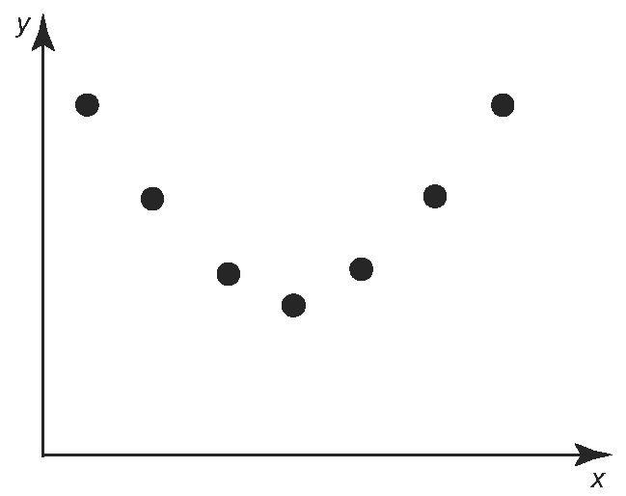
A linear model
B quadratic model
C exponential model
D no model is suitable

2. Which best describes the rate of change
in the relation in question 1?
A constant and negative
B constant and positive
C increasing
D decreasing

3. The value of Mikayla’s GIC is currently $5000. The GIC earns 10% per year, compounded annually. How much will
the GIC be worth in three years?
A $5500
B $6500
C $6655
D $6720

4. Which indicates that a linear model is the best fit for a set of data?
A first differences are constant
B second differences are constant
C ratios are constant
D second differences and ratios are constant

5. The table shows the number of Canadian males registered in apprenticeship programs from 1991 to 2000.
Year | Number of Male Apprenticeships
1991 | 185 000
1992 | 173 000
1993 | 160 000
1994 | 153 000
1995 | 152 000
1996 | 153 000
1997 | 158 000
1998 | 162 000
1999 | 171 000
2000 | 182 000
Source: Statistics Canada, CANSIM Table 477-0051
a) Let 1991 be year 0. Use technology to graph the data.
b) Describe the trend between 1991 and 2000 in words.
c) Which model—linear or quadratic—
would best fit the data? Justify your answer.
d) Use technology to fit your choice of model in part c) to your graph.
e) Use the graph in part d) to predict the number of male apprenticeships in 2005.
f ) The actual number of male apprenticeships in 2005 was 265 080. How does this compare with your model? Suggest reasons for any discrepancy.

6. Which model appears most suitable
for the data in the table: linear, quadratic,
or exponential? Justify your answer.
x | y
0 | 13
1 | 25
2 | 37
3 | 49
4 | 61

7. The table shows the percent of Canadian households having air conditioning from
1997 to 2006.
Year | Households With Air Conditioning (%)
1997 | 32.2
1998 | 33.2
1999 | 34.5
2000 | 34.6
2001 | 35.8
2002 | 37.5
2003 | 39.8
2004 | 41.7
2005 | 44.2
2006 | 48.1
Source: Statistics Canada, CANSIM Table 203-0020
a) Calculate the ratios. Can the relation be modelled using an exponential relation? Give a reason for your answer.
b) Use technology to fit an exponential relation to the data. Let 1997 be year 0. What is the equation that describes
the data?
c) Use the equation from part b) to predict the percent of households that will have air conditioning in 2009.
d) Sketch a graph with percent of households having air conditioning on the vertical axis and year on the horizontal axis.

8. The table shows the cost of purchasing
one loaf of bread in Canada over several years.
Year | Cost  ($)
1900 | 0.04
1914 | 0.05
1929 | 0.08
1933 | 0.06
1945 | 0.07
1955 | 0.13
1965 | 0.18
1975 | 0.43
1985 | 1.00
1995 | 1.30
2005 | 1.79
a) Calculate the ratios. Can the relation be modelled using a linear relation? Give a reason for your answer.
b) Use technology to fit a linear, quadratic, and exponential relation to the data. Which equation is the best model for the data? Explain.
c) Use the equation from part b) to predict the price of one loaf of bread in 2010. Does the price seem reasonable? Explain.

