Chapter 5 BLM Answers

BLM 5-1 Prerequisite Skills
1. a) D, E b) A c) B d) C
2. a) 10 km b) approximately 55 min
c) after approximately 105 min
3.
Time  (s) | Distance  (m) | First  Differences | Second  Differences
1 | 22 | First  Differences | Second  Differences
2 | 42 | 20 | Second  Differences
3 | 60 | 18 | –2
4 | 76 | 16 | –2
5 | 90 | 14 | –2
6 | 102 | 12 | –2
7 | 112 | 10 | –2

4.
Time  (d) | Area  (cm²) | First  Differences | Second  Differences
0 | 0 | First  Differences | Second  Differences
0 | 0 | 30 | Second  Differences
1 | 30 | 30 | 20
1 | 30 | 50 | 20
2 | 80 | 50 | 20
2 | 80 | 70 | 20
3 | 150 | 70 | 20
3 | 150 | 90 | 20
4 | 240 | 90 | 20
4 | 240 | 110 | 20
5 | 350 | 110 | 20
5 | 350 | 130 | 20
6 | 480 | 130
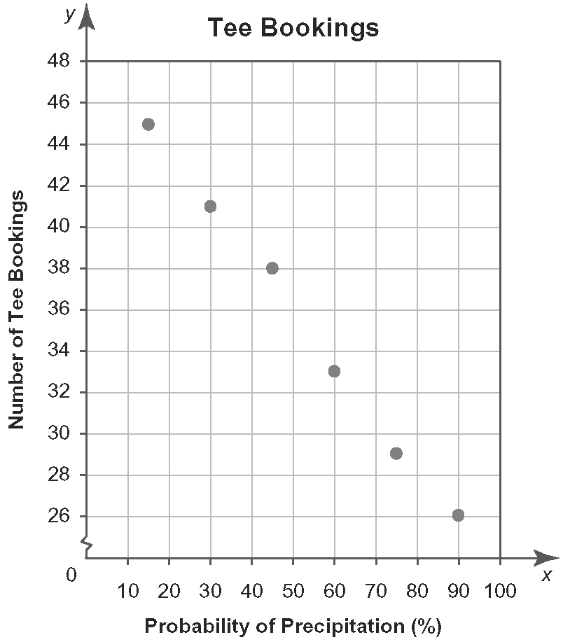
5.

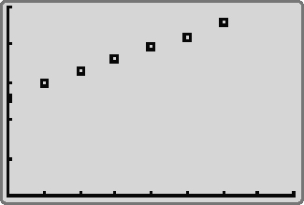
6. a)

Xmin = 0, Xmax = 8, Xscl = 1, Ymin = 0,
Ymax = 5000, Yscl = 1000
b) y = 325x + 2647
7. a) 64 b) 125 c) 0.6561
d) 9.61 e) 11 664 f) 924.2055
8. a) 4084 visitors b) 3 243 920 visitors
c) after approximately 12.5 days
9. $5472
10. $18 692.73
11. $6410.19

BLM 5-3 Section 5.1 Linear Models
1. B
2. a) C b) D c) A
3. a) 100 m/min b) 20 min
4. a) The number of sheets of plywood remaining decreases as time increases.
b) 1300 sheets c) 50 sheets; 50 sheets
d) 50 sheets
e) Constant. The number of sheets of plywood remaining decreases by 50 for every day that passes.
5. a) Linear. The time required increases by approximately 7 min for every 20 m of height.
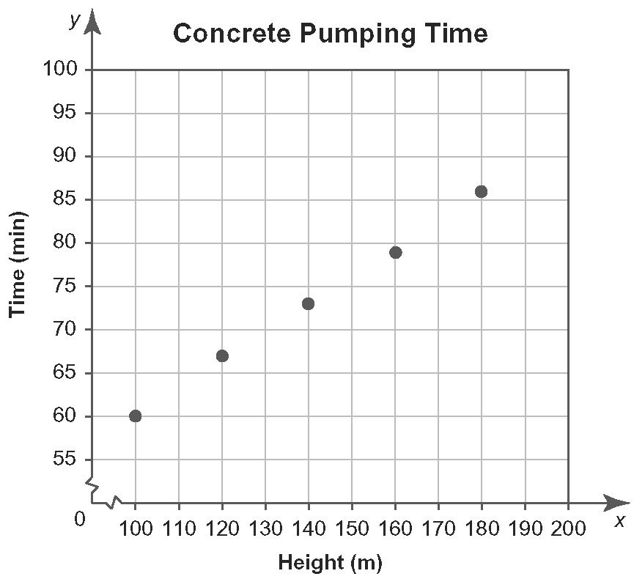
b)

Yes. The points are almost in a straight line.
c) approximately 0.35 min/m
d) approximately 93 min

6. a)
Height (m) | Temperature (°C)
0 | 15.00
500 | 11.75
1000 | 8.50
1500 | 5.25
2000 | 2.00
2500 | –1.25
3000 | –4.50
b) Linear. The changes in temperature are equal over equal height intervals.
c) −56.50 ºC
7. a) Increasing. Yes the rate of change is nearly constant, at approximately $1 700 000 000/year.
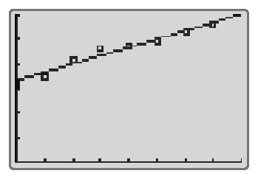
b), c)

Xmin = 0, Xmax = 8, Xscl = 1, Ymin = 0, Ymax = 30, Yscl = 5
y = 1.699x + 16.617
d) Yes, the line of best fit has a positive slope.
e ) $1 699 000 000/year; billions of dollars/year
f ) $45.500 000 000

BLM 5-7 Section 5.2 Quadratic Models
1. a) quadratic b) neither
2. | x | y | First  Differences | Second  Differences
 | 0 | 0 | First  Differences | Second  Differences
 | 0 | 0 | 2 | Second  Differences
 | 1 | 2 | 2 | 2
 | 1 | 2 | 4 | 2
 | 2 | 6 | 4 | 2
 | 2 | 6 | 6 | 2
 | 3 | 12 | 6 | 2
 | 3 | 12 | 8 | 2
 | 4 | 20 | 8 | 2
 | 4 | 20 | 10 | 2
 | 5 | 30 | 10
3. a) As the price increases, the revenue first increases, and then decreases.
b) at $50: approximately $32 000; at $60: approximately $34 250
c) No. Fewer people will attend the performance
if the ticket price is increased. From the graph, if the price of $50 is doubled, the revenue will remain the same.
d) thousands of dollars/dollars
e) Decreasing. As the ticket price increases,
the graph curves downward and becomes
less steep.

4. a) yes
b) No. The price does not increase by a constant amount over each 30-min interval.
c) decreasing rate of change
d) Yes. Second differences are constant.
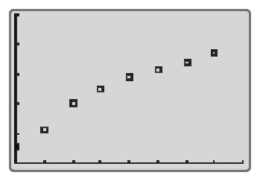
5. a)

Xmin = 0, Xmax = 8, Xscl = 1, Ymin = 0,
Ymax = 2.5, Yscl = 0.5
b) The operating revenue increases as time increases.
c) Quadratic. The operating revenue does not increase by a constant amount each year.
d) y = −0.0236x² + 0.3855x + 0.2726
e) approximately $1 848 000 000
f ) Answers may vary. For example, the predicted operating revenue is too low. In 2006, the increased popularity of Internet-capable cellular telephones and an increased availability of high-speed Internet in rural areas may have contributed to a higher than predicted revenue.
6. a) Yes. Second differences are constant.
b) Sketches may vary. Yes.
c) y = 0.000 000 25x² − 0.00375x + 24.5
d) The quadratic model has an a value that is positive, so a minimum average cost per unit does exist.
e) Minimum cost is approximately $10.44 when
7500 units are ordered.

BLM 5-12 Section 5.3 Exponential Models
1. after one year: 9900 people; after two years: 8910 people
2. The ratios between successive terms are constant, at approximately 0.9.
3. a) No. First differences are constant so growth is linear
b) Yes. Ratios are constant.
c) No. Second differences are constant so growth
is quadratic.
4. a) As the height increases, the atmospheric pressure decreases.
b) Estimates may vary. For example:
i) 77% ii) 59% iii) 45%
c) 0.766; 0.763
d) The pressure decreases by a factor of approximately 0.76.
e) percent of one atmosphere/kilometre
f ) Increasing. The first differences between atmospheric pressures become greater as the height increases.
5. a) Not linear or quadratic. First and second differences are not constant.
b) Yes. Ratios are constant.

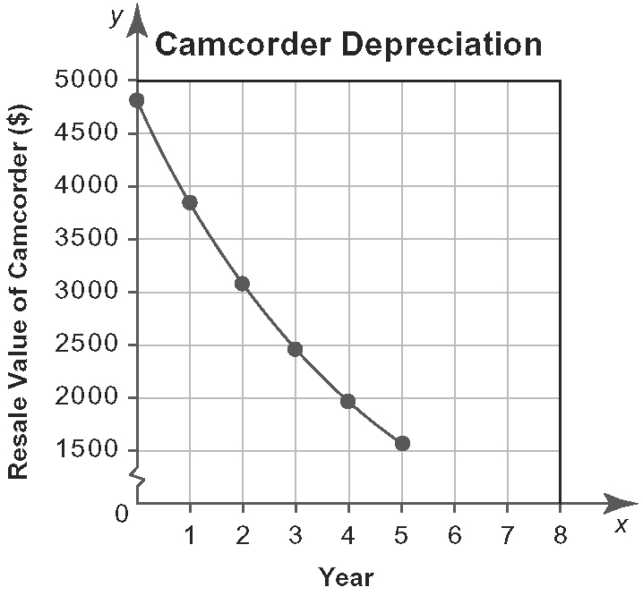
c)

Yes. Relation is not linear because the graph is curved. It is not quadratic because the graph does not appear to be a parabola.
d) Increasing. The first differences between resale values become greater as the time increases.
e) dollars/year
6. a) Not linear or quadratic. First and second differences are not constant.
b) Yes. Ratios are constant.
c) y = 320 000(1.025)^{x}
d) approximately $409 627
e) Sketches may vary.
7. a) Not linear or quadratic. First and second differences are not constant.
b) Yes. Ratios are constant.
c) y = 500(0.833)^{x}
d) approximately 139 μg
e) Sketches may vary.

BLM 5-15 Section 5.4 Analyse Graphical Models
1. C
2. Bank B. He will save $613.44 with Bank B.
3. a) First differences are nearly constant.
b) Yes. Second differences are nearly constant.
c) linear model: y = 1.391x + 30.85; quadratic model: y = 0.052x² + 1.030x + 31.2
d) linear; quadratic
4. a) degrees Celsius/minute
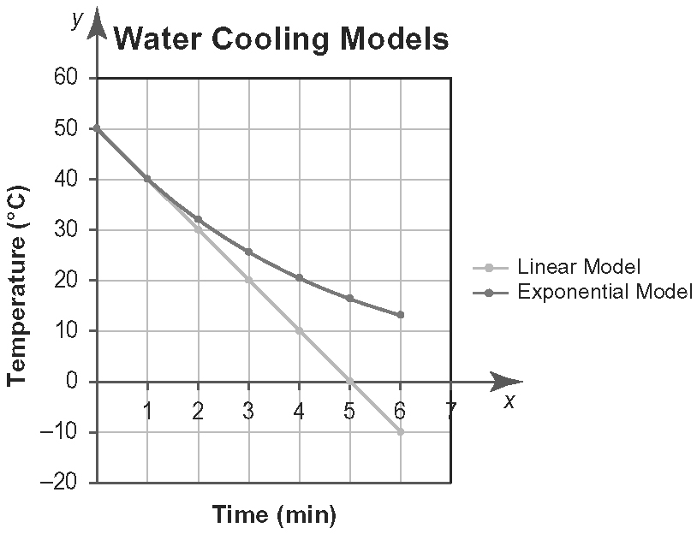
b)

c) Exponential model. The temperature of the cup of water should not fall below the outside temperature.
5. a) 13 500; 15 000; 16 500; 18 000; 19 500; 21 000;
22 500
b) y = 1500x + 12 000
c) 13 200; 14 520; 15 972; 17 569; 19 326;
21 259; 7; 23 385
d) y = 12 000(1.1^{x})
e) after approximately six years
6. a) First differences are nearly constant, so a linear model would fit the data.
b) Second differences are nearly constant, so a quadratic model would fit the data.
c) Ratios are nearly constant, so an exponential model could fit the data.
d) linear model: y = 183.7x + 3959; quadratic model:
y = 3.524x² + 155.5x + 4001; exponential model:
y = 4001(1.040^{x})
e) linear model: 5796 employees; quadratic model:
5908 employees; exponential model: 5922 employees
f ) linear model: 19.3 years; quadratic model: 16.4 years; exponential model: 16 years
7. a) Sketches may vary. b), c) linear
d) The coefficient of determination for the linear
model is greatest.
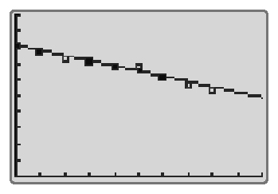
e)

Xmin = 0, Xmax = 10, Xscl = 1, Ymin = 0,
Ymax = 10 000, Yscl = 1000
y = −332.2x + 8126
f) in 2002

BLM 5-18 Section 5.5 Select a
Mathematical Model
1. quadratic
2. exponential
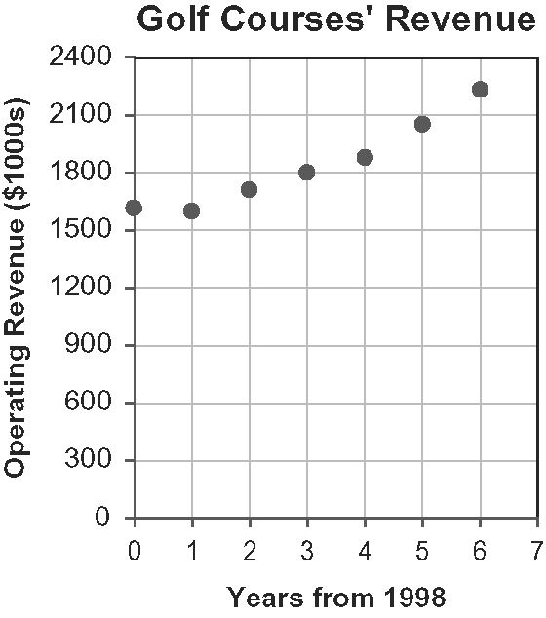
3. a)

b) Quadratic. The data points form a parabola.
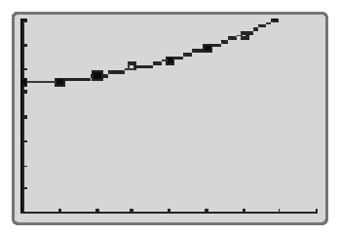
c)

Xmin = 0, Xmax = 8, Xscl = 1, Ymin = 0,
Ymax = 2400, Yscl = 300
y = 14.690x² + 13.429x + 1612
d) approximately $2.426 000 000
4. a)
Month | Number of New Subscribers | First  Differences | Second  Differences | Ratios
1 | 6 500 | First  Differences | Second  Differences | Ratios
1 | 6 500 | 650 | Second  Differences | 1.100
2 | 7 150 | 650 | 70 | 1.100
2 | 7 150 | 720 | 70 | 1.100
3 | 7 870 | 720 | 60 | 1.100
3 | 7 870 | 780 | 60 | 1.099
4 | 8 650 | 780 | 90 | 1.099
4 | 8 650 | 870 | 90 | 1.101
5 | 9 520 | 870 | 80 | 1.101
5 | 9 520 | 950 | 80 | 1.100
6 | 10 470 | 950 | 100 | 1.100
6 | 10 470 | 1050 | 100 | 1.100
7 | 11 520 | 1050 | 100 | 1.100
7 | 11 520 | 1150 | 100
8 | 12 670 | 1150
b) Exponential. Ratios are nearly constant.
c) Sketches may vary.
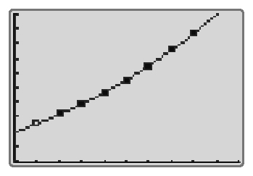
d)

Xmin = 0, Xmax = 8, Xscl = 1, Ymin = 0, Ymax = 2400, Yscl = 300
y = 5909(1.100^{x})
e) in month 10
f ) approximately 18 545 new subscribers
5. a) Linear. For each new diagram, two more squares are added; y = 2x
b) Quadratic. For each new diagram, a new row of squares is added; y = x²

BLM 5-23 Chapter 5 Review
1. a) 12.5 m/s b) 80 s
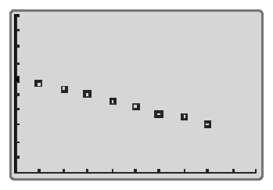
2. a) Linear. First differences are nearly constant.
b)

Xmin = 0, Xmax = 10, Xscl = 1, Ymin = 0, Ymax = 1000, Yscl = 100, Xres = 1
c) y = −36.2x + 600 d), e) week 14
f) litres/week

3. Quadratic; second differences are constant.
4. a) Quadratic; second differences are constant.
b) Decreasing. The rock is falling more quickly as
time passes.
c) y = −5x² + 320 d) after 8 s
5. a) $255 000; $260 100
b) There is a constant percent increase in value over equal intervals.
6. Yes. Ratios are nearly constant.
7. a) First differences are constant, so a linear model would fit the data.
b) Ratios are constant, so an exponential model would fit the data.
c) linear model: y = 50x + 5000; exponential model:
y = 5001(1.010^{x})
d) Exponential model. The rate of change of the exponential model is increasing while the rate of change of the linear model is constant.
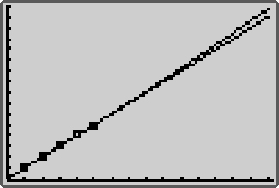
e)

Xmin = 0, Xmax = 15, Xscl = 1, Ymin = 5000,
Ymax = 5800, Yscl = 50, Xres = 1
linear model: 5700 km; exponential model: 5750 km
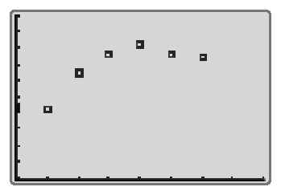
f) yes
8. a)

Xmin = 0, Xmax = 9, Xscl = 1, Ymin = 36 000 000, Ymax = 41 000 000, Yscl = 500 000
b) quadratic
c) in 2010: 37 206 000 L; in 2015: 29 779 000 L

BLM 5-25 Chapter 5 Practice Test
1. A
2. B
3. B
4. D
5. Exponential. Ratios are constant.
6. approximately six years
7. a)
Month | Participants | First  Differences | Second  Differences | Ratios
1 | 480 | First  Differences | Second  Differences | Ratios
1 | 480 | 96 | Second  Differences | 1.200
2 | 576 | 96 | 19 | 1.200
2 | 576 | 115 | 19 | 1.200
3 | 691 | 115 | 23 | 1.200
3 | 691 | 138 | 23 | 1.200
4 | 829 | 138 | 28 | 1.200
4 | 829 | 166 | 28 | 1.200
5 | 995 | 166 | 33 | 1.200
5 | 995 | 199 | 33 | 1.200
6 | 1194 | 199 | 40 | 1.200
6 | 1194 | 239 | 40 | 1.200
7 | 1433 | 239 | 40 | 1.200
b) Exponential. Ratios are constant.
c) Sketches may vary.
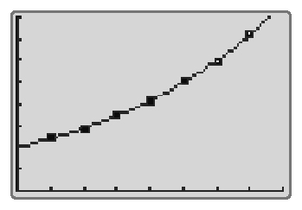
d)

Xmin = 0, Xmax = 8, Xscl = 1, Ymin = 0, Ymax = 1600, Yscl = 200
y = 400(1.200^{x})
e) after nine months
f ) 2477 participants
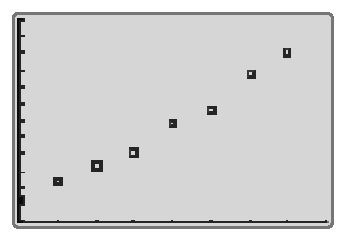
8. a)

Xmin = 0, Xmax = 8, Xscl = 1, Ymin = 600 000, Ymax = 1 200 000, Yscl = 50 000
b) exponential model
c) Model with greatest coefficient of determination is the exponential model. y = 659 632(1.075^{x}). Yes.
d) approximately $2 098 153 000
BLM 5-26 Chapter 5 Test
1. B
2. C
3. C
4. A
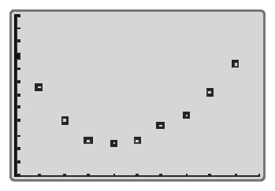
5. a)

Xmin = 0, Xmax = 10, Xscl = 1,
Ymin = 140 000, Ymax = 200 000, Yscl = 5000
b) As time increases, the number of male
apprenticeships first decreases, and then
increases back to near its original level.
c) Quadratic. The graph is shaped like a parabola.
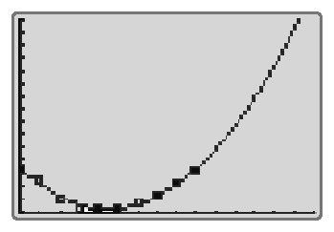
d)

Xmin = 0, Xmax = 15, Xscl = 1,
Ymin = 150 000, Ymax = 300 000,
Yscl = 10 000
e) 300 000 apprenticeships
f ) The actual number of apprenticeships is lower than the model's prediction. The lower number could be caused by the slowing of the rate of change of males registering in apprenticeship programs. Or perhaps the programs are beginning to reach maximum capacity and are unable to take on more apprenticeships.
6. Linear. First differences are constant.
7. a) Yes. Ratios are nearly constant.
b) y = 31.252(1.0435^{x})
c) approximately 52.1%
d) Sketches may vary.
8. a) No. Ratios are not constant. They range from
0.4 to 0.77.
b) y = 0.02x − 0.4; r = 0.85
y = 0.0003x² − 0.02x + 0.18; r = 0.98
y = 0.02b^{x}; r = 0.96
Quadratic model is the best because r is closest to 1. But exponential is good too.
c) $1.61; Not reasonable, since you would expect prices to increase over time.

