Section 6.5 Warm Up

1. Match each graph to the type of graph.

Graph
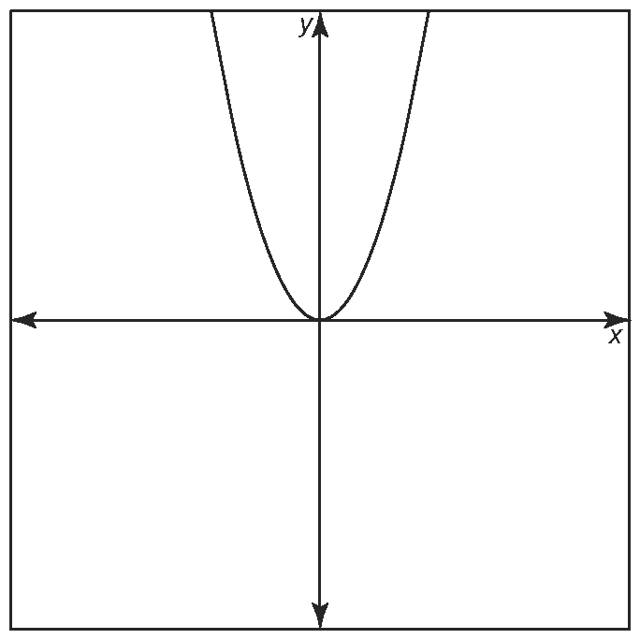
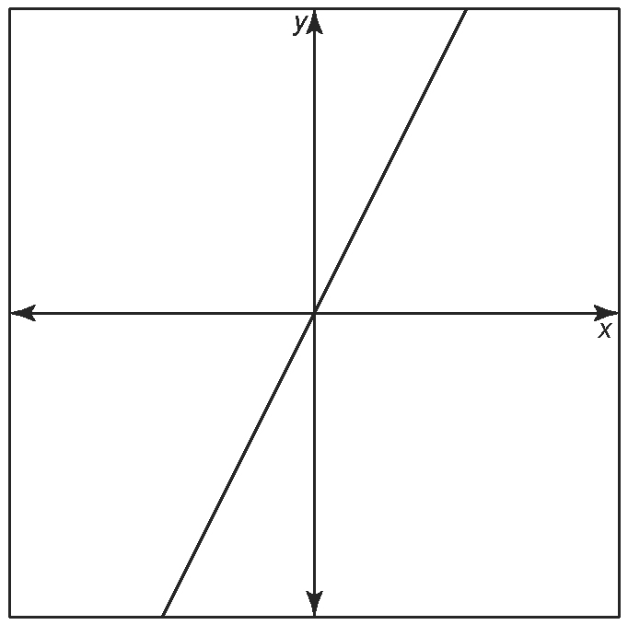
a) b)

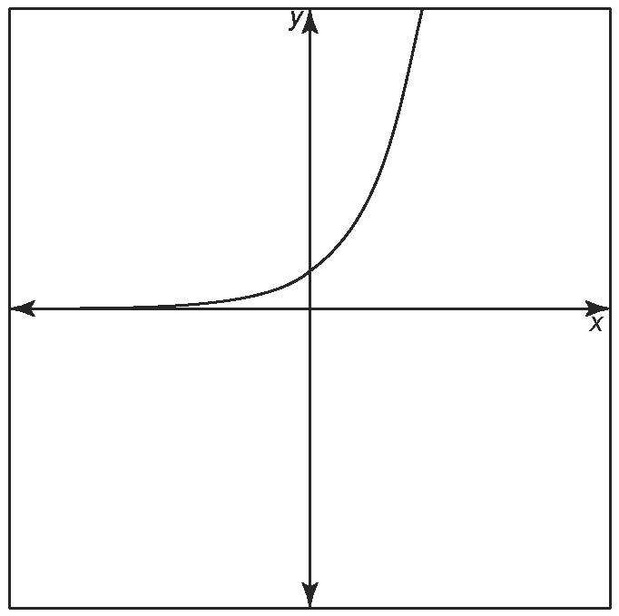
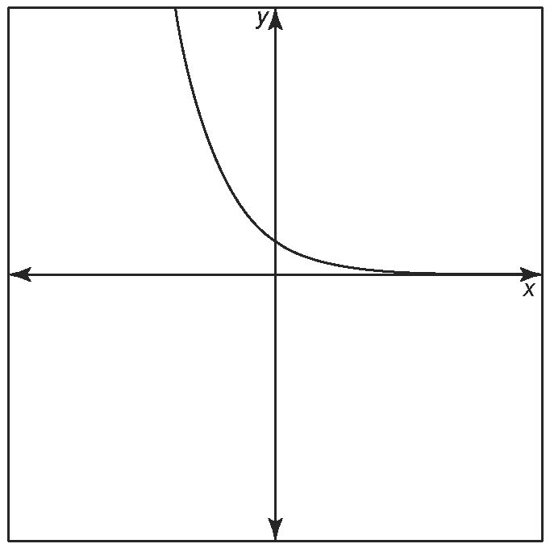
c) d)

Type of Graph
i) exponential decay: _____
ii) exponential growth: _____
iii) linear: _____
iv) quadratic: _____

2. What type of relation would best describe each scatter plot?
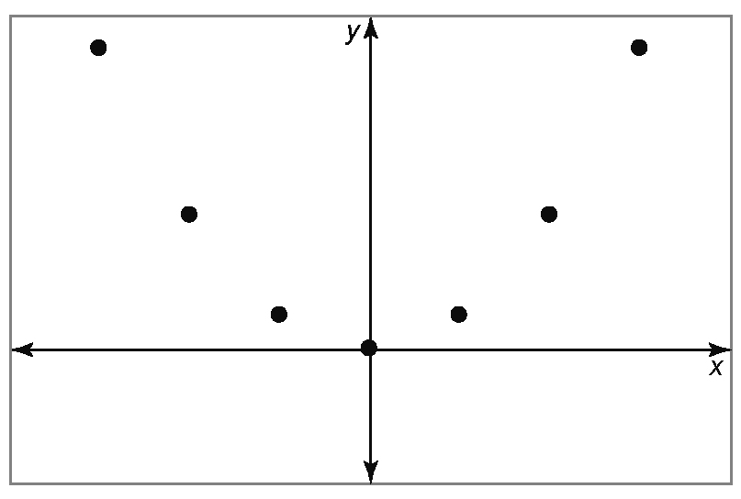
a)

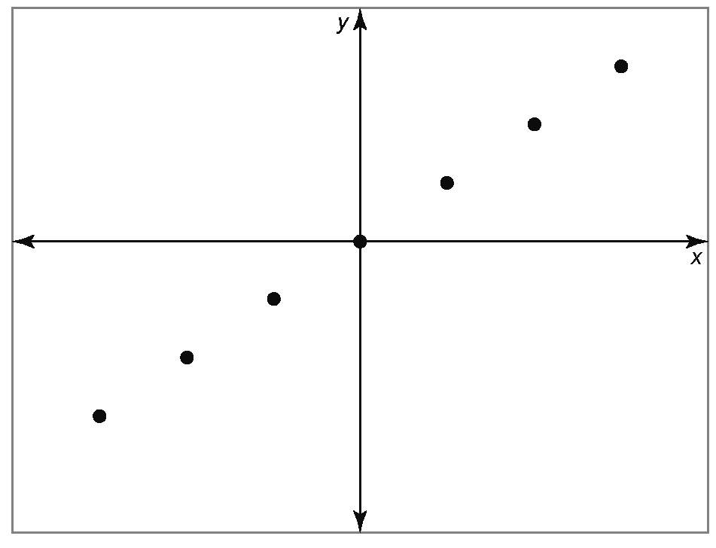
b)

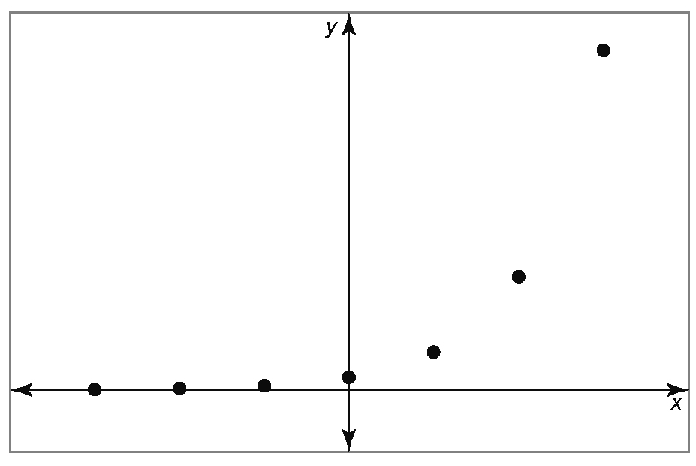
c)

