Section 6.5 Construct and Apply
Exponential Models

1. The graph shows the amount, A, of a substance over time.
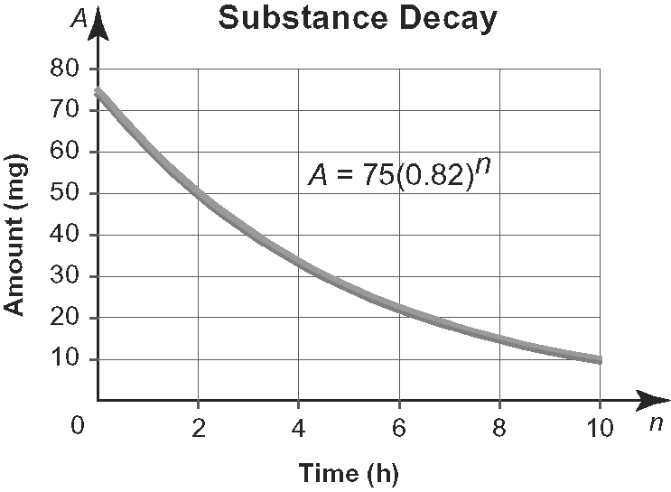
a) Is this graph linear, exponential, or neither? Explain how you know.
b) How much of the substance remains
after each number of hours?
i) 3 h ii) 7 h
c) How long will it take for the amount
to be reduced by half?

2. The graph shows the amount, A, in a
savings account after seven years. The annual interest rate on the account varies,
but is always compounded annually.
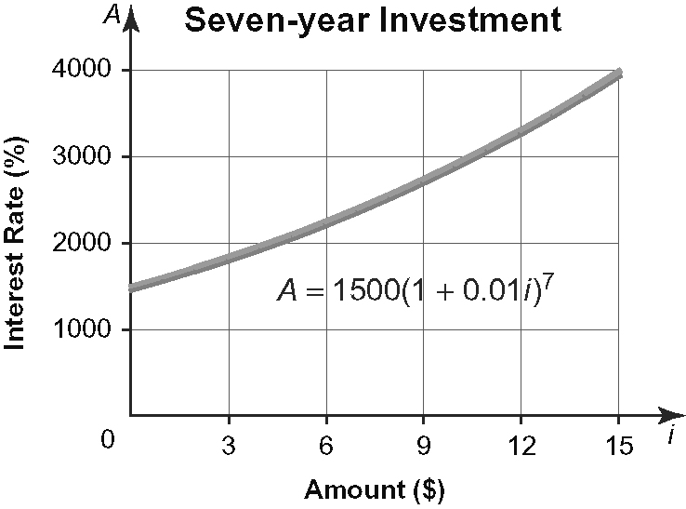
a) Is this graph linear, exponential, or neither? Explain how you know.
b) How much interest would be earned
after seven years at 6.3% per year, compounded annually?
c) What annual interest rate would be
needed to double the amount of the
original investment in seven years?
Use this information to answer
questions 3 to 5.
The table shows the mass, over time,
of a substance that is growing.
Time (h) | Mass (g)
0 | 24.00
1 | 25.93
2 | 27.89
3 | 32.25
4 | 32.55
5 | 35.11
6 | 40.10
7 | 41.17
8 | 44.42
9 | 48.91
10 | 52.03
11 | 55.89
12 | 62.49
13 | 65.21
14 | 74.43
15 | 76.32
16 | 82.13
17 | 89.72

3. a) Construct a scatter plot of the data
with Mass on the vertical axis and
Time on the horizontal axis.
b) Determine the equation of the line of
best fit. Interpret the meanings of the slope and the vertical intercept.
c) Use the linear model to predict the mass after 30 h.
d) According to the linear model, when will the mass be 140 g?

4. a) Determine the equation of the
parabola of best fit.
b) Use the quadratic model to predict the mass after 30 h.
c) According to the quadratic model,
when will the mass be 140 g?

5. a) Determine the equation of the
exponential curve of best fit.
b) Use the exponential model to predict
the mass after 30 h.
c) According to the exponential model,
when will the mass be 140 g?

6. Dana plans to invest $1000. She is
deciding between two investment options.
Super Saver Savings Account
Pays 5% per year, simple interest. The amount, A, after n years is given by
A = 1000 + 50n.
Secure Savings Bond
Earns 3.7% per year, compounded
annually. The amount, A, after n years is given by the equation A = 1000(1.037)^{n}.
a) Graph the relations on the same set of axes. Describe each relation.
b) Which option should Dana choose? Why?

7. Rajiv plans to invest $2500. He is considering these two options.
Option 1: Earns 4.5% per year, simple interest. The amount A, after n years is given by the equation A = 2500 + 51n.
Option 2: Earns 2.5% per year, compounded annually. The amount A, after n years is given by the equation A = 2500(1.025)^{n}.
Which option should Rajiv choose? Why?

8. Beryllium-11 has a half-life of approximately 14 s.
a) Complete the table for an initial amount of 4000 units of beryllium-11.
Time (s) | Units Remaining
0 | 4000
14
28
42
56
70
b) Calculate the first and second
differences. Is this relation linear
or non-linear?
c) Calculate the ratios. Is the relation exponential? Explain.
d) Construct a scatter plot of the data.
Does the scatter plot confirm your
answer to c)? Explain.
e) Determine an equation for the curve
of best fit.
f) Determine how long it will take for
the initial amount of beryllium-11 to decay to one unit.

9. Radioactive Iridium-192 (Ir-192) has a
half-life of approximately 74 days.
a) Complete the table for an initial amount of 1000 units of Ir-192.
Time (days) | Units Remaining
0 | 1000
74
148
222
296
370
b) Is this relation linear or non-linear? Explain.
c) Is the relation exponential? Explain.
d) Determine an equation for the line or curve of best fit.
e) How long will it take for the initial amount of Ir-192 to decay to 10 units?

