Chapter 6 BLM Answers

BLM 6-1 Prerequisite Skills
1. a) 3, 2, 9 b) (−2), 6, 64 c) 3, −2,
2. a) 2 b) 3
3. a) 12 b) 20
4. a) 6.63 b) 7.57
5. a) 3⁵, 243 b) 2⁸, 256 c) (−5)⁴, 625
6. a) 4⁴, 256 b) 12², 144
c) 10⁴, 10 000 d) (–2)⁶, 64
7. a) 2⁸, 256 b) 10⁹, 1 000 000 000
c) (−3)⁶, 729 d) (−10)¹⁵, −1 000 000 000 000 000
8. a) m⁸ b) pq⁴ c) 125b¹⁰
9. a) 1 b) 1 c) −1
d) −1 e) 1 f) 1
10. In parts c) and d), the whole power is negative, but in part e), only the base is negative.
11. a) b)
c) d)
e) 3⁴, 81 f) 6², 36
12. a)
x | y = 2x² − 5 | First Differences | Second Differences | Ratios
−2 | −13 | First Differences | Second Differences | Ratios
−2 | −13 | 6 | Second Differences | 0.538
−1 | −7 | 6 | −4 | 0.538
−1 | −7 | 2 | −4 | 0.714
0 | −5 | 2 | −4 | 0.714
0 | −5 | −2 | −4 | 1.4
1 | −7 | −2 | −4 | 1.4
1 | −7 | −6 | −4 | 1.857
2 | −13 | −6 |  | 1.857
b) Quadratic. Second differences are constant.
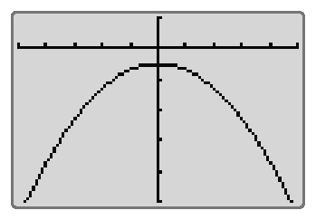
c)

Xmin = −5, Xmax = 5, Xscl = 1, Ymin = −50, Ymax = 10, Yscl = 10
Yes. The graph is a parabola.

13. a)
x | y = 3x + 2 | First Differences | Second Differences | Ratios
−2 | −4 | First Differences | Second Differences | Ratios
−2 | −4 | 3 | Second Differences | 0.25
−1 | −1 | 3 | 0 | 0.25
−1 | −1 | 3 | 0 | −2
0 | 2 | 3 | 0 | −2
0 | 2 | 3 | 0 | 2.5
1 | 5 | 3 | 0 | 2.5
1 | 5 | 3 | 0 | 1.6
2 | 8 | 3 |  | 1.6
Linear. First differences are constant.
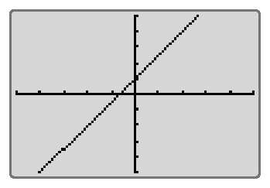
Xmin = −5, Xmax = 5, Xscl = 1, Ymin = −10, Ymax = 10, Yscl = 2
Yes. Graph is a line.
b)
x |  | First Differences | Second Differences | Ratios
−2 | 4 | First Differences | Second Differences | Ratios
−2 | 4 | –2 | Second Differences | 0.5
−1 | 2 | –2 | 1 | 0.5
−1 | 2 | –1 | 1 | 0.5
0 | 1 | –1 | 0.5 | 0.5
0 | 1 | –0.5 | 0.5 | 0.5
1 | 0.5 | –0.5 | 0.25 | 0.5
1 | 0.5 | –0.25 | 0.25 | 0.5
2 | 0.25 | –0.25 |  | 0.5
Exponential. Ratios are constant.
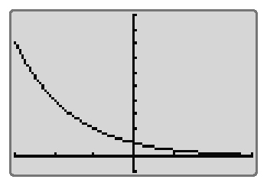
Xmin = −3, Xmax = 3, Xscl = 1, Ymin = −1, Ymax = 10, Yscl = 1
Yes. Graph is decreasing at a decreasing rate.

BLM 6-4 Section 6.1 Exponent Laws
1. a) 4², 16 b) 3^{–4},
c) 5⁻¹, d) 2^{–7},
2. b) c) d)
3. a) b)
4. a) g, 5 b)
c) d)
5. a) 7⁻³, b) 5⁻²,
c) 2⁹, 512 d) 10⁻²,
6. a) x³, −27 b)
c) d) s²t³, 200
7. a) 4⁻³, b) 5³, 125
c) (−2)⁸, 256 d) (−10)^{–6},
8. a) w², 49 b)
c) d)
9. a) y⁸ b) c) n
d) e) s³ f)
10. a) 1.07⁻³, 0.816 b) 1.04⁻⁴, 0.855
c) 8.1³, 531.441 d) (−1.01) ⁻⁶, 0.942
11. a), b)

BLM 6-6 Section 6.2 Rational Exponents
1. a) 13 b) 5 c) 4 d) 2
2. a) −6 b) −5 c) −6
d) Not possible. There is no number that when multiplied four times gives a negative value.
3. a) 2.872 b) −4.129
c) 4.547 d) 3.175
4. a), 4 b), 10
c), 2 d)
5. a) −1 b) −5
c) Not possible. There is no number that when multiplied four times gives a negative value.
d) 8
6. a) 512 b) 100 000
c) 8 d) 243
7. a) 4 b) 125
c) Not possible. There is no number that when multiplied four times gives a negative value.
d)
8. a) 4.481 b) 2.463 c) 2.776
d) 12.083 e) 0.727 f) 2.053
9. a) Not possible. There is no number that when multiplied twice gives a negative value.
b) −21.544
c) Not possible. There is no number that when multiplied four times gives a negative value.
d) –6.310
10. A power with a negative base and a
fractional exponent can only be evaluated
if the denominator is odd.
11. a) $32.85 b) $34.16 c)
12. 45a⁶b⁴

BLM 6-8 Section 6.3 Represent Exponential Expressions
1. a) 4⁵ b) 4⁶ c) 4⁰
d) 4¹² e) 4⁶ f) 4⁸
2. a) 10⁴ b) 10¹⁵ c) 10¹⁵
d) 10⁻² e) 10⁻⁴ f) 10⁻³
3. a) 2⁷ b) 2⁶ c) 2¹⁵
d) 2²⁴ e) 2⁰ f) 2¹⁶
4. a), b) x = −10
5. a) x = 3 b) a = c) p =
d) k = e) x = f) x =
6. a) x = b) x = 6

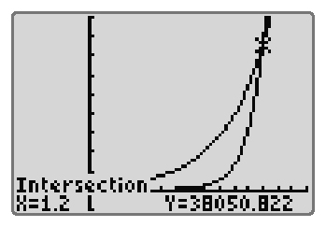
7. a, b)

Xmin = −0.5, Xmax = 1.5, Xscl = 1,
Ymin = −5000, Ymax = 45 000, Yscl = 5000
The point of intersection occurs at
x = 1.2, or . This is where the graphs cross.
8. a), b) x = 5 c) They are the same.
9. a), b) x = –4 c) They are the same.
d) Answers may vary.
10. a) i, ii) 5^{4−x} = 5⁻¹ iii) x = 5
b) i, ii) 3^{3x−1} = 3⁻⁴ iii) x = −1
c) i) 27^{x+1} = 9^{5−2x} ii) 3^{3x+3} = 3^{10−4x} iii) x = 1

BLM 6-11 Section 6.4 Tools and Strategies to Solve Equations Involving Exponents
1. a) 4.1 b) 3 c) 2 d) 2
2. a) 4.41 b) 7.58 c) 12.90 d) 7.28
3. Estimates may vary. For example:
a) 3.2 b) 7.1 c) 3.9 d) 2.5
4. a) 3.16 b) 7.13 c) 3.93 d) 2.49
5. a) 63.70 b) 56.56
6. 3.11
7. 9
8. 22 years
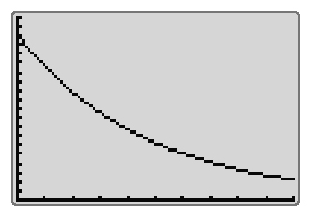
9. a)

Xmin = 0, Xmax = 10, Xscl = 1, Ymin = 0,
Ymax = 2, Yscl = 0.1
The graph is decreasing at a decreasing rate.
b) i) 1.458 m ii) 0.957 m iii) 0.508 m
10. a) 1.8 m b) 7 bounces
11. r = 14.51 cm
BLM 6-14 Section 6.5 Construct
and Apply Exponential Models
1. a) Exponential. The graph is decreasing at a decreasing rate.
b) i) 41.35 g ii) 18.70 g c) 3.5 h
2. a) Neither. The graph is a curve that appears to increase at a constant rate.
b) $800.51 c) 10.41%
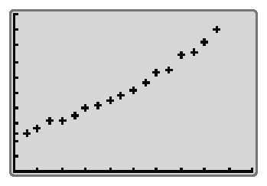
3. a)

Xmin = 0, Xmax = 20, Xscl = 2, Ymin = 0, Ymax = 100, Yscl = 10
b) m = 3.772t + 18.521; slope: rate of growth is 3.772 g/h; vertical intercept has no meaning in
this context.
c) 131.68 g d) 32.2 h
4. a) m = 0.138t² + 1.431t + 24.766
b) 191.90 g c) 24.2 h
5. a) m = 24.268(1.080)^{x} b) 244.20 g c) 22.8 h
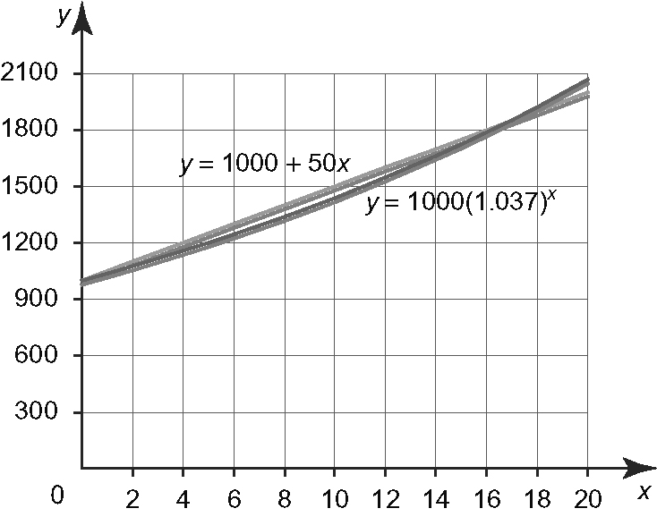
6. a)

The savings account is a linear relation.
The savings bond is an exponential relation.
b) Answer depends on the length of time the money is invested. For less than 16 years, the savings account earns more interest. For greater than 16 years, the savings bond earns more interest.
7. Option 1; after the initial investment, Option 2 will yield more interest than Option 1.

8. a), b) non-linear
Time (s) | Units Remaining | First Differences | Second Differences
0 | 4000 | First Differences | Second Differences
0 | 4000 | −2000 | Second Differences
14 | 2000 | −2000 | 1000
14 | 2000 | −1000 | 1000
28 | 1000 | −1000 | 500
28 | 1000 | −500 | 500
42 | 500 | −500 | 250
42 | 500 | −250 | 250
56 | 250 | −250 | 125
56 | 250 | −125 | 125
70 | 125 | −125
c) Yes. Ratios are all 0.5.
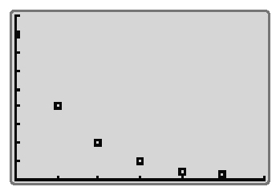
d)

Xmin = 0, Xmax = 84, Xscl = 14, Ymin = 0, Ymax = 4500, Yscl = 500
e) y = 4000(0.5)^{x ÷ 14} f) 167.5 s
9. a)
Time (days) | Units Remaining
0 | 1000
74 | 500
148 | 250
222 | 125
296 | 62.5
370 | 31.25
b) Non-linear; first and second differences are
not constant.
c) Exponential; the common ratio is a constant,
d) y = 10 00(0.5)^{x ÷ 74}
e) approximately 490 days

BLM 6-17 Chapter 6 Review
1. a) 6⁻², b) 5³, 125
c) 3⁻⁴, d) 10⁴, 10 000
2. a) b) c) d) a²b⁴
3.
4. a) 175.62 b) 0.02
5. a) 10
b) Not possible. There is no number that when multiplied four times gives a negative value.
c) –5 d) 2
6. a) , 16 b), −4
c) . Not possible. There is no number
that when multiplied eight times gives a
negative value.
d) , 216
e) . Not possible. There is no number that when multiplied twice gives a negative value.
f)
7. 5400 cm²
8. a) 4⁶ b) 4³ c) 4¹⁰ d) 4⁰
9. a) x = 6 b) x = 2 c) x = −16 d) x = −2
10. 10 h 50 min
11. 2 h
12. 19.1 cm²
13. 546.1 cm²
14. a), b)
Year | Value ($) | First Differences | Second Differences | Ratios
0 | 35 000.00 | First Differences | Second Differences | Ratios
0 | 35 000.00 | −3500.00 | Second Differences | 0.9
1 | 31 500.00 | −3500.00 | −350.00 | 0.9
1 | 31 500.00 | −3150.00 | −350.00 | 0.9
2 | 28 350.00 | −3150.00 | −315.00 | 0.9
2 | 28 350.00 | −2835.00 | −315.00 | 0.9
3 | 25 515.00 | −2835.00 | −283.50 | 0.9
3 | 25 515.00 | −2551.50 | −283.50 | 0.9
4 | 22 963.50 | −2551.50 | −255.15 | 0.9
4 | 22 963.50 | −2296.35 | −255.15 | 0.9
5 | 20 667.15 | −2296.35 |  | 0.9
c) Exponential. Ratios are constant.
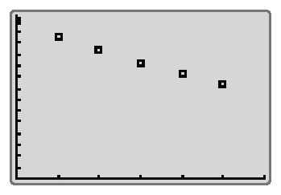
d)

Xmin = 0, Xmax = 6, Xscl = 1, Ymin = 0,
Ymax = 36 000, Yscl = 2400

15. a)
Year | Value ($) | First Differences | Second Differences | Ratio
0 | 35 000 | First Differences | Second Differences | Ratio
0 | 35 000 | –2750 | Second Differences | 0.921
1 | 32 250 | –2750 | 0 | 0.921
1 | 32 250 | –2750 | 0 | 0.915
2 | 29 500 | –2750 | 0 | 0.915
2 | 29 500 | –2750 | 0 | 0.907
3 | 26 750 | –2750 | 0 | 0.907
3 | 26 750 | –2750 | 0 | 0.897
4 | 24 000 | –2750 | 0 | 0.897
4 | 24 000 | –2750 | 0 | 0.885
5 | 21 250 | –2750 |  | 0.885
Linear. First differences are constant.
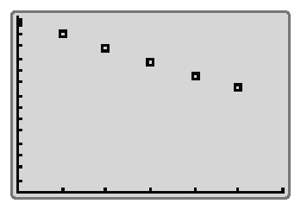
Xmin = 0, Xmax = 6, Xscl = 1, Ymin = 0,
Ymax = 36 000, Yscl = 2400
b) boat c) car
16. a)
Time (years) | Units Remaining
0 | 2500
12.5 | 1250
25.0 | 625
37.5 | 312.5
40.0 | 156.25
52.5 | 78.125
b) Non-linear; first and second differences are not constant.
c) Exponential; the common ratio is a constant,
d) y = 2500(0.5)^{x ÷ 12.5}
e) approximately 100 years
17. Option 1; the interest rate is such that it will yield the higher interest at the end of each year.
18. Option 2; after approximately 2 years, the interest paid will be greater than for Option 1.

BLM 6-18 Chapter 6 Practice Test
1. C
2. D
3. D
4. A
5. a) 4⁴ b) 4⁹
c) 4⁵ d) 4⁰
6. a) 4³, 64 b) 5⁵, 3125 c)
d) e)
7. a) x = 2 b) x = 6 c) x = 18
8. a) 2 b) 100
c) 16 d)
9. a) Not possible. There is no number that when multiplied twice gives a negative value.
b) 9 c) −5
10. a) 3.825 b) 82.819
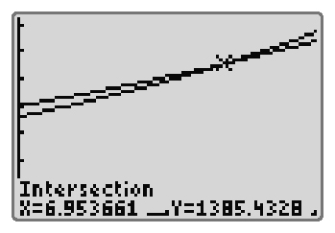
11. a)

Xmin = 0, Xmax = 10, Xscl = 1, Ymin = 0, Ymax = 1800, Yscl = 250
Exponential. Graphs are increasing at an increasing rate.
b) Answer depends on the length of time the money is invested. For less than seven years, Option A earns more interest. For greater than seven years, Option B earns more interest.
12. 284 cm²
13. a) Exponential. The value of the vehicle
decreases by a percent.
b) Exponential. The amount of the substance decreases by a percent.
c) Linear. The number of books increases by a constant amount.
14. a)
Time (years) | Units Remaining
0 | 370
2 | 185
4 | 92.5
6 | 46.25
8 | 23.125
10 | 11.5625
b) Non-linear; first and second differences are not constant.
c) Exponential; the common ratio is a constant,
d) y = 370(0.5)^{x ÷ 2}
e) approximately 17.1 years
15. 8 h 8 min

BLM 6-19 Chapter 6 Test
1. B
2. B
3. C
4. D
5. a) 8⁶ b) 8⁴
c) 8¹⁰ d) 8⁴
6. a) 5³, 125 b) (–2)^{–6}, c)
d) x³y³, 8 e)
7. a) x = 5 b) x = 2 c) x = −7 d) x = 10
8. a) 8 b) 4 c) −243 d)
9. a) −4
b) Not possible. There is no number that when multiplied twice gives a negative value.
c) Not possible. There is no number that when multiplied four times gives a negative value.
d) 4
10. a) 19.784 b) 106.921
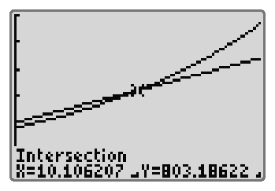
11. a)

Xmin = 0, Xmax = 20, Xscl = 2, Ymin = 0,
Ymax = 1500, Yscl = 250
Option A: Linear. The graph is a line.
Option B: Exponential. The graph is increasing at an increasing rate.
b) Answer depends on the length of time the money is invested. For less than ten years, Option A earns more interest. For greater than ten years, Option B earns more interest.
12. r = 9.4 cm
13. a) Linear. The value of the vehicle decreases by a constant amount each year.
b) Exponential. The number of sections increases by a percent.
c) Exponential. The amount of money remaining decreases by a percent.
14. a) m = 2.301t + 18.649
b) 76.17 g
c) 35.4 h
d) m = 0.099t² +1.113t + 20.827
e) 110.53 g
f) 23.3 h
g) m = 20.283(1.07)^{t}
h) 110.08 g
i) 23.6 h

