Section 7.1 Annuities

1. $1250 is invested at the end of each year for four years into a fund that pays 3.25% per year, compounded annually. Use a timeline to determine the future value of the annuity.

2. Use a TVM Solver or an Internet calculator to determine the future value of each annuity. Check your answer using a timeline.
a) $300 is invested at the end of each month for nine months into an account that pays 2.65% per year, compounded monthly.
b) $750 is deposited quarterly for two years into a fund that pays 8.25% per year, compounded quarterly.

3. Determine the monthly payment for a
three-year loan on a $15 000 motorcycle at 5.9% per year, compounded monthly.

4. Determine the weekly deposit needed to
save $1000 in one year if interest is earned
at 0.25% per year, compounded weekly.

5. Determine the present value of each annuity. Use a timeline to check your answer.
a) Monthly deposits of $375 at 5.75% per year compounded monthly for three years.
b) Annual income of $4250 for five years from a fund that earns 4.24% per year, compounded annually.

6. Rajinder would like to borrow $7500. His bank offered him a three-year personal loan with monthly payments. The interest rate on the loan is 6.25% per year, compounded monthly.
a) Determine Rajinder’s monthly payment.
b) Calculate the total amount that he will pay to the bank.
c) How much interest will Rajinder pay over the life of the loan?

7. Miyako is in grade 12 and lives at home. She has a part-time job and earns $1200 per month. Miyako deposits $500 at the end of each month into an account that pays 2.1% per year, compounded monthly.
a) How much was in Miyako’s account at the end of one year?
b) How much was in Miyako’s account at the end of three years?
c) Compare your answers to parts a) and b). Explain why the answer to part b) is not triple the answer to part a).
d) Calculate the total amount that Miyako has deposited over the three years.
e) How much interest has she earned in
three years?

8. Enrique plans to take a four-year college program. He estimates he will need $7000 per year for each of the four years. Currently, his savings are in an account paying 3.2% per year, compounded annually. What is the minimum amount Enrique will need in his account when he starts college so he can graduate without debt?

9. a) What amount should be invested now at 4.75% per year, compounded annually,
to generate a retirement income of
$35 000 per year for 25 years?
b) The sum of the payments is $35 000 × 25 or $875 000. Would the current amount be greater than or less than $875 000? Explain your reasoning.

10. a) Which TVM Solver screen is correct for question 7, part b)?
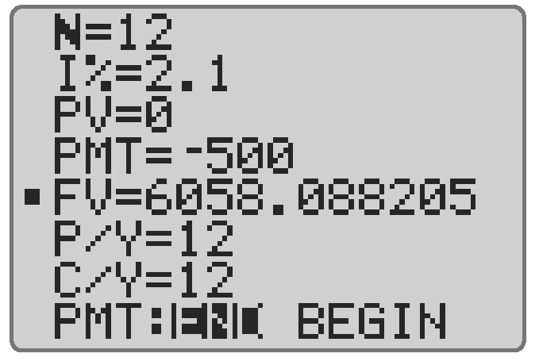
A

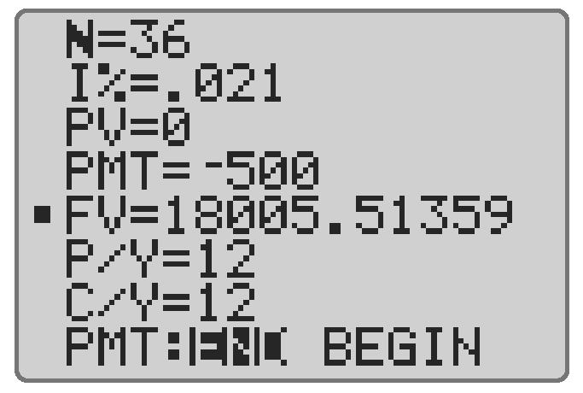
B

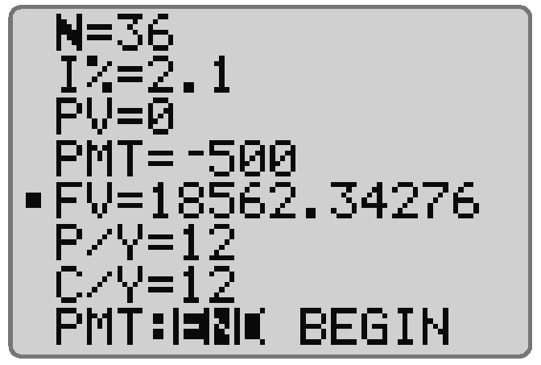
C

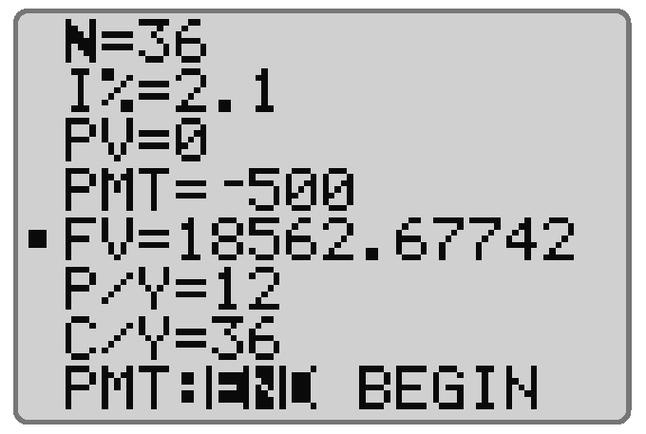
D

b) Explain the error in each of the
other screens.
11. Loretta currently has no savings. She plans to purchase a new laptop computer in one year. By then she would like to have $2500 in savings. She can invest her money
into an account that pays 3.1% per year, compounded monthly. Determine the amount she must deposit at the end of each month to reach her goal.

12. Which scenario could be modelled by this timeline?

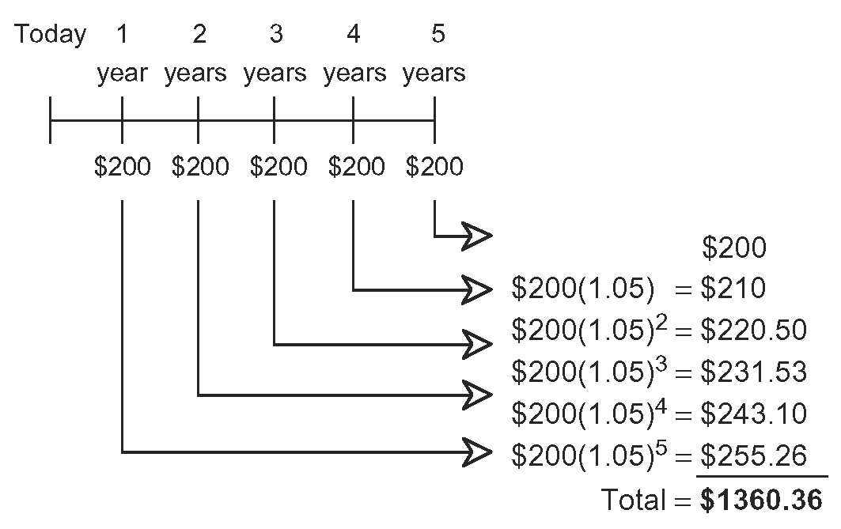
A $200 invested at 0.05% per year, compounded annually, for five years.
B $200 invested at 50% per year, compounded annually, for five years.
C $200 invested at 5% per year, compounded monthly, for five years.
D $200 invested at 5% per year, compounded annually, for five years.

