Chapter 7 Review

7.1 Annuities, pages 402–411
1. a) Complete the timeline.

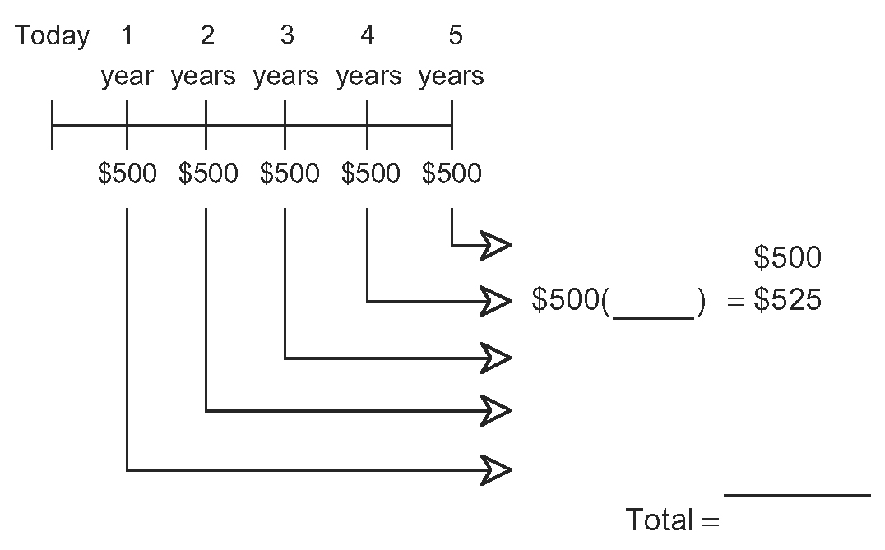
b) Which scenario best describes the timeline?
A $500 invested at 10% per year for
five years.
B $500 invested at 1% per year for
five years.
C $500 invested at 50% per year for
five years.
D $500 invested at 5% per year for
five years.

2. Use technology to determine the future value of each annuity.
a) $1000 is invested at the end of each month for nine months into an account that pays 3.1% per year, compounded monthly.
b) $2200 is deposited quarterly for two years into a fund that pays 12.5% per year, compounded quarterly.

3. Hernando’s bank is offering him a three-year personal loan of $7500 at 4.0% per year, compounded monthly.
a) Determine Hernando’s monthly
payment on the loan.

b) Calculate the total amount that he will
pay to the bank.
c) How much interest will Hernando pay over the life of the loan?

7.2 The Conditions of an Annuity,
pages 414–419
4. Hélène plans to borrow $25 000 at 3.75% per year, compounded monthly.
a) Determine the number of months required to repay the loan for each monthly payment amount.
i) $500 ii) $550
iii) $600 iv) $1000
b) Calculate the total interest paid for each monthly payment amount.

5. Repeat question 4 for bi-weekly payments.

6. Corey owes $10 000 for college, $5000 on his credit card, and $1000 to his brother. Corey is seeking a consolidation loan from his bank.
a) Calculate Corey’s monthly payment on
a five-year loan at 3.25% per year, compounded monthly.
b) Determine the total amount paid on the loan.
c) How much interest will Corey have to pay to eliminate his debt?
d) How much could Corey save by choosing a four-year loan?
e) Determine the monthly payment on a seven-year loan.
f) How much more interest will he pay compared to the five-year loan?

7.3 Mortgages and Amortization,
pages 420–429
7. For each five-year fixed term mortgage listed:
i) Determine the monthly payment.
ii) Calculate the total amount paid over
the term of the mortgage.
iii) Calculate the total principal paid over
the term of the mortgage.
iv) Calculate the total interest paid over
the term of the mortgage.
a) $212 000 amortized over 20 years at
an annual interest rate of 5.89%.
b) $368 000 amortized over 25 years at
an annual interest rate of 6.25%.
c) $127 500 amortized over 25 years at
an annual interest rate of 5.49%.
d) $422 000 amortized over 40 years at
an annual interest rate of 4.99%.

8. Ralph purchased a moped. Part of an amortization table for Ralph’s one-year personal loan is shown.
Principal Paid ($) | Interest Paid ($)
551.69 | 70.58
557.25 | 65.02
562.87 | 59.40
568.54 | 53.73
574.28 | 47.99
580.07 | 42.20
585.92 | 36.35
591.82 | 30.45
597.79 | 24.48
603.82 | 18.45
609.91 | 12.36
616.04 | 6.21
a) Determine the amount of Ralph’s
monthly payment.
b) Calculate the total amount needed to repay the loan.

c) Calculate the total interest paid.
d) Determine the amount Ralph borrowed.
e) Graph the data to show the remaining amount owing each month.

9. Wanda purchased a large cottage for
$179 900 with a 5% down payment. The mortgage rate is 4.10% per year, amortized over 25 years.
a) Determine Wanda’s monthly payment.
b) Assume the interest rate remains constant. How much will Wanda end up paying before the cottage is truly hers?
c) How much interest was charged over the life of the mortgage?
d) Cottage prices are expected to appreciate by 3% per year. Express the growth in the selling price as an exponential relation.
e) Calculate the estimated selling price of Wanda’s cottage in 25 years.

7.4 The Conditions of a Mortgage,
pages 430–437
10. Samir can afford to pay $1200 per month
on his mortgage.
a) Determine the payment amount for each payment frequency.
i) accelerated weekly
ii) weekly
iii) accelerated bi-weekly
iv) bi-weekly
v) semi-monthly
b) Calculate the amount paid in one year for each payment frequency.

11. Haylee has a $145 500 mortgage at 3.25% per year.
a) Determine the bi-weekly payment on a mortgage amortized over 25 years.
b) Use the ΣPrn function on your graphing calculator to determine the principal paid over the first five years of the mortgage.

