Chapter 7 BLM Answers

BLM 7-1 Prerequisite Skills
Assumptions for questions 1 to 5: There are 30 days per month, 365 days per year, 4 weeks per month, and 52 weeks per year.
1. a) 8 weeks b) 156 weeks c) 520 weeks
d) 481 weeks
2. a) 21 days b) 75 days c) 1460 days
d) 3723 days
3. a) $76.50 b) $765.00 c) $3978.00
d) $5508.00
4. a) $9333.33 b) $3230.77 c) $153.42
5. a) 3 payments b) 9 payments c) 39 payments d) 6 payments
6. a) 0.0042 b) 0.0319 c) –0.0002
d) 0.013 75 e) 0.000 01 f ) 0.2165
7. a) 10 b) 12 c) 48
d) 210 e) 365 f ) 300

8. a)
x | y = 3^{x} | First  Differences | Common  Ratio
0 | 1 | First  Differences | Common  Ratio
0 | 1 | 2 | 3
1 | 3 | 2 | 3
1 | 3 | 6 | 3
2 | 9 | 6 | 3
2 | 9 | 18 | 3
3 | 27 | 18 | 3
3 | 27 | 54 | 3
4 | 81 | 54 | 3
4 | 81 | 162 | 3
5 | 243 | 162 | 3

b)
x | y = 0.25^{x} | First  Differences | Common  Ratio
0 | 1 | First  Differences | Common  Ratio
0 | 1 | 0.75 | 4
1 | 0.25 | 0.75 | 4
1 | 0.25 | 0.187 5 | 4
2 | 0.062 5 | 0.187 5 | 4
2 | 0.062 5 | 0.046 875 | 4
3 | 0.015 625 | 0.046 875 | 4
3 | 0.015 625 | 0.011 718 75 | 4
4 | 0.003 906 25 | 0.011 718 75 | 4
4 | 0.003 906 25 | 0.002 929 687 5 | 4
5 | 0.000 976 562 5 | 0.002 929 687 5 | 4
9. a), b), c), e) less than d), f) greater than
10. a) 149.8501 b) 14.2594 c) 9898.8678
d) 2376.0810 e) 0.0019 f) 450 788.8805
11. a) $584.27 b) $5033.19 c) $26 940.09
12. a)
x | y = 750 + 750(0.25)^{x}
0 | 1500
1 | 937.5
2 | 796.875
3 | 761.718 75
4 | 752.929 687 5
5 | 750.732 421 875
b)
x | y = 750(1.25)^{x}
0 | 750
1 | 937.5
2 | 1171.875
3 | 1464.843 75
4 | 1831.054 687 5
5 | 2288.818 359 375

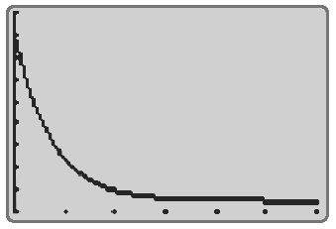
13. a)

Xmin = 0, Xmax = 6, Ymin = 700, Ymax = 1600, Yscl = 100
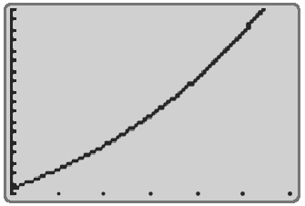
b)

Xmin = 0, Xmax = 6, Ymin = 700, Ymax = 2500, Yscl = 100

BLM 7-3 Section 7.1 Annuities
1.
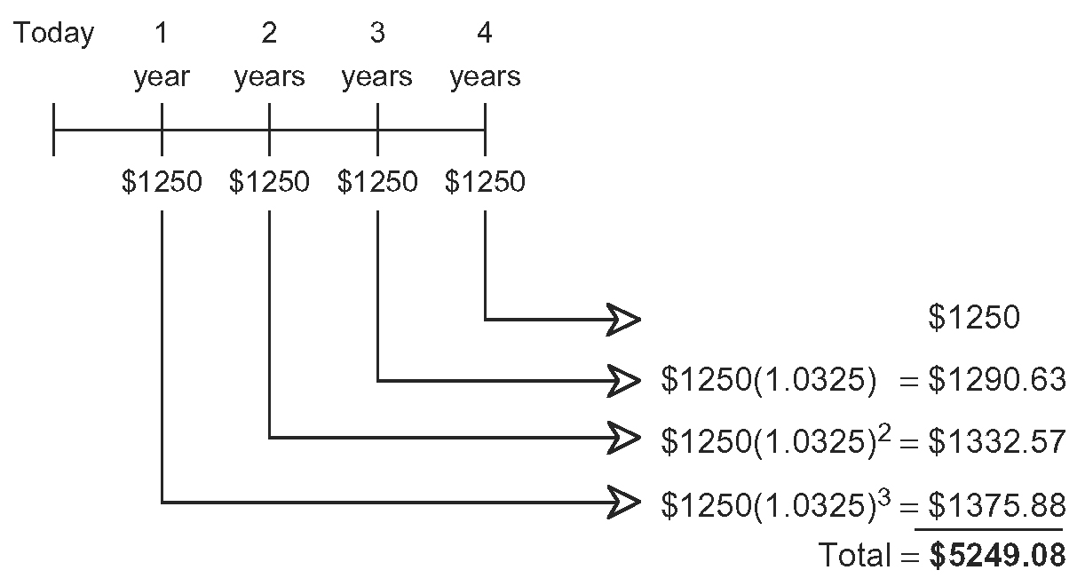
2. a) $2723.97 b) $6451.46
3. $455.65
4. $19.21
5. a) $14 696.01 b) $23 130.04
6. a) $229.02 b) $8244.72 c) $744.72
7. a) $6058.09 b) $18 562.34
c) The interest is compounded, so interest is earned on each previous month’s principal plus the interest amount. This means the growth of the money is not linear but exponential.
d) $18 000 e) $562.34
8. $26 724.39
9. a) $529 918.82
b) Less than. Each year, the unused amount will earn interest and increase in value.
10. a) C
b) In A, N should equal 36. In B, I% should equal 2.1. In D, C/Y should equal 12.
11. $205.39
12. D

BLM 7-4 Section 7.2 The Conditions of an Annuity
1. a) $232.07 b) $119.36 c) $96.84
d) $76.07 e) $66.84
2. a) $84.84 b) $164.64 c) $205.20
d) $266.73 e) $307.80
3. a) 100.8 months b) 83.8 months
c) 71.7 months d) 59 months e) 45.5 months
4. a) $5240 b) $4330 c) $3680
d) $3025 e) $2300
5. a) $923.95 b) $931.14 c) $945.60
d) $963.84 e) $971.19
6. a) $1087.40 b) $1173.68 c) $1347.20
d) $1566.08 e) $1654.28
7. a) 20 months b) $63.91 c) $1533.84
d) 20 months; $62.68; $29.52
8. a) $87 388.18
b) Don: $246 952.64; Donna: $626 743.39
c) Don: $91 200; Donna: $84 000 d) $1015.16
e) Yes. If he invests the $400 per month into an investment that earns more than 16.5% per year, compounded monthly, he will catch up to his
sister by age 54.

BLM 7-6 Section 7.3 Mortgages and Amortization
1. a) i) $1152.22 ii) $69 133.20
iii) $30 411.98 iv) $38 720.95
b) i) $1722.20 ii) $103 332
iii) $32 219.52 iv) $71 112.66
c) i) $2253.59 ii) $135 215.40
iii) $27 262.03 iv) $107 953.36
2. a) $302 000 b) $432 000 c) $624 000
3. a) $1702.89 b) $20 434.68 c) $8919.58
d) $11 515.10 e) $216 080.42
4. a) $619.49 b) $7433.84 c) $433.84
d) $7000
e)
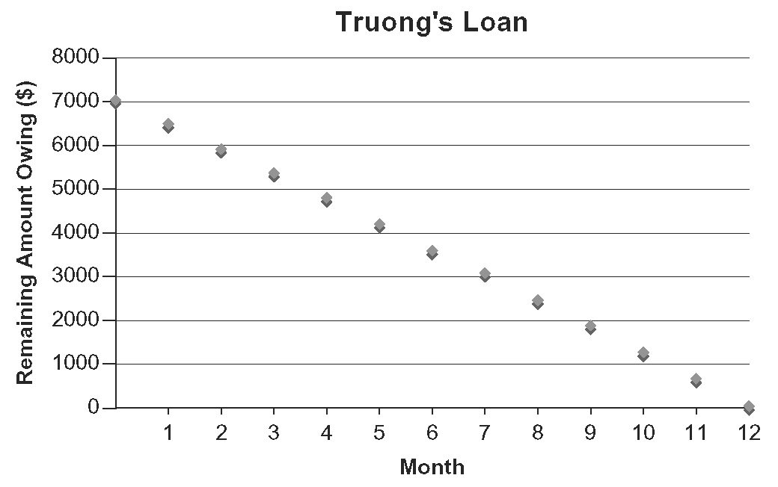

5. a) $8950 b) $170 050 c) $1013.36
d) $151 091.76
6. a) $175 000 b) $1320.98 c) $170 667.39 d) $1249.10

7. a) $1111.69 b) $333 507 c) $156 057
d) Selling price = 189 000(1.04)^{n}, where n is the number of years after the purchase.
e) $503 843.07 f) $314 843.07
8. a)
Year | Principal Paid ($) | Interest Paid ($) | Balance ($)
1 | 375.91 | 1847.72 | 9624.09
2 | 452.95 | 1770.67 | 9171.14
3 | 545.79 | 1677.83 | 8625.35
4 | 657.65 | 1565.97 | 7967.70
5 | 792.44 | 1431.18 | 7175.26
6 | 954.86 | 1268.76 | 6220.40
7 | 1150.57 | 1073.06 | 5069.83
8 | 1386.38 | 837.24 | 3683.45
9 | 1670.53 | 553.09 | 2012.92
10 | 2012.92 | 210.71 | 0.00
b) principal: $545.79; interest: $1677.83
c) principal: $954.86; interest: $1268.76
d) year 7
9. a) $2431.34 b) $2187.58
c) The second financial institution. If Denzel can pay the extra $11 000 for the down payment, his monthly payment will be $1971.64. He will save $64 782.00 on monthly payments over the 25 years.
10. Problems may vary. For example:
Gala purchased a three-bedroom house for
$275 000 with a 10% down payment. The mortgage is at 4.25% per year, amortized over
20 years.
a) Determine Gala’s monthly payment.
(Answer: $1527.71)
b) Assume the interest rate remains constant. How much will Gala end up paying before the house is truly hers? Remember to include the down payment. (Answer: $394 150.40)
c) How much interest was charged over the life of the mortgage? (Answer: $119 150.40)
d) Housing prices are expected to appreciate by 3% per year. Express the growth in the selling price of the house as an exponential relation. (Answer: Selling price = 275 000(1.03)^{n}, where n is the number of years after the purchase.)

BLM 7-7 Section 7.4 The Conditions of
a Mortgage
1. a) $1936.73 b) $581 019 c) $2179.75
d) $243.02 e) $523 140 f) $57 879
2. a) $227 900 b) $1325.48 c) $1497.59
d) $38 222.40
3. a) $375 b) $346.15 c) $750
d) $692.31 e) $750
4. a) $19 500 b) $17 999.80 c) $19 500
d) $18 000.06 e) $18 000
5. a) $889.79 b) i) 403.1 months ii) 292.1 months
c)
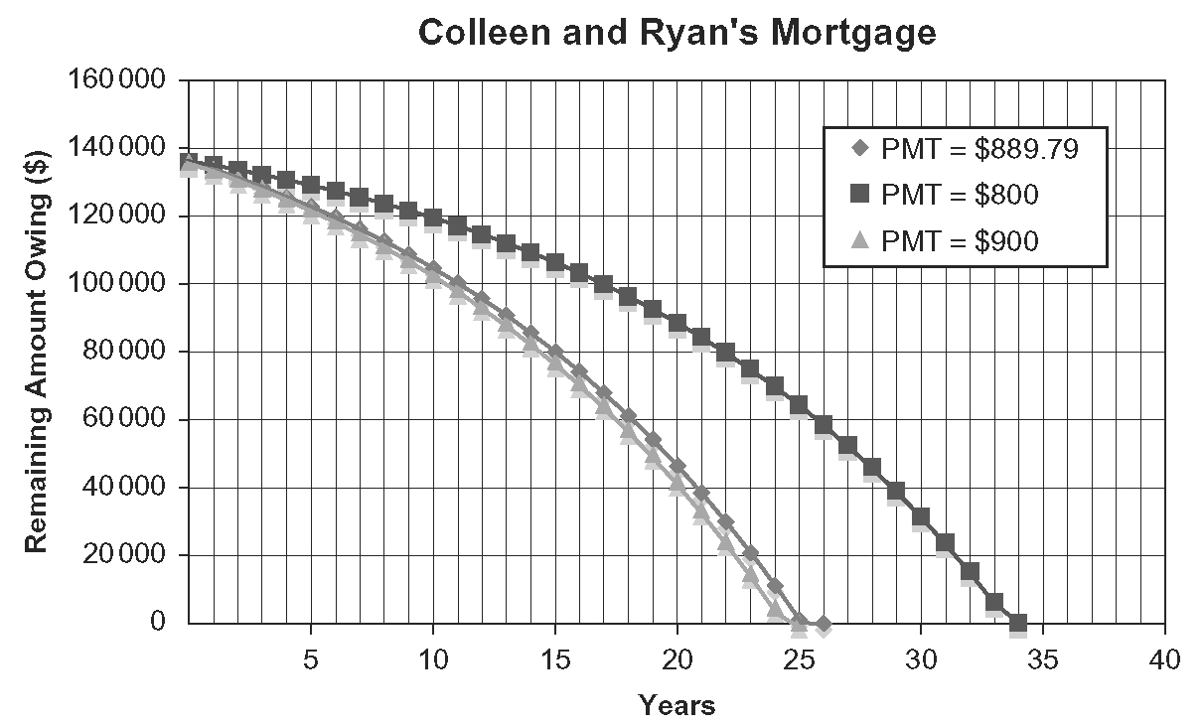
6. a) $538.47 b) $19 594.73
7. a) i) $1701.40 ii) $1701.40 iii) $2126.75
b) $2977.45
8. a) $956.74 b) approximately 6.9 years
c) $4500
9. a) monthly: $1404.61; semi-monthly: $701.63
b) monthly: $421 383; semi-monthly: $420 978
c) approximately 12.7 years
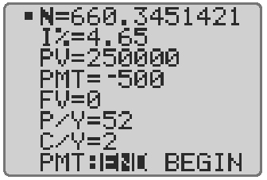
10. a) i) $328 789 ii) $398 239 iii) $453 970
b) Answers may vary. For example: They can obtain a larger mortgage to purchase a larger house. Or they can afford to buy a house because the smaller monthly payments are manageable.
11. a) $1618.98 b) $29 307.81
c) The lump sum payment goes directly to the principal, reducing the total amount of interest paid over the life of the mortgage and the total profit earned by the bank. Banks limit the amount of the lump sum payment because they want to make a large profit on mortgages.

BLM 7-9 Chapter 7 Review
1. a)
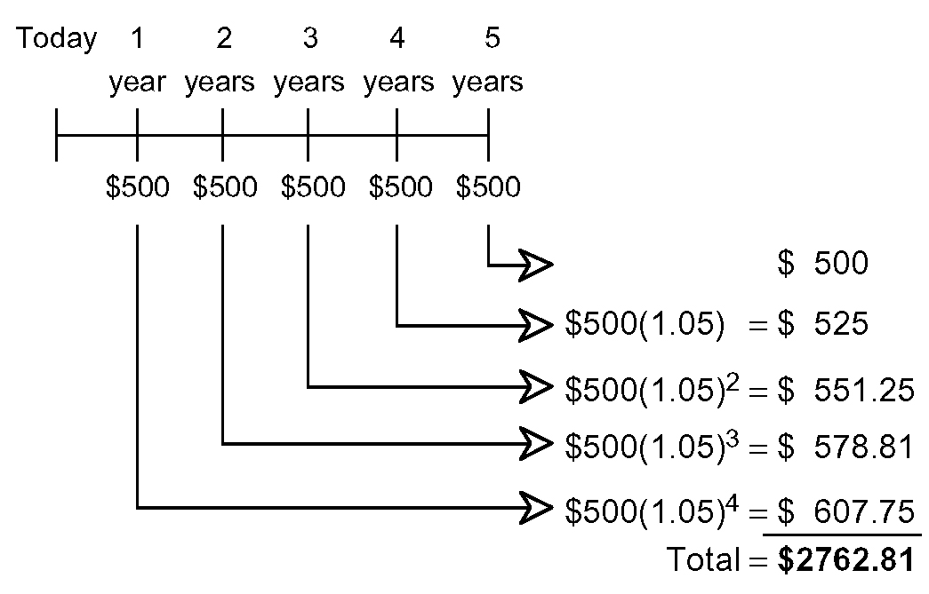

b) D
2. a) $9093.56 b) $19 650.13
3. a) $221.43 b) $7971.48
c) $471.48
4. a) i) 54.5 months ii) 49.1 months
iii) 44.7 months iv) 26.1 months
b) i) $2250 ii) $2005
iii) $1820 iv) $1100
5. a) i) 104 weeks ii) 94 weeks
iii) 86 weeks iv) 51 weeks
b) i) $1000 ii) $850
iii) $800 iv) $500
6. a) $289.28 b) $17 356.80
c) $1356.80 d) $272.64
e) $213.22 f) $553.68
7. a) i) $1505.41 ii) $90 324.60
iii) $32 340.70 iv) $57 983.97
b) i) $2427.58 ii) $145 654.80
iii) $35 876.64 iv) $109 778.36
c) i) $782.20 ii) $46 932
iii) $13 696.05 iv) $33 235.97
d) i) $2032.08 ii) $121 921.80
iii) $18 850.48 iv) $103 074.05
8. a) $622.27 b) $7467.22
c) $467.22 d) $7000
e)
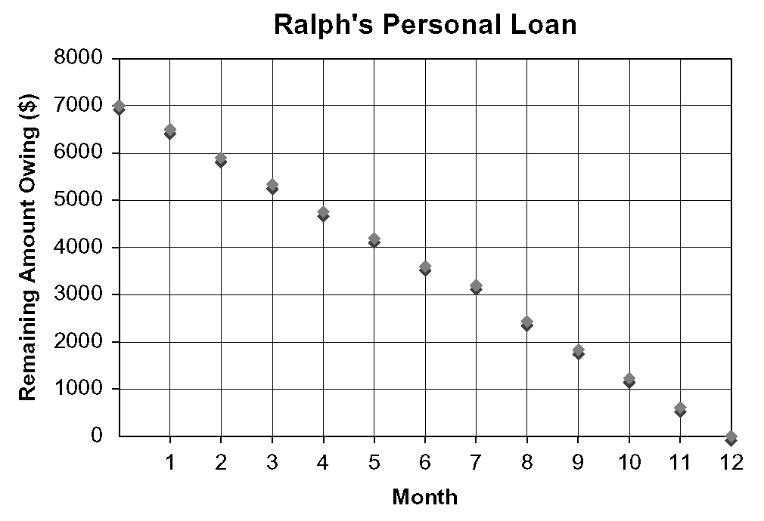

9. a) $911.56 b) $282 463
c) $102 563
d) Selling price = 179 900(1.03)^{n}, where n is the number of years after the purchase.
e) $376 670.65
10. a) i) $300 ii) $276.92
iii) $600 iv) $553.85
v) $600
b) i) $15 600 ii) $14 399.84
iii) $15 600 iv) $14 400.10
v) $14 400
11. a) $326.24 b) $20 542.83

BLM 7-11 Chapter 7 Practice Test
1. D
2. A
3. B
4. a), d) false b), c) true
5. no
6. a) $1267.17 b) $46 337.15
c) $156 206.96
7. a) $1 250 000 b) $533 738.80
8. a) $3308.85 b) $189.33
c) $3407.94
9. a) $2662.50 b) $14 234.10
c) $3000 at 3.25% by $1773.11
10. a) $406.02 b) $744.48
c) $203.01 d) $665.96
e) Changing from monthly to accelerated bi-weekly payments means Svetlana will make two additional payments each year, reducing the principal faster, and reducing the total amount she pays in interest.
11. a) $1387.73 b) $333 055.20
c) $103 155.20
d) Selling price = 229 900(1.06)^{n}, where n is the number of years after the purchase
e) $737 320.45
12. a) monthly: $1409.53; semi-monthly: $704.22
b) monthly: $422 859; semi-monthly: $422 532
c) 555.5 weeks
d) Increasing weekly payments reduces the principal faster, which reduces the time needed to pay off the mortgage and the total interest paid.
13. a) $197.31 b) $7103.16
c) $4413.53 d) $321.91

BLM 7-12 Chapter 7 Test
1. B
2. C
3. C
4. B
5. A
6. a), b) false c), d) true
7. a) $2729.20 b) $288.80
8. a) $10 329.55 b) $20 946.77
c) Interest is earned on the principal and the previous months’ interest. So the money grows in an exponential, not a linear, pattern.
d) $20 400 e) $546.77
9. $17 545.98
10. a) 21 months b) $107.33
c) $2575.92
d) 21 months; $107.00; $7.92
11. a) $414.18 b) $16 090.20
c) $37 752.91
12. a) $691.66 b) $8299.94
c) $299.94 d) $8000

e)
