Chapter 10 Test
For #1 to #4, circle the correct answer.

1. The perpendicular line from the centre of a circle to a chord ______________ the chord.

A bisects B intersects C is tangent to D passes through

2. Which of the following describes an inscribed angle in a circle?
A segments that have both endpoints on the
circumference of a circle
B the angle formed by two chords that share a
common endpoint on the circumference of a circle
C an angle formed by two radii of a circle where the
endpoints are on the circle
D an angle where the vertex is inside the circle at the
intersection of two chords

3. The measure of the central angle of a circle is ____________ the measure of an inscribed angle subtended by the same arc in the circle.

A twice B half C equal to D supplementary to

4. Which of the following describes a tangent to a circle?
A a line that intersects the circle at two points
B a chord that intersects the circle at two points
C a line that intersects the circle at only one point
D a chord that intersects the circle at only one point
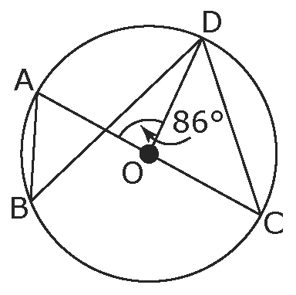
Use the diagram to complete the statements in #5 to #7.

5. If the measure of ∠AOD is 86°, then the measure
of ∠ACD is ______.

6. The measure of ∠ACD and ∠ABD is the ______________
because they are both _____________________ angles that share the same arc.

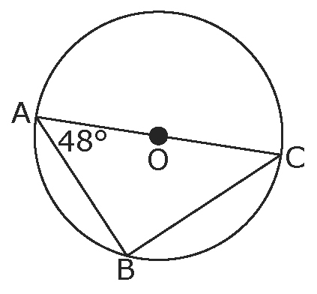
Short Answer

7. Use the diagram to find the measure of the following angles.

∠AOC is the central
angle to ∠ABC.

a) ∠AOC = _______° b) ∠ABC
Sum of angles in
a triangle = 180°.

c) ∠ACB

8. The centre of the circle is O. PA and PB are tangent to the circle.
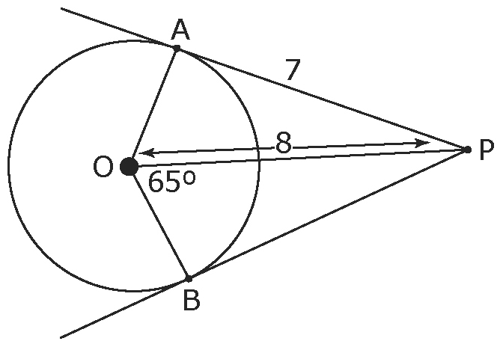
a) What is the measure of ∠PAO?

Use the Pythagorean relationship.

b) What is the length of OA?

c) What is the measure of ∠BPO?

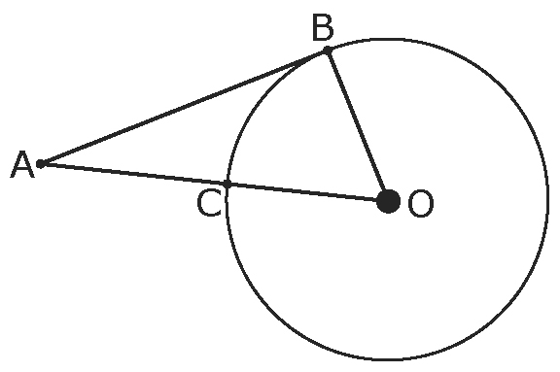
9. In the diagram, AB is tangent to the circle.
AB = 24 cm
OB = 10 cm

a) What is the length of AO?
Use the Pythagorean relationship.

OC is the radius of the circle.
b) What is the length of AC?

