Chapter 10 BLM Answers

BLM 10–1 Chapter 10 Problems of the Week
1. a) 14.52 cm b) The length of each side of the square is 10.27 cm. c) The length of WX is 20.54 cm. d) 421.89 cm²
2. a)

b) Angle measures will vary but they should all be the same.
c) Angle measures will vary but they should all be the same.
d) ∠AXB is twice any other angle for the circle.

BLM 10–3 Section 10.1 Extra Practice
1. a) central, inscribed, half; ∠ABC = ∠AEC = 59°.
b) ∠ABC = 61°, ∠AEC = 122°. Inscribed angles subtended by the same arc of a circle are equal. A central angle is twice the measure of an inscribed angle subtended by the same arc.
2. a) central, 180°, inscribed, 90°; BC = 5 units b) BC = 5 units
3. central, 90°, 8, right; 11.3 m
BLM 10–5 Section 10.2 Extra Practice
1. 4, 4, radius, 7; 5.7 units
2. a) 8, 4, 4, right; 6.4 units b) radii, 1.4 units c) 12.8 units
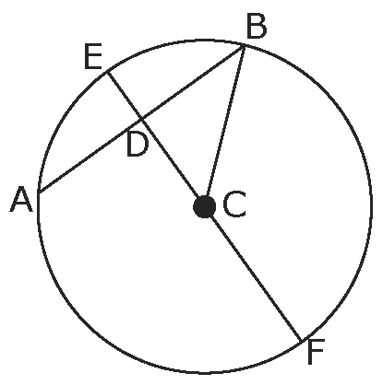
3. a)
24
16

b) CF = CB = 12 units c) BD = 8 units
d) CD = 8.9 units e) DE = 3.1 units

BLM 10–8 Section 10.3 Extra Practice
1. ∠OEF = 17°
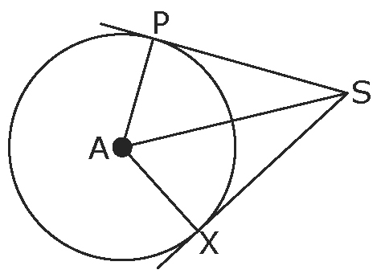
2. a)

b) AP = 8 cm
3. a) BE = 12 km
b) Jorge = 13 km + 6 km = 19 km
Sarah = 6 km + 6 km = 12 km
Sarah travels 7 km less than Jorge.
4. a) 5, isosceles, equal b) 90°, right, Pythagorean; CN = 13 cm c) PN = 8 cm
BLM 10–10 Chapter 10 Test
1. A 2. B 3. A 4. C
5. 43° 6. same, inscribed
7. a) 180° b) 90° c) 42°
8. a) 90° b) 3.9 c) 25°
9. a) 26 cm b) 16 cm

