Section 10.2 Extra Practice
- Find the length of CD to the nearest tenth.
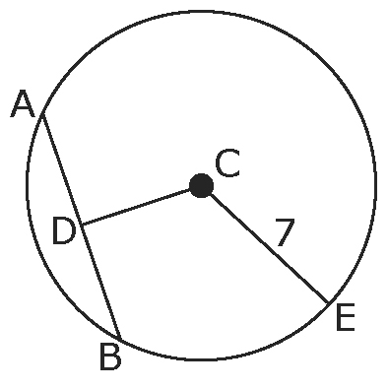
D is the midpoint of AB.
AB is 8 units in length.

Label the diagram.
AD = ______
DB = ______
CB is a _______________ of the circle. So, CB = _______.
CD² + DB² = CB²
CD² + =
CD² + ______ = ______
CD² ______ – ______ = ______ – ______
CD =
CD = ______

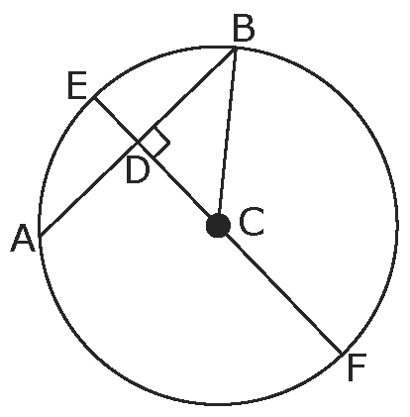
2. AB = 8 units
CD = 5 units.

a) Find the length of CB to the nearest tenth.

Label the diagram with measurements you know.
AB = ______, so AD = ______ and BD = ______.
∆BDC is a ___________________ triangle, so use the Pythagorean relationship to find the length of CB.

BD² + CD² = CB²

b) Find the length of ED.
C is the centre of the circle, so CB and CE are _____________.
CD + ED = CE
5 + ______ = ______
______ = ED
EF is the diameter.
c) Find the length of EF.

3. Diameter EF = 24 units
Chord AB = 16 units
Find the lengths of CF, CB, BD, CD, and DE to the nearest tenth.

a) Label the diagram with measurements you know.
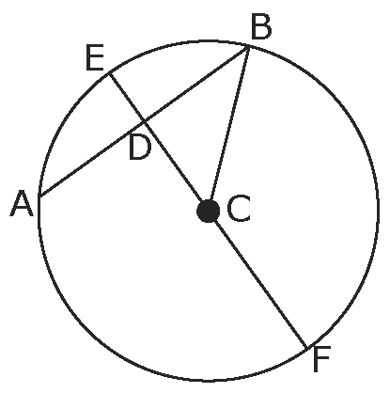
b) Find the lengths of CF and CB.

c) Diameter EF bisects chord AB at D.
Find the length of BD.

d) Find the length of CD.

∆BDC is a _____________________ triangle, so use the Pythagorean relationship to find the length of CD.

CD² + BD² = CB²
CD² + =

Label the measure of CD on the diagram.

CE is the radius.
e) Find the length of DE.

