hSection 11.1 Extra Practice
Influencing factors:
• bias
• use of language
• ethics
• cost
• time and timing
• privacy
• cultural sensitivity
1. For each situation, write the type of influencing factor.
The first one is done for you.

a) A vote is taken by a show of hands.
The type of influencing factor is privacy.

b) Parents are asked if they would support a curfew for teens.
The survey is being done the week after several incidents of vandalism at the high school were reported in the newspaper.

The type of influencing factor is ________________________.

c) A town council wants to know if residents are in favour of building a new skating arena. The council decides to survey 500 people at the next hockey game.

The type of influencing factor is ________________________.

d) The coach of a baseball team needs drivers with good safety records to drive players to tournaments. She asks each parent at a parent meeting if they have had any traffic accidents in the last 6 months.

The type of influencing factor is ________________________.

e) A manufacturing company surveys its shareholders about a proposed expansion.

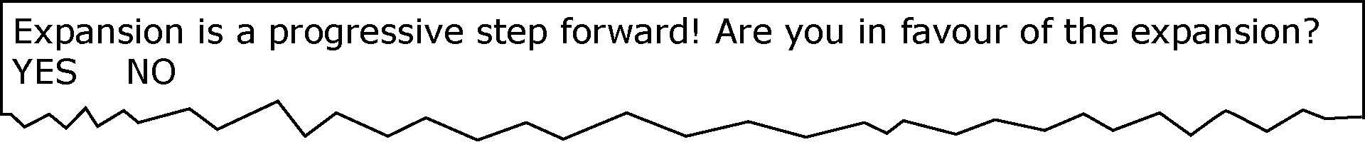

The type of influencing factor is ________________________.

f) An information package and survey are mailed to 3000 residents. It is about a proposal to improve the gardens in the local park. The cost to print and mail each survey is $10.

The type of influencing factor is ________________________.

2. For each situation, write a survey question that is clearly written and free from influencing factors.

a) The local service club wants to know if its members are in favour of buying seeds and tools to start a community garden.

_____________________________________________________________________________________________________________________

b) A school cafeteria is picking 2 vegetable snacks and wants to know the 2 most popular vegetables to serve raw.

______________________________________________________________________________________________________________________

