Chapter 11 Test
For #1 to #4, circle the correct answer.
1. Claire selects every tenth name from an alphabetical list of students in grade 9. Which sampling method is this?

A convenience sample B voluntary response sample
C random stratified sample D random systematic sample

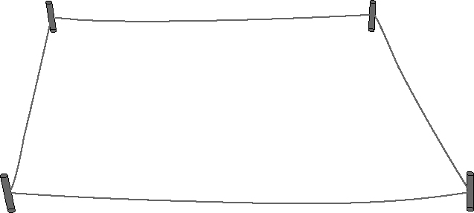
2. A naturalist wants to count the population of a rare
plant. He throws a peg into the area where
they grow, and then uses where the peg landed
as one corner of a 100 cm by 100 cm square.
He will count the plants inside the square.
Which sampling method is this?

A convenience sample B random sample
C systematic sample D voluntary response sample

3. Which of the following survey questions is biased?

A Who is your favourite musician?
B What movies have you watched in the past month?
C Why is Smiley’s Toothpaste the best?
D What brand of ice cream do you prefer?

4. For which situation would a survey of the population be most appropriate?
all the individuals in the group
A the kind of pizza your class will order for lunch
B the number of drivers in western Canada who wear seat belts
C the percent of Canadian grade 12’s who plan to attend college
D the most popular brand of soft drink in Canada.

Complete the statements in #5 and #6.
5. Daniel plans to find the average height of grade 9 male students in his school. He decides to record the height of every male grade 9 student.
Daniel’s survey group represents a ______________________.
(population or sample)
6. A city planner wants to know if a traffic light is necessary at a new intersection. He sets up a camera to record the traffic from
7:30 a.m. to 8:30 a.m. Based on the results, he installed a traffic light.
A factor that may have influenced the results is ______________________. (timing or cost)

Short Answer

7. A random sample shows that 1% of tennis balls are defective.
How many are likely to be defective in a container of 1200 tennis balls? Show your work.

8. Sara plans to survey 25 out of the 100 grade 9 students in her school. She wants to know where to hold the year-end party.

a) Is Sara surveying the population or a sample? ____________________

b) Sara surveys the first 25 students she sees. What type of sample is this? ______________________
Types of samples:
● convenience ● voluntary
● random ● systematic
● stratified

9. In the survey question below, identify an influencing factor. Then, rewrite the question so it is free of any influencing factors.

Question: “Do you prefer to drink watered down 1% milk or creamy and smooth 2% milk?”

Influencing factor: ________________________
Rewrite the question: ___________________________________________
_____________________________________________________________
10. A marketer wants to determine which type of music 14 year old girls in Canada prefer.

a) Identify the population. ______________________

b) Should he survey the population or a sample?
Circle POPULATION or SAMPLE. Give 1 reason for your answer.

____________________________________________________________________________________________________________________

c) Write a survey question that is free from bias.
____________________________________________________________________________________________________________________

