Chapter 11 BLM Answers

BLM 11–1 Chapter 11 Problems of the Week
1. Answers will vary. Example:
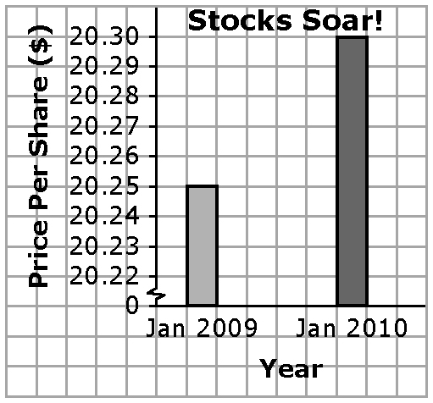
a)

b) The break in the scale creates the misleading impression that the stocks have increased a lot in value.
2. a) Answers will vary. Example: DISAGREE. This year an average of 6.4% of students were absent. Last year an average of 7% of students were absent. Although this is a slight improvement, it is not a significant change.
b) Answers will vary. Examples:
• How many months does the 6.4% rate represent? If it is early in the school year, it would be premature to make a statement about improved attendance.
• What absentee rate would be considered a significant improvement?
• Is an absentee rate of 6% or 7% reasonable?
3. a) Amy: Mean: 7; Median: 9; Mode: 9
Peter: Mean: 6.2; Median: 7; Modes: 3 and 9
Molly: Mean: 8.6; Median: 9; Mode: 9
b) MEAN. It is the most accurate reflection of their quiz scores.
4.
Survey Idea | Influencing Factor
Ask “What does a good band sound like?” | Bias
Hire a survey company and pay them. | Cost
Make all students fill out the survey. | Privacy
Ask if the band members are good looking. | Bias
BLM 11–2 Section 11.1 Extra Practice
1. b) Time and timing: The group is taking advantage of the recent vandalism at the high school to promote their agenda. The population might believe that teens were involved in the acts of vandalism and may more likely support a curfew.
c) Bias: Many people attending a hockey game are more likely in favour of building a new arena.
d) Privacy: The coach is violating the privacy rights of parents. The coach could have asked parents who are interested in driving to submit a confidential criminal record check.
e) Language: The wording in the question may lead people to answer favourably.
f) Cost: Sending the package and survey by mail is very costly. The money spent on promotion could be better directed to buying plants. Using a survey method that is more cost effective should be considered.
2. Answers will vary. Examples: a) Are you in favour of starting a community garden? YES NO If Yes, are you in favour of buying seeds and tools? YES NO
b) What are your favourite 2 raw vegetables?
BLM 11–3 Section 11.2 Extra Practice
1. a) All members of the team; a sample
b) All grade 9 students; population
c) All Arctic grayling in Lake Athabasca; sample
2. a) Stratified sample; The results would fairly represent the population because the same proportion of each type of resident is represented in the sample.
b) Survey 500 homeowners, 100 condo owners, 300 apartment renters, and 100 home renters.
BLM 11–4 Section 11.3 Extra Practice
1. a) 36%; 500 × 36% = 180. 180 students would choose science fiction.
b) Answers may vary. Example: NO. The students in one school may not represent the students in another school. Therefore, the prediction may not be reasonable.
2. a) The average sales for the first three months are $215. b) The average sales for ten months is $268. NO. The students assumed that the lower sales in the first three months represent the whole school year. This is false.
BLM 11–7 Chapter 11 Test
1. D 2. B 3. C 4. A 5. population 6. timing
7. 1200 × 0.01 = 12
8. a) sample b) convenience sample
9. bias; Which type of milk do you prefer to drink—1% or 2%?
10. a) All 14 year old girls in Canada.
b) Sample. It would be too costly and time consuming to survey the population.
c) Answers will vary. Example: What is your favourite type of music?
BLM 11–9 Practice Final Exam
1. A
2. A
3. B
4. 1
5. C
6. A
7. D
8. A
9. C
10. C
11. A
12. 0.2
13. C
14. 18
15. C
16. 9
17. D
18. C
19. B
20. D
21. B
22. D
23. B
25. B
26. A
27. , –0.3, ,
28. D
29. B
30. B
31. B
32. Answers will vary. a) Customers between the ages of 15 and 30. b) What is your favourite brand of jeans?
33. n = number of jeans sold; 89.99n ≥ 1000
34.
The store must sell at least 12 pairs of jeans.

