Section 1.3 Extra Practice
1. Estimate the surface area. Then, calculate surface area of each figure.
Each cube is 1 cm × 1 cm × 1 cm.

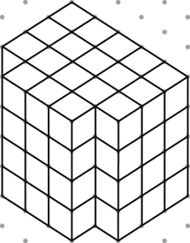
a) b)

Estimate: Estimate:

Calculate: Calculate:

Side 1: _______ cm

Side 2 and 3:

Side 4, 5 and 6:

Side 7:

Side 8:

Total Surface Area:
2. The following objects have been drawn on isometric dot paper. The distance between dots is 1 cm. Find the surface area of each object.
Number the sides.
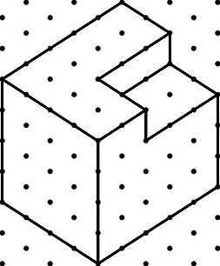
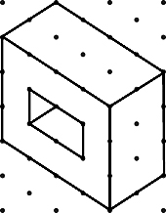
a) b)

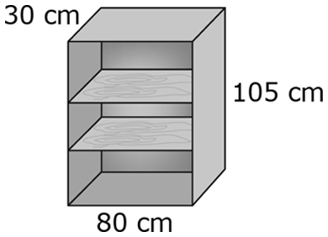
3. Jocelyn is building a bookcase using unfinished wood.
The shelves are 2 cm thick. The back of the shelves is made
of thin plywood. She wants to paint all the pieces before
she builds the bookcase. Draw the shapes she needs to paint.
Label the dimensions. How many of each shape is there?

Shape | Number
Sides:  cm  cm | 4

