Chapter 1 Test
For #1 to #4, circle the best answer.

1. Which figure has the largest number of lines of symmetry?
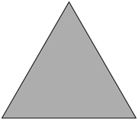
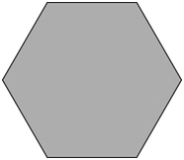
A B

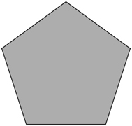

C D

2. Both line symmetry and rotation symmetry are shown in which figures?
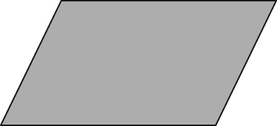
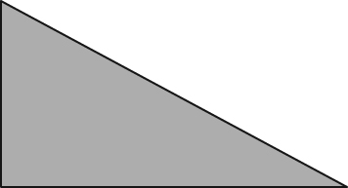
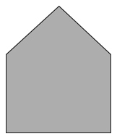

I II III IV

A I and III B II and III
C I and IV D III and IV
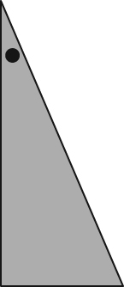
3. The figure to the right was rotated about a vertex.
Which image shows the resulting image?

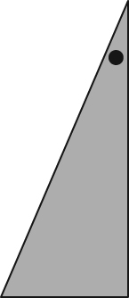
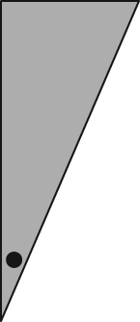
A B

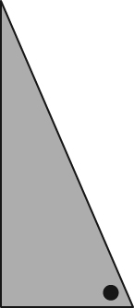
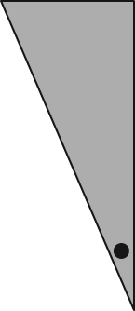
C D

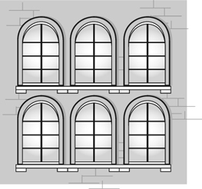
4. Which of the following statements is true when
describing the picture to the right?
A There is a horizontal line of symmetry.
B There is an oblique line of symmetry.
C The line of symmetry is vertical.
D A line of symmetry does not exist.

Complete the statements in #5 and #6.
5. The order of rotation of the snowflake shown in the diagram is ________.
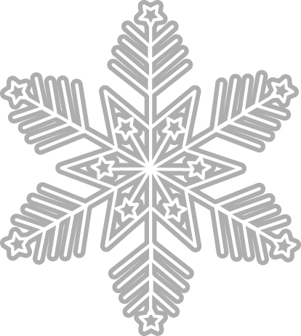
6. In the diagram below, the angle of rotation is ________.

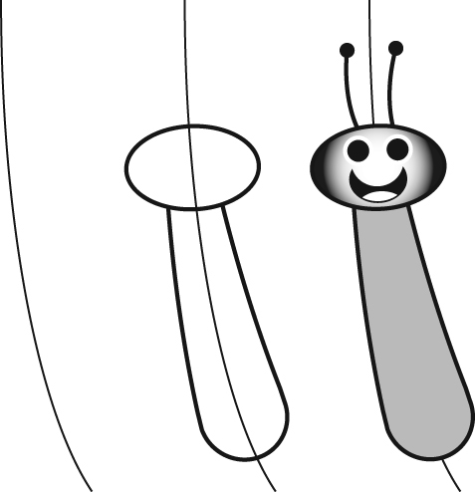
Short Answer

7. Omari says that the cartoon figure he drew is symmetrical
with respect to a vertical line. Do you agree with Omari?
Circle YES or NO. Give 1 reason for your answer.

________________________________________________________

8. A triangle is drawn on a coordinate grid.
a) Draw the image of the triangle b) Label the coordinates of the
after it is translated 6 units translated points.
to the left.
A′ __________
B′ __________
C′ __________
c) Circle the type of symmetry which results from the translation of the graph. VERTICAL or HORIZONTAL or NEITHER.

