Chapter 1 BLM Answers

BLM 1–1 Chapter 1 Problems of the Week
1. 16 cm
2. a)

b) The square and hexagon. Any even sided shape will appear to have the same orientation.
3. Answers will vary.
BLM 1–5 Section 1.1 Extra Practice
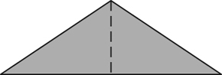
1. a) 1

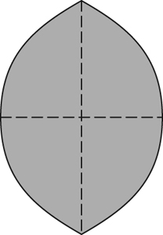
b) 2

c) 0
d) 4

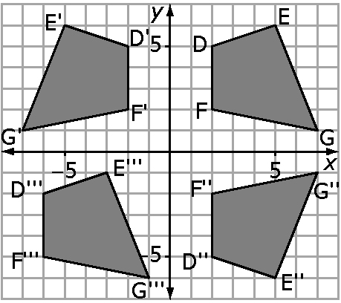
4. a) to c)

d) NO. If it was a reflection, each of the reflected points would be the same distance from the
y-axis and they are not.
BLM 1–7 Section 1.2 Extra Practice
1. a) Order of rotation: 4
Angle of rotation: 90°, turn
b) Order of rotation: 8
Angle of rotation: 45°, turn
2. a) Number of lines of symmetry: 2
Order of symmetry: 2
b) Number of lines of symmetry: 5
Order of symmetry: 5
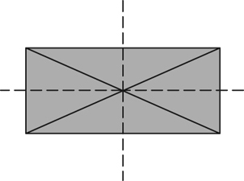
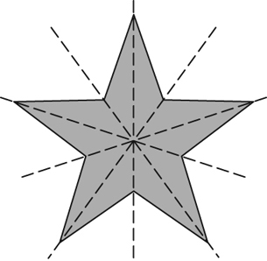
3. a) b)

,

4. a) Number of lines of symmetry: 0
Angle of rotation: 180°
b) Number of lines of symmetry: 3
Angle of rotation: 120°

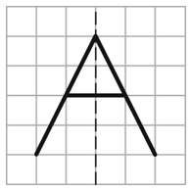
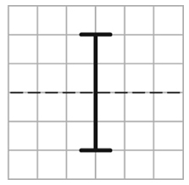
5. a) b)

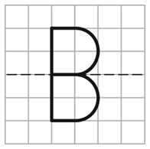
c)

d) B. The bottom half is a reflection of the top half. Also, the bottom half is a vertical downward translation image of the top half.

BLM 1–9 Section 1.3 Warm Up
1. a) 10.82 b) 18.03
2. a) 4 b) 8.94

BLM 1–10 Section 1.3 Extra Practice
1. Estimates will vary. a) Estimate: 80 cm²; Calculate: Side 1 = 5, Sides 2 and 3 = 16, Sides 4, 5, 6 = 30, Side 7 = 20, Side 8 = 15,
Total = 86 cm²
b) Estimate: 100; Calculate: top/bottom = 36, back = 20, 2 sides = 32, front = 20, total = 108 cm²
2. a) back/front = 40, sides = 32, top/bottom = 40, total = 112 cm²
b) sides = 12, top/bottom = 16, front/back
= 20, inside = 6, total = 54 cm²

3.
Shape | Number
Sides:  105 cm  30 cm | 4
Top and bottom:  30 cm  80 cm | 4
Back:  105 cm  80 cm | 2
Top and bottom of shelves:  30 cm  80 cm | 4
Front of shelves, front of top and bottom:  2 cm  80 cm | 4
Front of sides:  105 cm  2 cm | 2

BLM 1–11 Chapter 1 Test
1. B 2. C 3. D 4. C
5. 6 6. 90º
8. NO. The cartoon is symmetrical to a curved line, not a straight line.
9. a)

b) (–5, 5), (–5, 1), and (1, 1)
c) NEITHER.

