Section 1.1 Extra Practice
1. For each of the following shapes,
• find the number of lines of symmetry
• draw the lines of symmetry if possible.

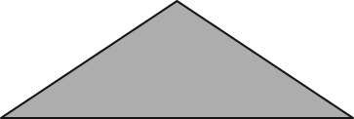
a)

Number of lines of symmetry:

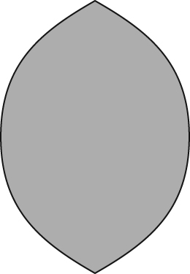
b)

Number of lines of symmetry:

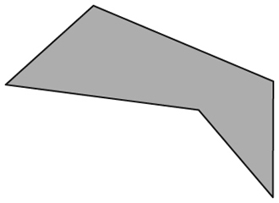
c)

Number of lines of symmetry:

d)

Number of lines of symmetry:
2.

a) Draw the reflection image if the y-axis is the line of reflection. Label the figure D'E'F'G'.

b) Draw the reflection image of the figure DEFG if the x-axis is the line of reflection. Label the figure D"E"F"G".

c) Translate the figure DEFG 8 units to the left, and 7 units down. Label the translated image D"'E"'F"'G"'.

d) Is the figure D"'E"'F"'G"' a reflection of the figure D"E"F"G" with the y-axis as the line of reflection? Circle YES or NO. Give 1 reason for your answer.
_____________________________________________________________
_____________________________________________________________

