Section 1.2 Extra Practice
1. Complete the table.

 | Order of Rotation | Angle of Rotation
 | Order of Rotation | Degrees | Fraction of a Turn
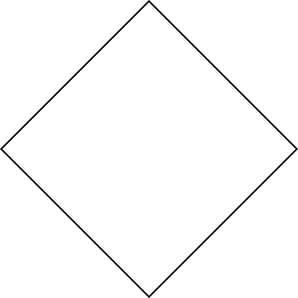
a)

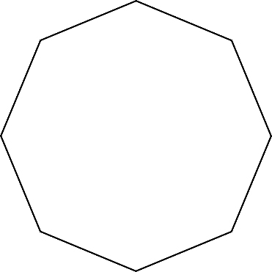
b)

2. Complete the table.

 | Number of Lines of Symmetry | Order of Symmetry
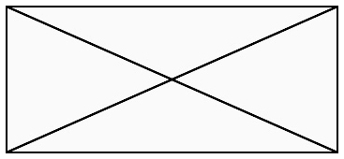
a)


b)

3. Draw the lines of symmetry and show the centre of rotation for the shapes in #2.

4. Complete the table.

 | Number of Lines of Symmetry | Angle of Rotation
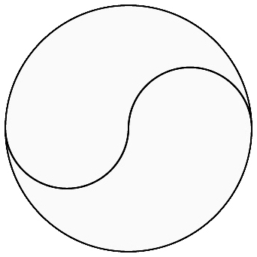
a)

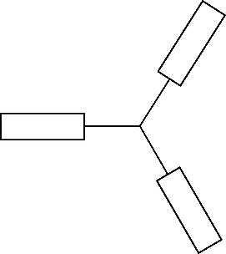
b)

5. a) The following capital letters are only half drawn.
• Complete the letters.
• Draw the line(s) of reflection and/or the centre(s) of rotation.

b) Which letter can be completed using a reflection or a translation?
Give 1 reason for your answer.

___________________________________________________________________________

___________________________________________________________________________

