Section 2.1 Extra Practice
A rational number is a number that can be written as a fraction.
1. Circle the rational numbers.
a) 17 −3.606 –

b) –0.2 7.1234 . . .
2. Compare and order the rational numbers from least to greatest.
9 –17.6 401 –7
Change the fractions into decimal numbers.

3. Match each letter on the number line to one of the following rational numbers.
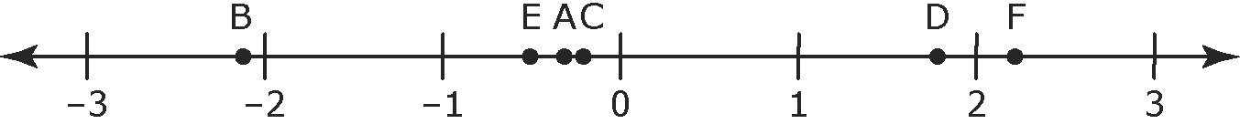
: ______ –0.3: ______ : ______
: ______ –2.1: ______ −: ______
4. Compare , 1.7, –0.6. Write the numbers in ascending order.
Change the fractions into decimal numbers.

5. Compare –0.5,, and . Write the numbers in descending order.

Change both numbers to decimals or fractions.

6. Which pairs of rational number are equivalent?
a) , b) , c) ,

7. Circle the smaller value in each pair.
Find a common denominator.

a) ,

b) ,

c) ,

8. Write a fraction between each pair of rational numbers.
Change each decimal
to a fraction.
a) 0.8, 0.9 b) –0.65, –0.66

9. Solve. Write each answer as a fraction or mixed number in lowest terms.
a) 7 ÷ (–14) b) –75 ÷ 100

c) –4 ÷ 12 d) (–12 )÷ (–8)

10. Write >,<, or = to make each statement true.

a) –5 ______ b) _______

c) –0.5 _______ d) _______ 0.25

