Section 3.4 Extra Practice
1. What is the volume of a cube with a side length of 4 cm?
Show your work.

V = s

2. A colony of bacteria triples every hour. There are 30 bacteria now.
How many will there be after each amount of time? Show your work.

a) 1 h b) 3 h
# of bacteria after 1 h = 30(3) # of bacteria after 3 h = 30(3)
= _______ = _______

c) 5 h d) n h

3. What is the surface area of a cube with a side length of 6 cm?
Show your work.

SA = 6s

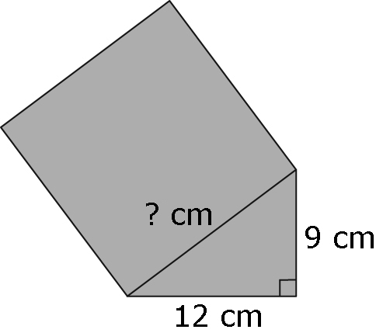
4. Find the side length of the square attached to the hypotenuse in the diagram. Show your work.
c² = a² + b². Find c.

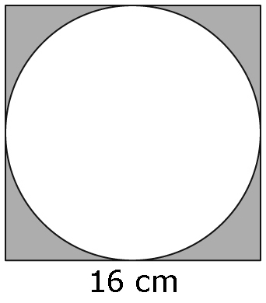
5. The diagram shows a circle inscribed in a square with a side
length of 16 cm. What is the area of the shaded region?
Round your answer to the nearest hundredth of a square
centimetre. Show your work.
A = s², A = πr²

Area of shaded region = Area of ______________ − area of _____________

6. A formula used to calculate the distance a skydiver falls is d = 4.9t².
d is the total distance, in metres.
t is the time, in seconds.
Calculate the distance the skydiver falls in the following times.
Show your work.
Substitute into the formula.
a) 2 s b) 4 s

7. A cylinder has a radius of 7 cm and a height of 12 cm.
Calculate its surface area.
Round your answer to the nearest hundredth of a square centimetre.
Show your work.
SA = 2πr² + 2πrh

