Section 4.1 Extra Practice
1. a) Use a scale factor of 2 to enlarge the letter.
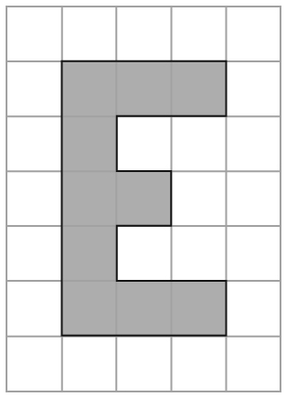

b) Use a scale factor of 3 to enlarge the letter.
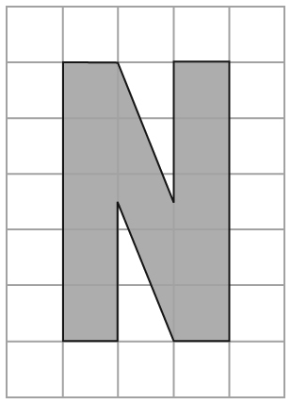

2. Draw an enlargement of the flag using a scale factor of 3.

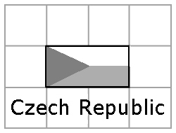

3. Draw an image with dimensions that are half as large as each letter.
Use a scale factor of 0.5.
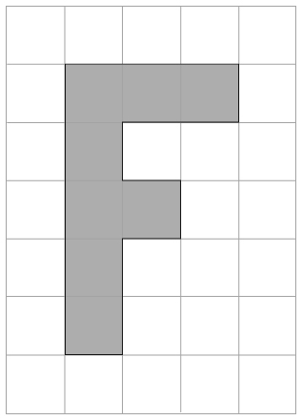
a)

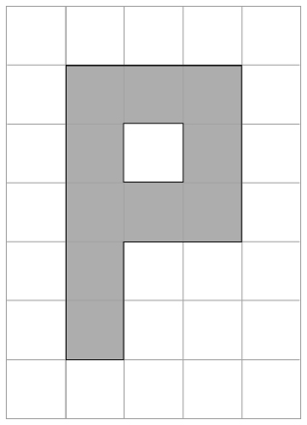
b)

Multiply each side by 0.5.

4. Draw a reduction of the flag using a scale factor of 0.5.

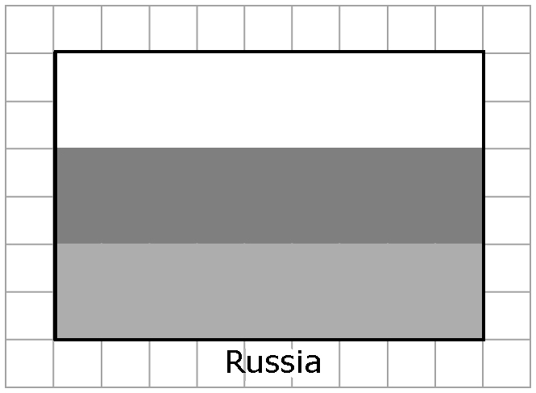

5. The small fish has been enlarged. Circle the scale factor that was used.
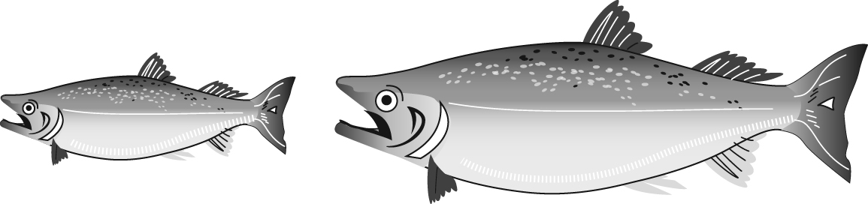
EQUAL TO 1 or GREATER THAN 1 or LESS THAN 1.
Give 1 reason for your answer.

________________________________
________________________________

6. Is Figure B an enlargement of Figure A? Circle YES or NO.
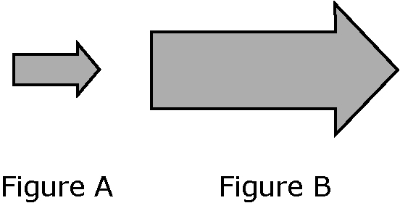
Give 1 reason for your answer.

________________________________
________________________________

