Section 4.2 Extra Practice
1. Circle whether you would multiply or divide to find each missing value.

a) b)
MULTIPLY or DIVIDE. MULTIPLY or DIVIDE.

c) d)
MULTIPLY or DIVIDE. MULTIPLY or DIVIDE.

2. Find the missing value.

× _____

a) b)

× _____
÷ _____

c) d)

÷ _____

e) f)

3. Calculate the actual length of each object.

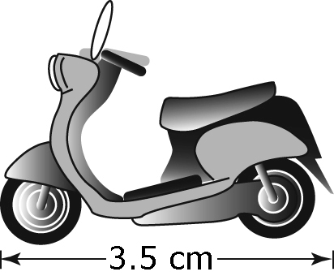
a) The scale for the reduction of the scooter is 1 : 20.
diagram : actual

b) The scale for the enlarged image of a housefly is 1 : 0.3.
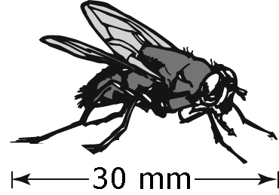

Divide to find the scale factor.

4. Determine the scale factor.

a) = ______ b) = ______

c) = ______ d) = ______

e) = ______ f) = ______

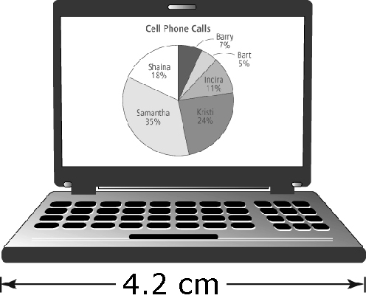
5. An actual laptop has a width of 39.5 cm.
Calculate the scale factor used in the image of the
laptop. Round your answer to the nearest tenth.

= ______

6. A driving distance is 650 km. The distance shown on a map is 4 cm.

a) What is the scale factor?
Hint: 1 km = 100 000 cm

b) Express the map scale in words.

________________________________________________________

