Section 4.3 Extra Practice
1. List the corresponding angles and the corresponding sides in each pair of triangles.
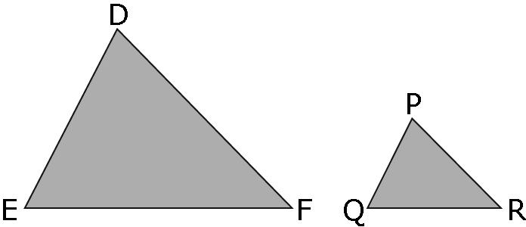
a) b)

D corresponds to ______. ___________________________
E corresponds to ______. ___________________________
F corresponds to ______. ___________________________
DE corresponds to ______. ___________________________
EF corresponds to ______. ___________________________
DF corresponds to ______. ___________________________

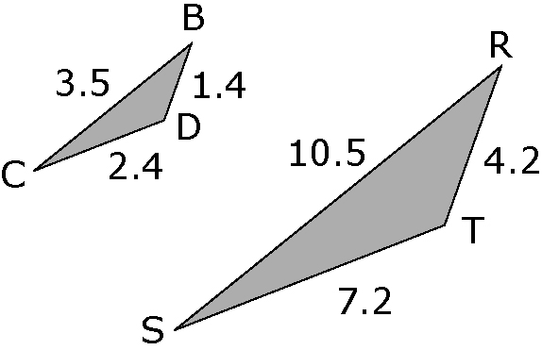
2. Compare the corresponding sides.
Are the triangles similar?
Show your work.

= = =
= ______ = ______ = ______

______________________________________________________________

3. a) Use a scale factor of 2 to draw WXY so that it is similar to JKL.

b) List the corresponding angles and the corresponding sides.

J corresponds to ______. JK corresponds to ______.
K corresponds to ______. JL corresponds to ______.
L corresponds to ______. KL corresponds to ______.

4. Δ MNO is similar to Δ MPR.
Calculate the missing length, x, to the nearest tenth.

Hint: Use the scale factor to solve for the missing length.
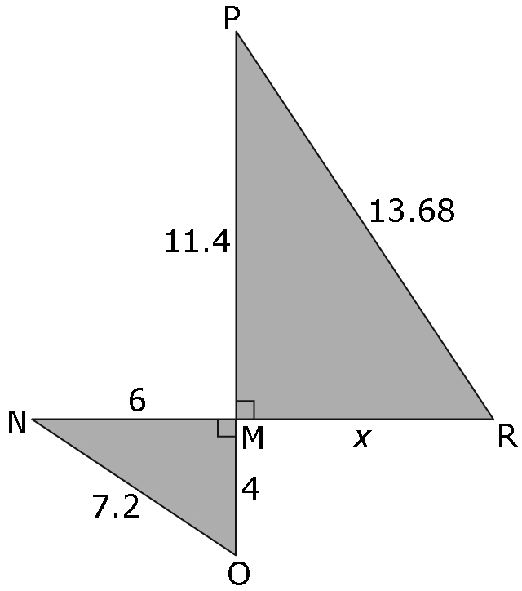
=

= ______

Find x.

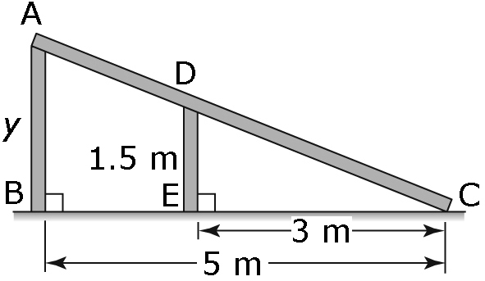
5. The two vertical supports on a ramp form 2 triangles.
Δ ABC is similar to Δ DEC.

a) Draw the 2 triangles separately and label with
the correct measurements.

b) Write the corresponding sides and angles.

c) Find the scale factor.

d) Find the height of the ramp by calculating the missing length, y.
Show your work.

