Section 4.4 Extra Practice
Compare all of the corresponding sides to find the scale factor.
1. Is each pair of polygons similar?

a) CDEF and RSTU are parallelograms. b)
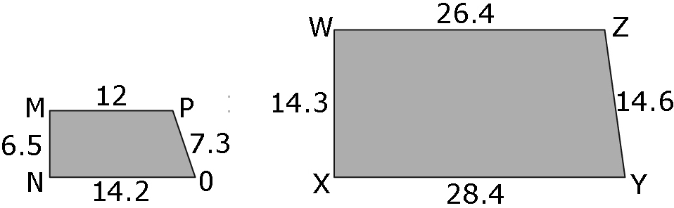
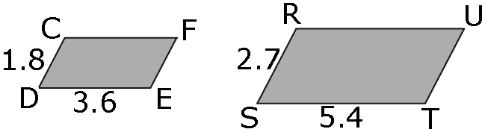

2. The two pentagons DFHIJ and EFGLK are similar.

a) Find the scale factor.

b) Find the missing length, x. Show your work

3. The trapezoid is a scale drawing of a cattle pasture.
The actual length of the shortest side of the pasture is 200 m.
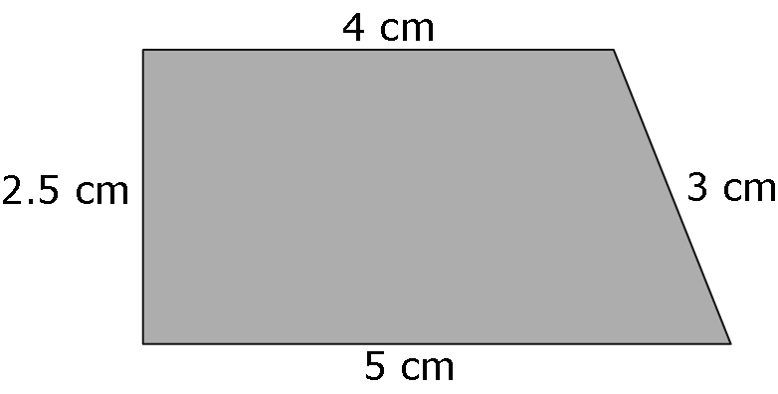

Actual length of shortest side = 200 m

a) Find the actual length of the other sides of the pasture. Show your work.
Hint: 200 m = 20 000 cm
Use a proportion or find the scale factor.

b) How long is the fence surrounding the pasture? Show your work.

Find the perimeter.

