Chapter 4 Test
For #1 to #4, circle the best answer.

1. Jason arranged shapes into sets of similar polygons.
How many of the shapes in the sets
do not appear to be similar to any other shape?

A 5 B 4 C 3 D 0

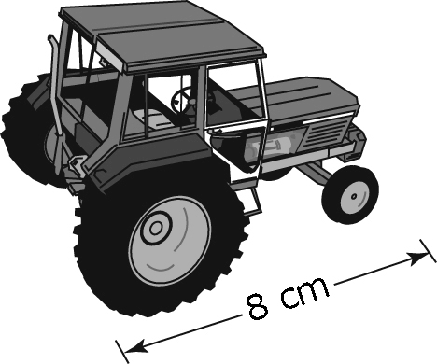
2. A local farm equipment dealership has model tractors.
The length of the actual tractor is 5.6 m.
What scale factor was used for the reduction?
Hint: First, change metres to centimetres.
A B 7 C 70 D 700

19 mm
3. A penny has a diameter of 19 mm.
Brenda used a scale factor of 3 to create a scale drawing of the penny. Which of the following statements about Brenda’s drawing is true?

A Brenda drew an enlargement. The drawing has a diameter of 57 mm.
B Brenda drew an enlargement. The drawing has a diameter of about
6.3 mm.
C Brenda drew a reduction. The drawing has a diameter of 57 mm.
D Brenda drew a reduction. The drawing has a diameter of about 6.3 mm.

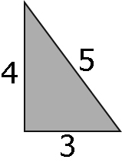
4. Which of the following triangles is similar to the given triangle?

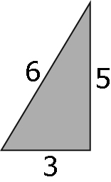
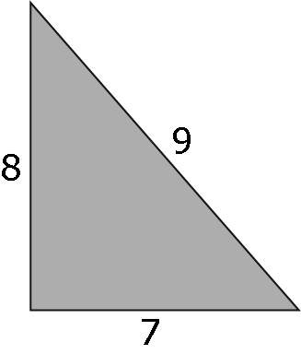
A B

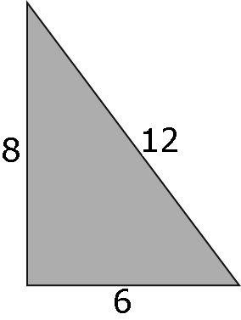
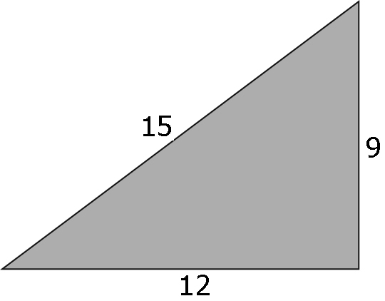
C D

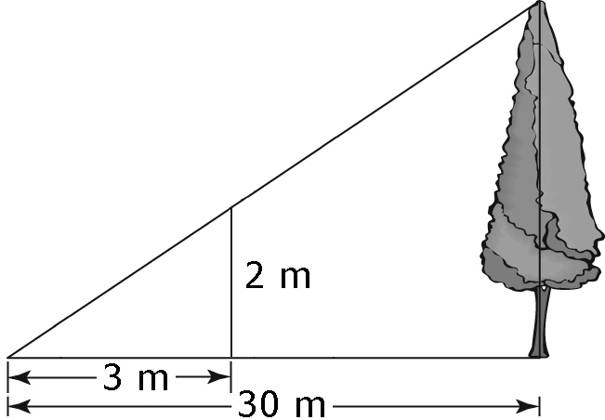
Complete the statements in #5 and #6.

5. Using the information given in the diagram, the
height of the actual tree is _____ m.

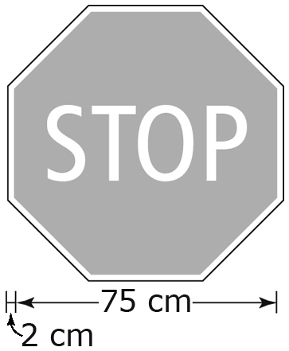
79 cm

6. A standard stop sign is 79 cm across.
If the scale of the image is 1:14, the width of the image
of the stop sign is _____ cm, to the nearest tenth of a centimetre.

Short Answer
7. Use a scale factor of 0.5 to draw a reduction of this figure.

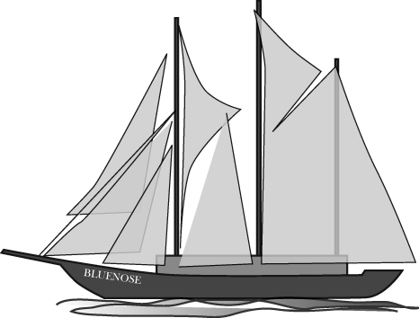

8. Raul’s grandfather collects models of ships such as Bluenose.
The model measures 120 mm in length.
The scale used to make the model is 1 : 470.
Hint: 1 m = 1000 mm.

Calculate the length of the actual ship to the nearest tenth of a metre.

1 m = 1000 mm

Written Response
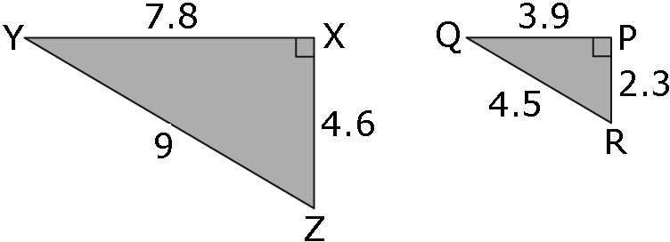
9. Are the triangles similar? Show your work.

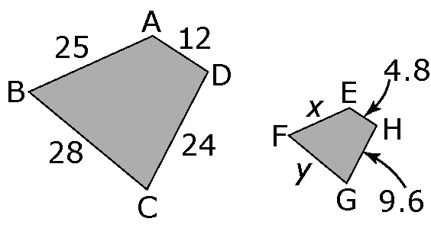
10. The trapezoids are similar. Find the missing side length, x.
Show your work.
11.2

First, find the scale factor.

