Chapter 4 BLM Answers

BLM 4–1 Chapter 4 Problems of the Week
1. cannot; can
2. a) Example:

Side Length of Cube  (cm) | S.A. of Cube  (cm²) | V of Cube  (cm³)
1 | 6 | 3 | 2
2 | 24 | 8 | 3
3 | 54 | 27 | 2
4 | 96 | 64 | 1.5
b) As the size of a cube increases, the surface area (related to heat loss) increases less than volume (related to body size) does. Therefore, large animals lose heat less rapidly than small animals, relative to body size.

BLM 4–2 Section 4.1 Extra Practice
1. a)
b)

2.
3. a) b)

4.
5. a) GREATER THAN 1. The second image is an enlargement.
b) YES. The image is bigger than the original.
BLM 4–3 Section 4.2 Extra Practice
1. a) MULTIPLY b) MULTIPLY c) DIVIDE
d) MULTIPLY
2. a) 20 b) 1250 c) 7.2 d) 8 e) 5 f) 4
3. a) 70 cm b) 9 mm
4. a) 0.5 b) 0.06 c) 0.02 d) 0.25 e) 0.75
f) 0.8
5. The scale factor is approximately 0.1.
6. a) or b) 1 cm on the map represents 162.5 km.
BLM 4–4 Section 4.3 Extra Practice
1. a) ∠P; ∠Q; ∠R; PQ; QR; PR
b) Corresponding angles: ∠N and ∠G; ∠M and ∠H; ∠O and ∠F. Corresponding sides: ON and FG; NM and GH; MO and HF.
2. Yes, the triangles are similar.
= 3; = 3;
= 3
3. a)
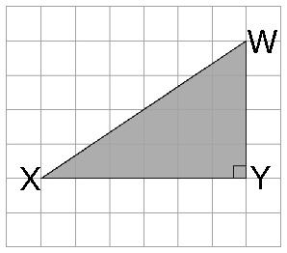
b) ∠W; ∠X; ∠Y; ∠J; WX; WY; XY
4. = 1.9; x = 4 × 1.9 = 7.6. The missing side length is 7.6.
5. a)

b) Corresponding sides: AB and DE; BC and EC; AC and DC; Corresponding angles: ∠A and ∠D; ∠B and ∠E; ∠C and ∠C
c) 0.6.
d)
y = 2.5
The ramp is 2.5 m in height.
BLM 4–5 Section 4.4 Extra Practice
1. a) CDEF and RSTU are similar. Example: Corresponding angles are equal in measure:
∠C = 115° and ∠R = 115°; ∠D = 65° and
∠S = 65°.
Corresponding sides are proportional in length: = 1.5; = 1.5. Both conditions for similar polygons have been met.
b) MNOP and WXYZ are not similar. Example: Corresponding sides are not proportional in length: = 2.2; = 2; = 2; = 2.2. Since both corresponding angles are equal in measure and corresponding sides proportional in length are necessary for similar polygons, MNOP and WXYZ are not similar.
2. a) The scale factor is 2.1.
= 2.1; = 2.1;
b) = 2.1; x = 3. The missing side
length is 3.
3. a) The scale factor is 8000. The missing lengths of the fencing are shown.
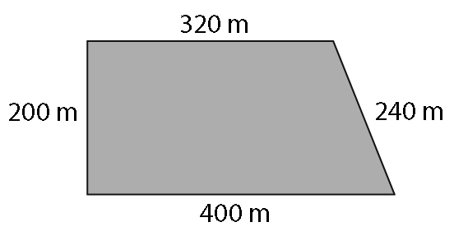
b) 1160 m

BLM 4–13 Chapter 4 Test
1. B 2. A 3. A 4. D
5. 20 6. 5.6
7.
8. 56.4 m
9.  PQR is similar to XYZ. The corresponding sides are proportional with a scale factor of 2: ; ; .
The corresponding angles are equal: ∠X = ∠P
= 90°; ∠Y = ∠Q = 30°; ∠Z = ∠ R = 60°
10. x = 10

