Section 5.1 Extra Practice
1. For each expression, state the
• number of terms
• type of polynomial

 | Number of  Terms | Type of Polynomial  Monomial, Binomial, or Trinomial
a) –2x²
b) a + b² + s | 3
c) y – 5
d) 3d² – 5xy
e) r |  | monomial
f) b² – 2b + 7

2. For each expression, state the
• number of terms
• type of polynomial
• degree of the polynomial

 | Number  of  Terms | Type of Polynomial | Degree of Polynomial
a) 6t
b) x² + 3y – 2
c) 9 – r
d) a – 2b + 4ab
e) –cd
f) 5s² – st

3. For the polynomial 3a² – 4ac – 8, state the following.
a) Number of terms ______ b) Coefficient of the 1st term ______
c) Coefficient of the 2nd term ______ d) Number of variables ______
e) Degree of polynomial ______ f) Constant term _____
4. For each polynomial,
• state the degree
• state the number of terms
 | Degree of  Polynomial | Number of  Terms
a) f + g + h
b) m² – mn + n²
c) x – y
d) s²
e) 31
f) 5d² + dh – 11h² + 3

5. Write the expression represented by each set of algebra tiles.

 = positive 1-tile    = positive x-tile    = positive x² | 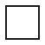 = negative 1-tile  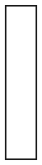  = negative x-tile    = negative x²

a) 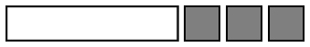 ____________________

b)  ____________________

c) 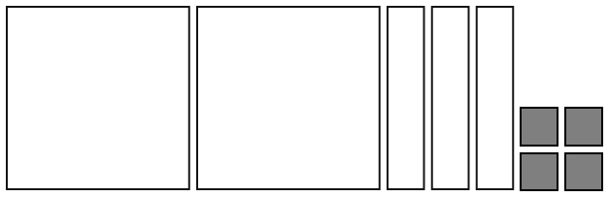 ____________________

d)  ____________________

