Section 5.3 Extra Practice
1. Rewrite the polynomials by collecting like terms. Then, simplify.

a) (3x² –2x) + (x² + x) b) (4n² –2n – 4) + (–n² + 5n)
= 3x² –2x + x² + x
= 3x² –2x + x² + x
= 3x² + x² – 2x + x
= _____x² – ______x

c) (7r – 8) + (3r² – 11) d) (2b² – 8b) + (–2b² + 11b)

e) (7t² – 6t + 9) + (–2t² + 6t – 5) f) (–14k – 10) + (8k –23)

2. Find the opposite of the expression shown by each diagram.
Draw a diagram and write the symbols.
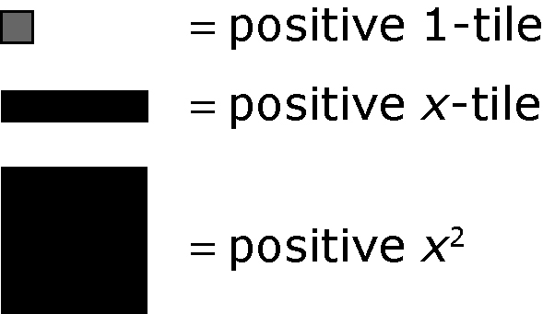
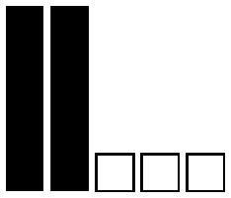

a) b)

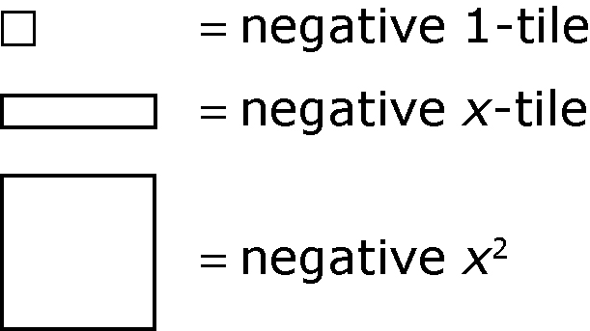

3. Write the opposite of each expression.

a) 6a b) –3c² – 9

c) d² – 8d + 2 d) 6w² + 4w – 0.8

4. Subtract the polynomials by adding the opposite terms, collecting like terms, and then simplifying.

a) (5a – 4) – (3a – 2) b) (7 – 6r) – (3 + r)
= 5a – 4 + (–3a) + _____ Add the opposite.
= 5a – 3a – 4 + _____ Collect like terms.

= _____a – _____ Simplify.

c) (6y² – 2y) – (–y² – 3y) d) (8 – 5t) – (–9 – 4t)

e) (h – 1) – (3h² + 7) f) (4k² – 6k + 1) – (–2k² + 5)

5. A triangle has the dimensions shown.
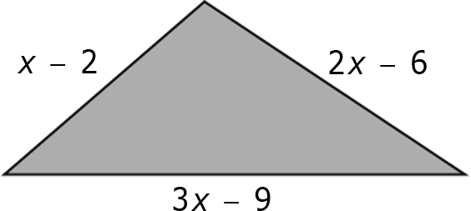

a) Write an expression for the perimeter of the triangle.

b) If x = 6, what is the perimeter? Show your work.

c) Simplify the expression in part a) for the perimeter of the triangle.

d) Use this expression to find the perimeter if x = 6. Show your work.

e) What do you notice about the answers from b) and d)?

___________________________________________________________
___________________________________________________________

