Section 6.1 Extra Practice
1. a) Draw the next 2 figures in this series.
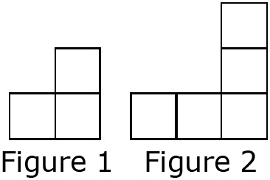

b) Complete the table of values
comparing the figure number and number of squares.

Figure  Number (n) | Number of  Squares(s)
1
2
3
4

c) The pattern starts with __
squares in the first figure.
Then, add ___ squares to make the next figure.

d) Develop the equation that shows this pattern.
Figure Number, n | Multiply by 2 | n × 2 | Add 1 To Result | Number of Squares, s
1 | × 2 → | 2 | 2 + 1 →
2 | × 2 → | 4 | 4 + 1 →
3 | × 2 → |  | – →
4 | × 2 → |  | – →

s = ____________ or ____________ = s

e) How many squares are in Figure 15? f) Which figure has 69 squares?

2. A number pattern starts at –5. Each number after that is 4 more than the number before.

a) Make a table of values for the first 5 terms.

Term Number, n | 1 | 2
Term Value, v | –5

b) Develop an equation that can be used to determine the value
of each term in the pattern.

Term Number, n | Multiply by 4 | n × 4 | Subtract 9  From Result | Term  Value, v
1 | × 4 → | 4 | 4 – 9 →
2 | × 4 → | 8 | 8 – 9 →
3 | × 4 → |  | – →
4 | × 4 → |  | – →

c) What is the value of the 95th term? d) Which term has a value of 219?

3. What linear equation models the relationship between the values in each table?
a) |  | b)
  d | t
  0 | 11
  1 | 16
  2 | 21
  3 | 26
  c | r
  1 | 2
  2 | 0
  3 | –2
  4 | –4
  d |  | t
  0 | ×______ + ______ →
  1 | ×______ + ______ →
  2 | ×______ + ______ →
  3 | ×______ + ______ →
  c |  | r
  1 | ×______ + ______ →
  2 | ×______ + ______ →
  3 | ×______ + ______ →
  4 | ×______ + ______ →
 | Linear Equation: _____________ |  | Linear Equation: _____________

4. Sam’s cell phone plan charges a fee of $45 per month.
He is also charged $0.15 for every text message he sends or receives.

a) Develop an equation to calculate Sam’s monthly bill.
Let C = the cost in dollars.
Let t = 1 text message.

C = ____________

b) Complete a table of values showing how the monthly cost is related to
the number of text messages.
Number  Of Text  Messages, t | Monthly  Cost, C

c) What would Sam’s bill be if there were 20 text messages in a month?

d) If Sam budgets $80 a month for his cell phone, how many text messages can he send or receive each month?

