Chapter 6 Test
For #1 and #2, circle the best answer.

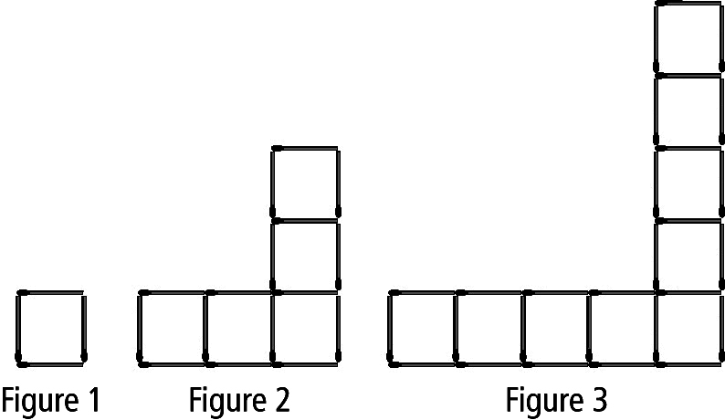
1. Which equation best shows the
relationship between the number of
matches, m, and the figure number, f ?

A m = f + 3 B m = f + 12
C m = 4f – 3 D m = 12f – 8

2. Which table of values best represents
this graph of a linear relation?

A | x | y
 | –2 | 0
 | 0 | 3
 | 2 | 6
 | 4 | 9

C | x | y
 | –2 | 0
 | 0 | 3
 | 2 | 9
 | 4 | 27

B | x | y
 | –2 | 0
 | 0 | 3
 | 2 | –6
 | 4 | –9

D | x | y
 | –2 | 0
 | 0 | 3
 | 2 | –9
 | 4 | –27

Complete the statements in #3 and #4. Use the graph in #2.
3. When x = 4, the approximate y-coordinate is ____.
4. When y = –6, the approximate x-coordinate is ____.

Short Answer
5. The yearbook committee is pricing the yearbook.
The printing company charges a flat fee of $7 per book plus $0.03 per page. Write a linear equation to represent the relationship between the number of pages in the yearbook and its cost.
Let p = the number of pages
Let c = the cost

Linear Expression: ________________________
Change 75% to a decimal.

6. Amanda works as a waitress.
She earns $50 a day plus 75% of the tips her customers leave.
a) Write a linear equation that represents the relationship between earnings and tips.

Let ______ = total earnings

Let ______ = tips ($)

Equation: __________________________

b) The table of values represents Amanda’s earnings on different days.
Use one of the day’s earnings and check your equation.
Left Side Right Side
Tips ($) | Total Earnings ($)
20.00 | 65.00
50.00 | 87.50
100.00 | 125.00

7. Alex runs at an average speed of 100 m/min. The equation relating distance in metres, d, and time in minutes, t, is d = 100t.

a) Complete the table of values. b) Graph the linear relation.
Time, t | Distance, d
0
10
20
30
40
50

c) Use the graph to estimate how long it takes Alex to run 3.5 km.
1 km = 1000 m

8. a) Complete the table of values.
x | y

b) Write the linear relation this graph represents. ________________________

