Section 7.1 Extra Practice
 = positive x-tile | 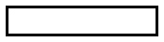 = negative x-tile
  = positive x²-tile |   = negative x²-tile
 = positive y-tile |   = positive xy-tile
1. Write a monomial multiplication statement for each set of algebra tiles.

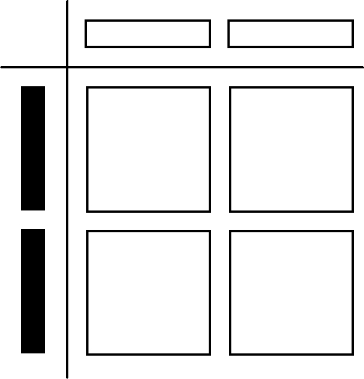
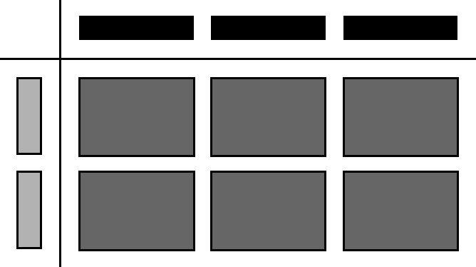
a) b)

(_____x)(−_____x) = −_____x²

2. Show each of the following monomial multiplication statements with a model.
Find each product.

a) (–3x)(–2x) b) (x)(4x)

(–3x)(–2x)= ____________ ________________________

3. Find the product of each pair of monomials.

a) (–4x)(2x) b) (3y)(7y)
=(–4)× (2) × (x) × (x)
=__________

c) (5x)(–3y) d) (6m)(–0.2m)

e) f) (–2.1y)( –4y)

4. Write a monomial division statement for each set of algebra tiles.
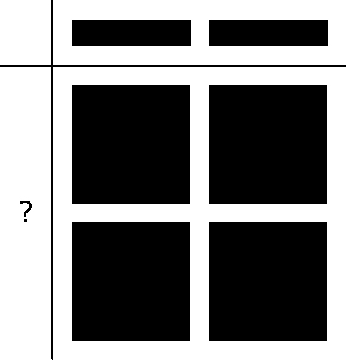
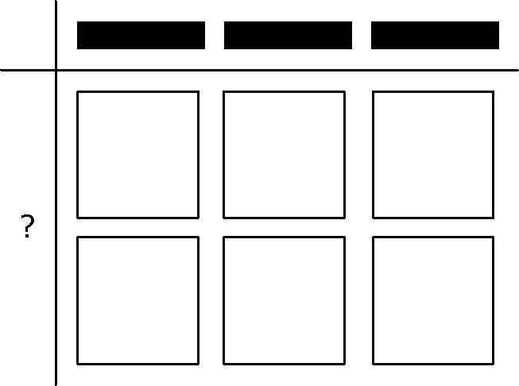
a) b)

_________

5. Show each of the following monomial division statements with a model.
Find each quotient.

a) b)

= ___________

6. Determine the quotient of each pair of monomials.

a) b)

c) d)

e) f)

7. A triangle has a base of 12x cm and a height of 3.4x cm.
12x
3.4x
What is the area of the triangle?

Substitute into the formula.

Simplify.

8x
A = 25.6x²
8. The area of a parallelogram is 25.6x² m².
Find the height if the base is 8x metres.

Substitute into the formula.

Simplify.

9. Marko’s rectangular lawn has an area of 36x m².
9 m
A = 36x m
The length of the lawn is 9 metres.

a) Find the width of the rectangle.

Substitute into the formula.

Simplify.

b) Marko wants to add a circular cement patio.
What is the area of the largest circular patio that he could add?
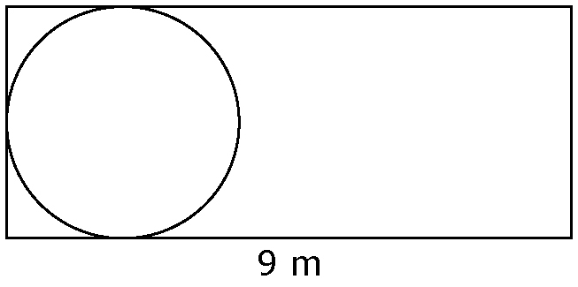
Show your work.
Use π for pi, not an approximate value.

diameter = width of the rectangle

diameter = ______ metres

radius = ______ metres

Area of circular patio:
A = πr²

