Section 7.2 Extra Practice
= positive 1 |  = negative 1
 = positive x | 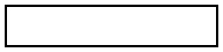 = negative x
  = positive x² |   = negative x²

1. What polynomial multiplication statement is represented by each area model?
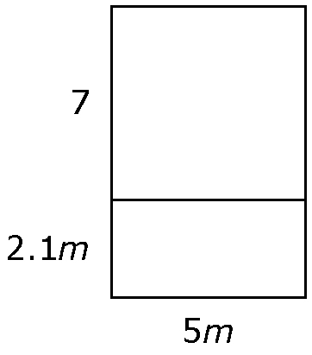
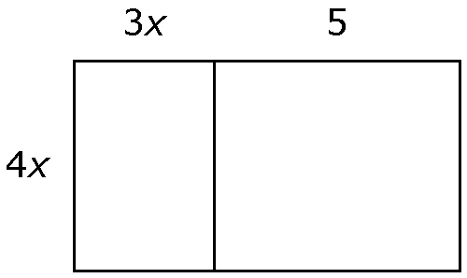
a) b)
A₁
A₂

A₁ = (4x)(______x)
= ______x²
A₂ = 4x(5)
= ______x
A₁ + A₂
= ______x² + ______x

2. Use an area model to expand each expression.

a) (3x)(2x – 1) b) (4m + 3)(3m)

3. Find the polynomial multiplication statement shown by the diagrams.
a) b)

(______x)(______x +______) ___________________________

= ______x² + ______x

4. Use models to expand each expression.

a) (4x + 1)(2x) b) (–x)(x + 4)

(4x + 1)(2x) = __________ ________________________

c) (2x)(3x – 1) d) (−x)(x − 1)

___________________________ __________________________

5. Use the distributive property to expand each expression.

a) (5m)(2m + 3) b) (–n)(n + 1)
= (5m)(2m) + (5m)(3)
=______m² +______m

c) (1.3x)(2x – 5) d) (3m)(–m + 2)

e) (–3k)(4.1k – 5.3) f) (–5b)(1.1b – 2)

6. Multiply.

a) (4m + 1)(3m) b) (2x – 3)(–4x)
= (3m)(4m + 1) Rewrite.
Multiply.

c) (4.2n)(2n – 7) d)

7. The length of a cement pad on a playground is 3 metres longer than the width. The width is 5x metres.

a) Write an expression for the length of the cement pad.________________

b) Write an expression for the area of the cement pad.
Area = length × width
____________________

b) If x = 2 m, what is the area of the cement pad?
Substitute x = 2 into your answer from part b).

