Section 7.3 Extra Practice
 = positive 1-tile |  = negative 1-tile
 = positive x-tile | 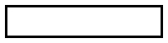 = negative x-tile
  = positive x²-tile |   = negative x²-tile
 = positive y-tile |   = positive xy-tile

1. What polynomial division statement is represented by the algebra tiles?
Find the quotient.

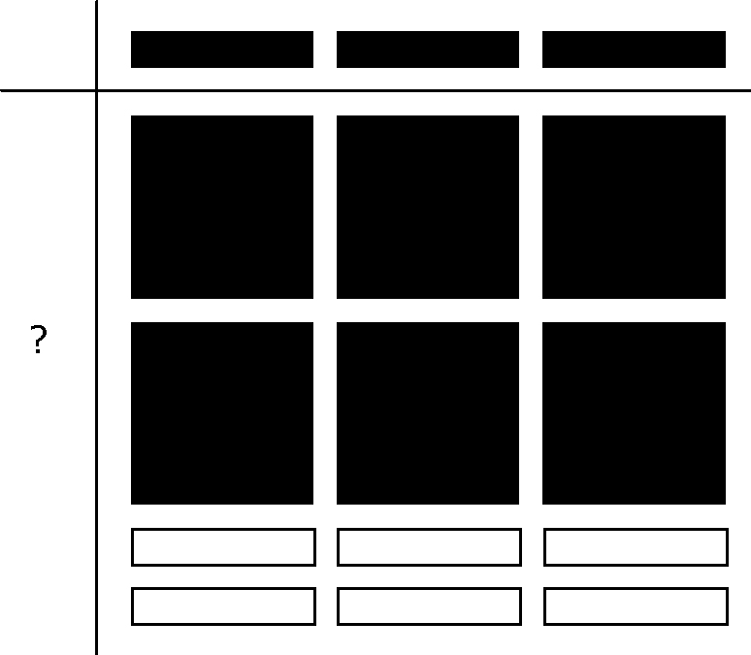
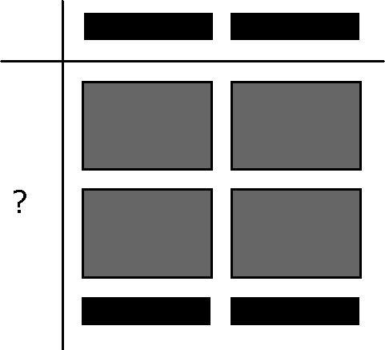
a) b)

________________________

2. Use a model to divide each expression. Find the quotient.

a) b)

= ____________

3. Write the polynomial division statement shown by the algebra tiles.
Find the quotient.

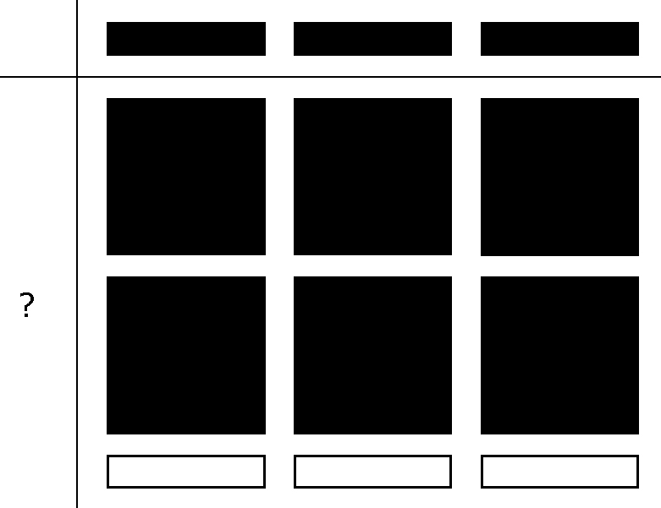
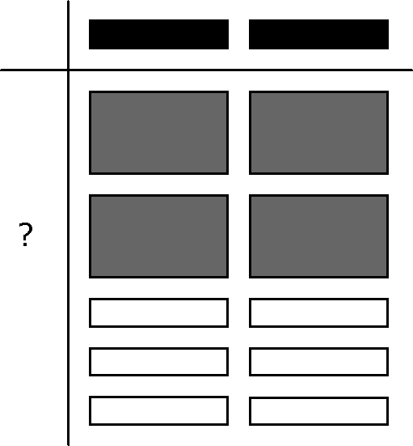
a) b)

4. Use algebra tiles to divide each of the following expressions.

a) b)

= ___________

5. Divide.

a) b)

c) d)

e) f)
6. You are decorating the bulletin board in your classroom with pictures of your classmates.
Each picture covers an area of 4x cm².
The area of the board is 4x² + 16x cm².
Write an expression to represent how many pictures are required to cover the board.
Divide.

Sentence: _____________________________________________________

7. A rectangular lawn has a width of 3x metres .
3x
A = 15x² + 45x
The area is 15x² + 45x m².
You wish to put a fence around the lawn.

a) Write an expression for the length of the rectangle.

b) Write an expression to show the perimeter of the lawn.
Perimeter = (2 × length) + (2 × width)

c) You are placing a post every 2 m. Write an expression to show how many posts will be required.

