Chapter 7 Test
For #1 to #4, circle the best answer.
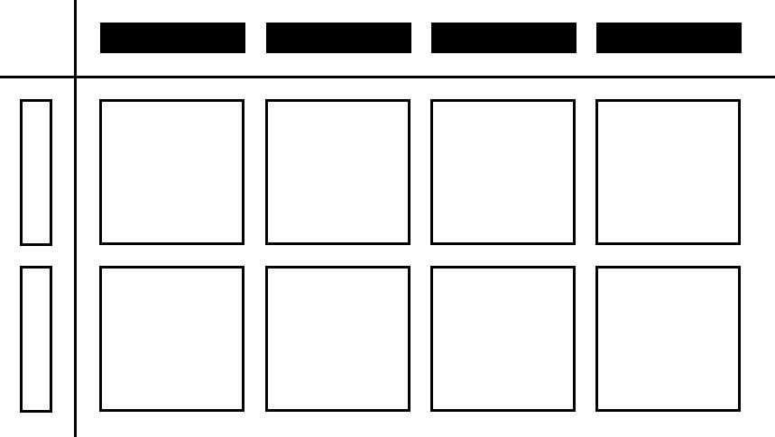
1. Which monomial multiplication equation is
modelled by the algebra tiles?

A (–2x)(4x) = –8x² B (–2x)(4x) = 8x²
C (–2x)(4y) = –8xy D (–2x)(–4y) = 8xy

2. What is the correct solution to ?
A 4 B 4x
C 4x² D 64x²

3. Leah simplified the expression .
Which of the following describes the answer?

A monomial B binomial
C trinomial D constant

4. Which of the equations best shows the use of the distributive property?

A 3(4x +2x) = 3(6x) B 5(2 – 3x) = 5(–3x + 2)
C 2(–x + 4) = (–x + 4)2 D 4(2x – 7) = (4)(2x) + (4)(–7)

Complete the statements in #5 to #7.

5. The product of (–3x)(5.1y), in simplified form, is _____________.
6. The quotient , in simplified decimal form, is _____________.
7. Multiplying the polynomial x – 6 by 5x produces the expression ____________.
Short Answer

8. Write each product in simplified form.

a) (5x)(3x) b) (–2y)(–4x + 5)

9. Write each quotient in simplified form.

a) b)

10. Use a model to find the product of (–2x)(2x – 1) .

(–2x)(2x – 1) = ________________

11. Sergio wanted to determine 5x(7x – 2). His solution is shown below.

(5x)(7x) + (5x)(–2) Step 1
= (5)(7)(x)(x) + (5)(–2)(x)(–2) Step 2
= 35x² – 10(–2x) Step 3
= 35x² + 20x Step 4

Sergio discovered an error in his solution.

a) In which step did Sergio make the error? ____________
b) Show the correct solution.

Written Response

12. Provide each of your answers in simplified form.

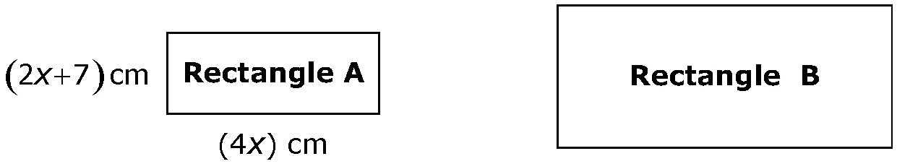

a) Write an expression to represent the area of Rectangle A.
Area = length × width
______________________________

b) The area of Rectangle B is three times the area of Rectangle A.
Write an expression for the area of rectangle B.

c) If the width of Rectangle B can be represented by 12x, what is an expression for the length of Rectangle B?

length =

