Chapter 7 BLM Answers

BLM 7–1 Chapter 7 Problems of the Week

1. a) $360 b) $13.50 c) n – 40
d) 360 + 13.5(n – 40)

2. a) Circle with radius x: πx²;
Circle with radius 2x: π(2x)² or 4πx²
b) c)

BLM 7–3 Section 7.1 Extra Practice
1. a) (2x)(–2x) = –4x² b) (2y)(3x) = 6xy
2. Shaded tiles are positive, and white tiles are negative.

a) Example: 6x²

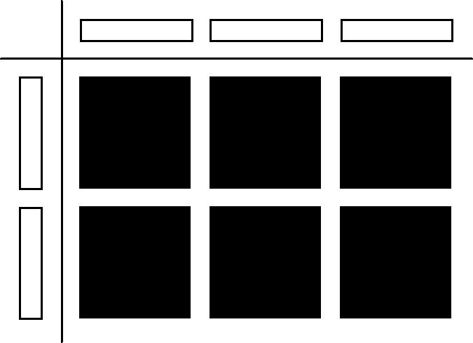

b) Example: (x)(4x) = 4x²

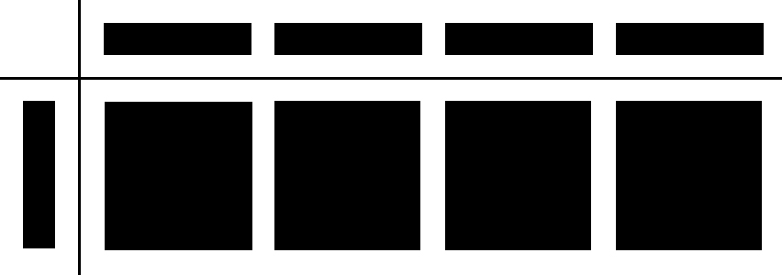
3. a) –8x² b) 21y² c) –15xy d) –1.2m² e) 8n² f) 8.4y²
4. a) = 2x b) = –2x
5. a) Example: 2x

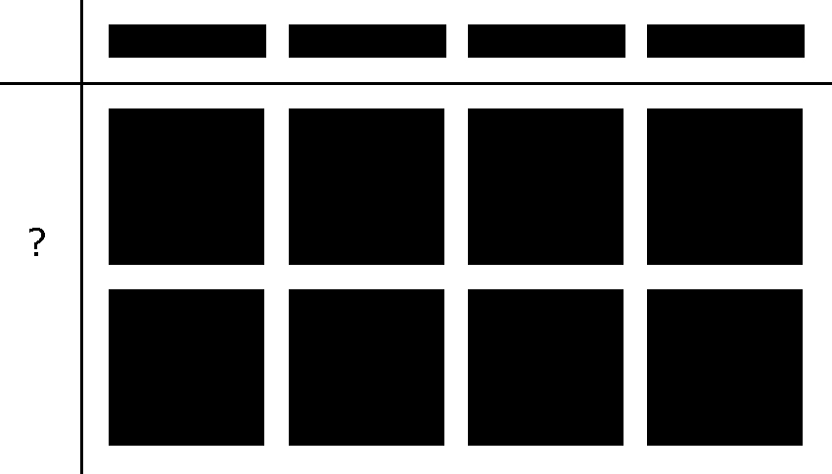

b) Example: = 2x

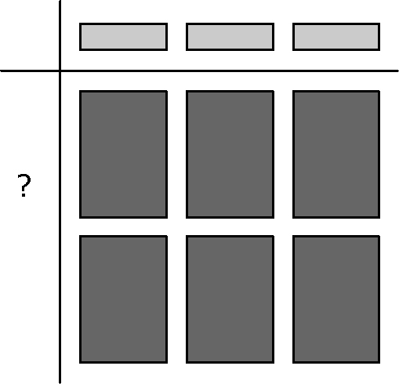

6. a) –2x b) 5x c) 3 d) or e) –7.1m f) –5.1x
7. (20.4x²) cm²
8. (3.2x) m
9. a) (4x) m b) Diameter of circle = 4x m;
radius = 2x m; Area of circle = π(2x)² = (π4x²) m²

BLM 7-4 Section 7.2 Extra Practice
1. a) 12x² + 20x b) 10.5m² + 35m
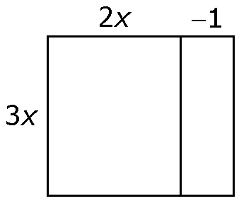
2. a) 6x² – 3x

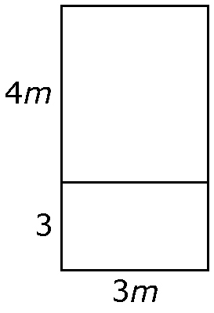
b) 12m²+9m

3. a) (x)(2x + 3) = 2x² + 3x

b) (2x)(2x + 3) = 4x² + 6x
4. a) 8x²+ 2x

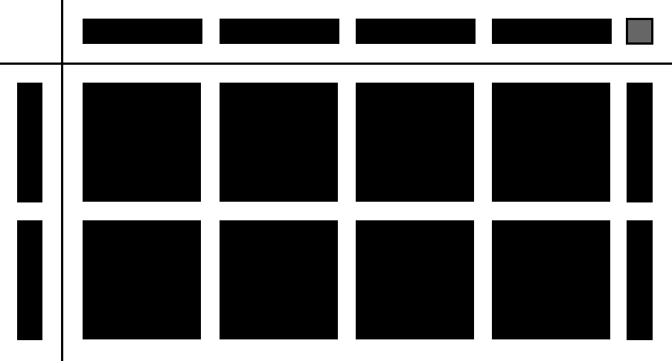

b) (–x)(x + 4) =–x² – 4x

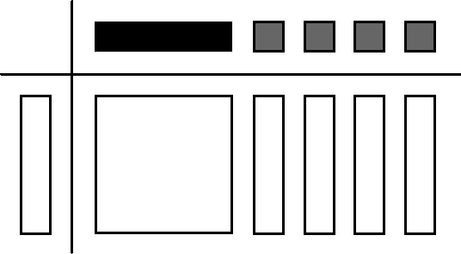

c) (2x)(3x – 1) = 6x² - 2x

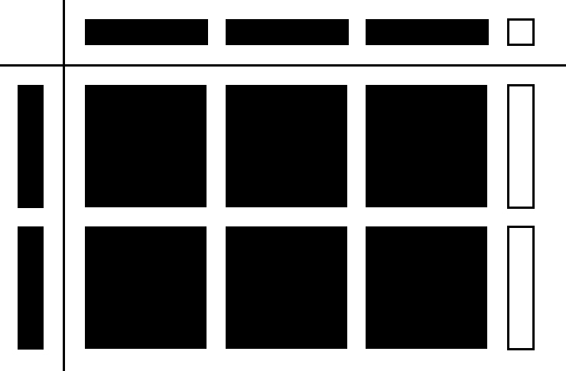

d) (–x)(x – 1) = –x² + 1
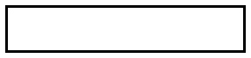




5. a) (5m)(2m) + (5m)(3) = 10m² + 15m
b) (–n)(n) + (–n)(1) = –n² – n
c) (1.3x)(2x) – (1.3x)(5) = 2.6x² – 6.5x
d) (–m)(3m) + (2)(3m) = –3m² + 6m
e) (4.1k)(–3k) – (5.3)(–3k) =
–12.3k² + 15.9k
f) (–5b)(1.1b) + (–5b)(–2) = 5.5b² +10b
6. a) 12m² + 3m b) –8x² + 12x
c) 8.4n² – 29.4n d) –6m² – 36m

7. a) l = 5x + 3
b) A = (5x)(5x + 3) = 25x² + 15x
c) The area of the cement pad is 130 m².

BLM 7–5 Section 7.3 Extra Practice
1. a) = 2y + 1
b) = 2x – 2

2. a) –3x + 1

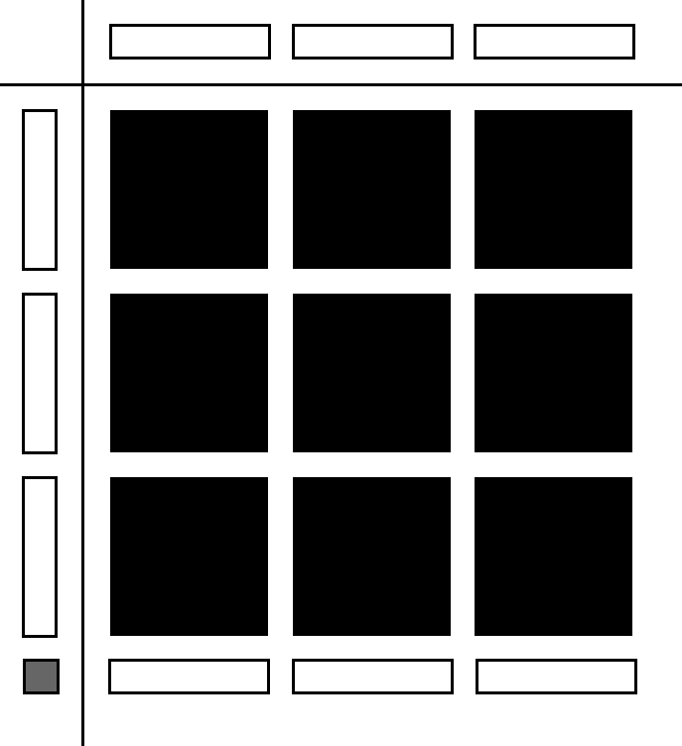

b) = 2x + 3

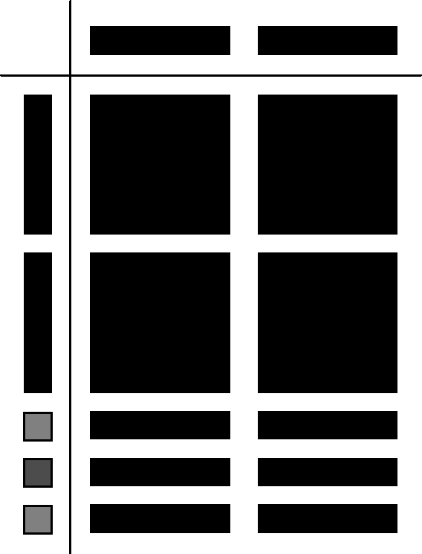
3. a) = 2x – 1 b) = 2y – 3
4. a) –2x + 3

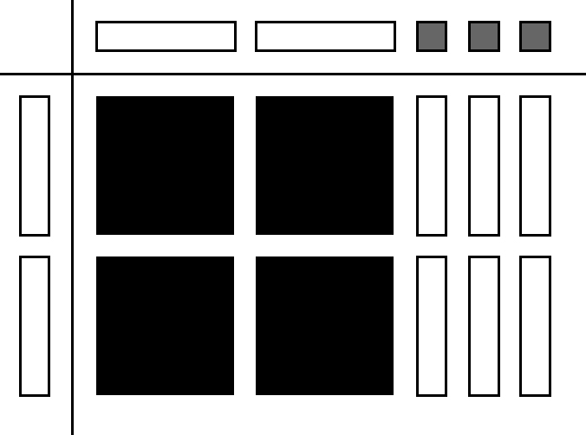

b) = 3x + 2y

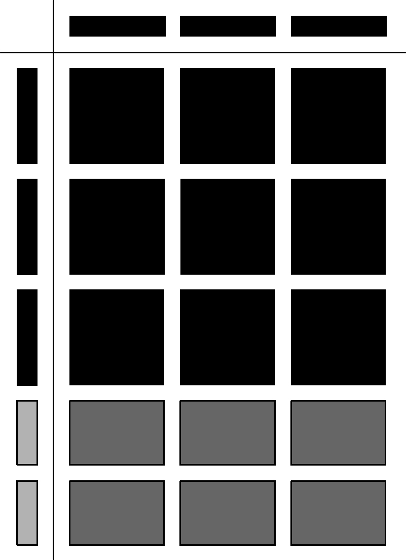

5. a) 3x – 4 b) 4m + 5n
c) 2k – 1 d) –2 – 3n
e) 0.7d + 0.9k – 0.8 f) –3c² +4c – 2

6. You will require (x + 4) pictures to cover the bulletin board.
7. a) Length = = (5x + 15) m
b) Perimeter = 2(3x) + 2(5x + 15)
= 6x + 10x + 30
= 16x + 30
c) = 8x + 15

BLM 7–6 Chapter 7 Test
1. A 2. B 3. B 4. D
5. –15.3xy 6. 2.5x 7. 4x² – 30x
8. a) 15x² b) 8xy – 10y
9. a) 9x b) –8 + 2x

10. –4x² + 2x
11. a) Step 2
b) (5)(7)(x)(x) + (5)(–2)(x) = 35x² – 10x
12. a) 8x² + 28x b) 24x² + 84x c) 2x + 7

BLM 7–7 Sample Polynomial Puzzle

