Section 9.1 Extra Practice
1. Write a word statement to express the meaning of each inequality.

Inequality | Word Statement
a) m > –2 | m is __________________ than  (less or greater)  negative two.
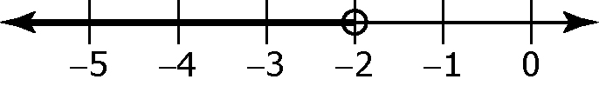
b)

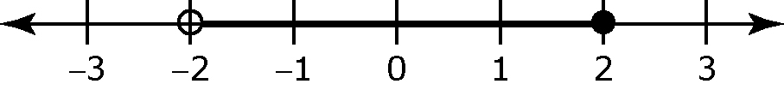
c)

d) m ≥ 2

2. Circle true or false for each of the following statements.
If the statement is false, rewrite it to make it true.
a) True / False A closed circle indicates that the boundary point is not a possible value.
_____________________________________________________________
_____________________________________________________________
b) True / False The inequality –4 < x means x is greater than –4.
_____________________________________________________________
_____________________________________________________________
c) True / False A boundary point is always shown on a number line using an open circle.
_____________________________________________________________
_____________________________________________________________
For #3 to #6, fill in the missing information.
a) Represent the inequality verbally using a real-life example.
b) Represent the inequality graphically.
c) Represent the inequality algebraically.

a) Verbally | b) Graphically | c) Algebraically
Example:  The height of a rocket that is launched 1 m below sea level | 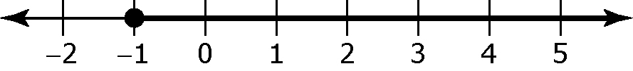 | h ≥ –1, where h is the height of the rocket
3. The temperature below –4 ºC.

4. |  | 2 ≥ x
5. | 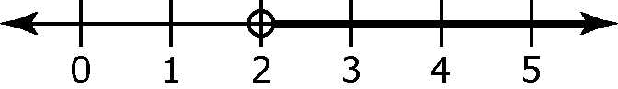
6. |  | x ≥ 0 and x ≤ 5

