Section 9.2 Extra Practice
1. List 3 values that would make each inequality or combination of inequalities true.

a) x ≤ –4 b) x > –3
___________ ___________
c) x >−4 and x < 3 d) x ≥ –2 and x ≤ 5
___________ ___________

2. Solve each inequality.

a) x + 5 ≤ 12 b) 2 > x – 9

c) 7.4 + x ≥ 6.2 d) x – 4.2 < 3.5

e) 4x ≤ –16 f) –1.3x > 16.9
When multiplying or dividing by a negative, reverse the inequality sign.

g) ≤ –4 h) –≥ 3

3. Verify if the specified solution is correct for each inequality.
Check the solution.
a) 2x < –10; x > –5 b) –3x ≤ –24; x ≤ 8

Check x > –5. Let x = ______ Check x = 8
Left Side | Right Side
2 × ______ < –10
______ < –10
True or False.
Is x > –5 the solution?
Circle YES or NO.

Check x < 8. Let x = 6.
–3 × ______ ≤ –24
______ ≤ –24
True or False.
Is x ≤ 8 the solution? Circle YES or NO.

c) –9 ≥ –x; x ≤ 3 d) ; x < 20

e) 2x ≥ –16; x ≥ –8 f) –7 + x > –2; x > –9

4. A balloon company guarantees that at least 18 of the balloons in each package are red. Fifteen percent of the balloons are red. How many balloons are in a package?

a) Write an inequality to model the situation.
Let n = the number of balloons in a package
Inequality: ________________________

b) Solve and verify the inequality.
Check the solution.

c) Represent your answer verbally and graphically.
Verbally: _________________________________________________
Graphically:

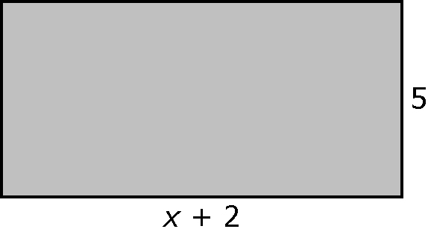
5. a) Write an inequality to find the values of x
that give the rectangle an area of no more
than 25 square units.

_________________________________

b) Solve the inequality.

c) Are there values of x that would not be possible for the length of the rectangle? Circle YES or NO. Give 1 reason for your answer.

______________________________________________________

