Chapter 9 Test
For #1 to 4, choose the best answer.

1. Mr. Lau asked his class to write an inequality to show the solution set for the number line below.

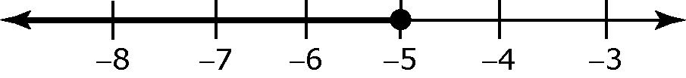 | Erik | x ≤ –5
 | Marissa | x ≥ –5
 | Laurie | –5 ≤ x
 | Steven | –5 ≥ x

Which student(s) correctly represented the solution set given by the graph?

A Erik B Erik and Steven
C Erik, Steven, and Marissa D All four students

2. Which student correctly wrote a problem with a solution set that could be shown by the given diagram?



Ronald
Thomas | 2(x + 5)>11
Jasmine | 4x – 5 ≥ 7
Stephanie | –6x < 18

A Ronald B Jasmine
C Thomas D Stephanie

3. The solution set for the inequality 3(–2x + 15) < –21 is found by solving for x. The solution is shown below.

Step 1 3(–2x + 15) < –21
Step 2 –6x + 45 < –21
Step 3 –6x + 45 – 45 < –21 – 45
Step 4 –6x > –66
Step 5 x < 11

In which step was an error made?

A An error was made in Step 2. B An error was made in Step 3.
C An error was made in Step 4. D An error was made in Step 5.

4. Which rational number is a possible value of x for the linear inequality
3x – 3 < –9 – x?

A 7 B −3
C 1 D 0

Complete the statements in #5–#7 by inserting the symbol <, >, ≤, or ≥.
5. Given x + 5 ≥ 12, the solution set is x ____ 7.
6. For the inequality 3x – 2 < 13, the solution set is x ____ 5.
7. The solution set for –10 ≤ 5x + 10 is x ____−4.

Short Answer

8. Your cell phone plan allows you to send up to 200 text messages per month for $5. Write an inequality to represent the number of text messages you can send for $5 per month.

9. Find the solution for each of the inequalities. Write your answers in simplest form.

a) 4(2x – 1) < 16 b) ≥ –

10. Solve the inequality. Then, show the solution for the linear inequality on the number line.
6 – 3x < 14 + x.

Written Response

11. Victoria is helping her mother plan a lunch for the people attending a workshop. Their budget is $1000. Lunch costs $17 per person.
There is also a $25 charge to rent the room.

a) Write an inequality that shows the number of people, n, that they can serve lunch and stay within the budget.

b) Solve the inequality for the variable n. Round your answer to 2 decimal places.

c) Victoria and her mother disagree about the number of people that they can provide lunch for and stay within their budget. Victoria says that they can have 58 people but her mother says 57 people. Who is correct? Circle VICTORIA or MOTHER. Give 1 reason for your answer.

________________________________________________________________________________________________________
d) If the maximum number of people attend the lunch, how much money will be left over from the original $1000?

Sentence: __________________________________________________

