Chapter 9 BLM Answers

BLM 9–1 Chapter 9 Problems of the Week
1. a)

b)

c)

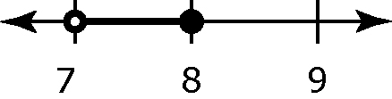
d)

2. a) Statement: 2x + 3 < 9 – x; Solution: x < 2 b) Statement: 4x – 2 ≤ –10; Solution: x ≤ –2
c) Statement: –5x + 3 = –x + 15;
Solution: x = –3
BLM 9–2 Section 9.1 Extra Practice
1. a) m is greater than negative 2.
b) A number is less than negative 2.
c) A number is greater than negative 2 and less than or equal to 2.
d) m is greater than or equal to 2.
2. a) False. A closed circle indicates that the boundary point is a possible value.
b) True
c) False. A boundary point is shown on a number line using either an open circle or a closed circle.
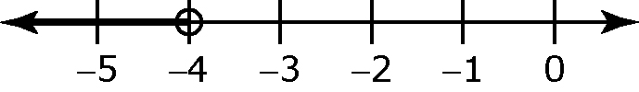
3. b)

c) t < –4, where t is the temperature.
4. a) Answers will vary. Example: The temperature of a town that is never warmer than 2 ºC.

b)

5. a) Answers will vary. Example: The number of players for a game that requires more than two people to play.
c) p > 2, where p is the number of players
6. a) Answers will vary. Example: The number of people that can fit in a car that seats five.
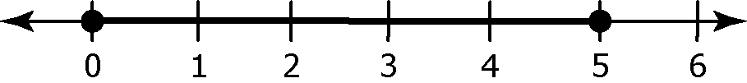
b)

BLM 9–4 Section 9.2 Extra Practice
1. a) –4 or any number less than –4. Examples: –4, –5, –6
b) Any number greater than –3. Examples: –2,
–1, 0
c) Any number between –4 and 3, not including
–4 and 3: –3, –2, –1, 0, 1, or 2
d) Any number between –2 and 5, including –2 and 5: –2, –1, 0, 1, 2, 3, 4, or 5
2. a) x ≤ 7 b) 11 > x or x < 11 c) x ≥ –1.2 d) x < 7.7 e) x ≤ –4 f) x < –13 g) x ≤ –20
h) x ≤ –12
3. a) NO b) NO c) NO d) NO e) YES f) NO
4. a) 0.15b ≥ 18, where b is the number of balloons in the package.
b) b ≥ 120
c) The number of balloons in a package is 120 balloons or more.
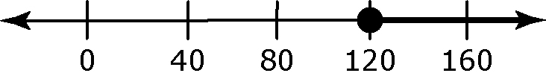
5. a) 5(x + 2) ≤ 25 b) x ≤ 3 c) YES. The value of x must be greater than –2 or the length of the rectangle would not exist.
BLM 9–5 Section 9.3 Extra Practice
1. Example: Substitute the boundary point to check that both sides are equal.
Left Side Right Side
– 2 6
– 2 6
8 – 2 6
6 6
Then, substitute one other number from the solution to determine if it makes
the inequality true.
– 2 ≤ 6
– 2 ≤ 6
–3 – 2 ≤ 6
–5 ≤ 6
2. a) x > 3 b) x < –0.45 c) x > 5 d) x ≥ –2
3. a) x ≤ 2
b) x < 2;
c) x < 5;
d) x ≥ 1;

4. a) YES b) YES
5. a) Inequality: 30n + 200 ≤ 2000, where n is the number of people; Solution: n ≤ 60
b) Inequality: 20n + 400 ≤ 2000, where n is the number of people; Solution: x ≤ 80
c) Hall B is the best deal because you can invite 20 more people for the same price.

6. 75n + 90 > 60n + 120; g > 2
Job B pays more than Job A if you build more than two grain bins each day.
BLM 9–6 Chapter 9 Test
1. B 2. A 3. C 4. B 5. ≥ 6. < 7. ≥
8. x ≤ 200 9. a) x < 2 b) x ≤
10. x > –2
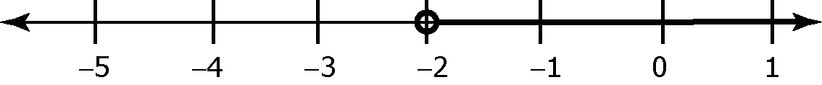
11. a) 17n + 25 ≤ 1000 b) n ≤ 57.35
c) MOTHER. 17(58) + 25 = 1011. They would be $11 over the budget with 58 people.
d) 1000 – 25 - (17 × 57) = 1000 – 25 – 969 = 6 The money left over will be $6.

