Get Ready
Working With Circles

≈ means approximately equal to
● π ≈ 3.14
● diameter: the distance across the circle, passing through the centre; d = 2r
● radius: half the distance across the circle, starting at the centre; r =
● circumference: the distance around the circle; C = π × d or C = 2 × π × r

The radius of a circle is 3 cm. Find the circumference.
C = 2 × π × r
C ≈ 2 × 3.14 × 3
C ≈ 18.84
The circumference is about 18.84 cm.

1. Find the circumference of each circle.

a) |  | b)
C = 2 × π × r | ← Formula → | C = π × d
C ≈ 2 × 3.14 × | ← Substitute →
C ≈ cm | ← Solve →

Working With Angles

You can estimate the size of an angle by comparing it to a 90º angle.
Estimate ∠A.
∠A is less than 90º.

A 45º angle is half of 90º.

∠A is between 45º and 90º. A reasonable estimate is 55º.
The actual measure of the angle is 60º.
2. Estimate the size of each angle. Then, measure each with a protractor.
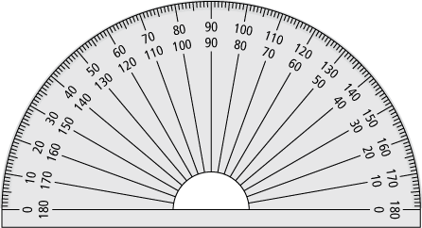
a)  Estimate: º  Measurement: º | b)  Estimate: º  Measurement: º

Bisecting Angles


angle bisector
● the line that divides an angle into 2 equal parts
● mark equal angles with the same symbol
● example: OB bisects angle AOC
To bisect an angle:
● fold the angle in half
or
● measure the angle with a protractor and then divide by 2

3. Bisect each angle.

a) | b)

Perpendicular Bisectors

perpendicular bisector
● a line that divides a line segment in half and forms a
90º angle to the line
● example: DC is the perpendicular bisector of AB.

To make a perpendicular bisector:
● fold the line in half and use a right triangle to draw a line from the halfway point
or
● measure the length of the line, divide by 2, mark the halfway point, and use a right triangle to
draw a line from that point

4. Draw the perpendicular bisector for each line segment.

a) | b)

