Get Ready
Using Two-Term Ratios

A part-to-part ratio compares 1 part of a group to other parts of the same group.
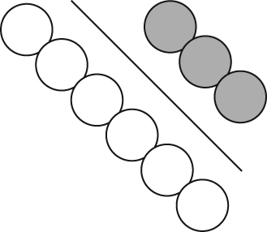
• The ratio of white circles to grey circles is 6 : 3 or 6 to 3.
• The ratio in lowest terms is 2 : 1 or 2 to 1.

A part-to-whole ratio compares 1 part of a group to the whole group.
• The ratio of white circles to the total number of circles is 6 : 9, 6 to 9, or .
• The ratio in lowest terms is 2 : 3 or 2 to 3.
• You can write a part-to-whole ratio as a fraction, a decimal, and a percent.
• White circles to total number of circles = or , 0., and 66.%.

1. Complete the table. Write the ratio of grey circles to the total number of circles.

 | Ratio Notation | Equivalent Fraction in Lowest Terms | Decimal | Percent
a) | 2 : 6 | ÷ 2  =  ÷ | 2 ÷ 6  = | decimal × 100  = × 100  =
b) |  | ÷  =  ÷

2. Find the missing value to make an equivalent fraction.

×  a)  × | ÷  b)  ÷

Using Proportional Reasoning

proportion

● a relationship that shows 2 ratios are equal
● can be written as 2 equivalent fractions
× 7 ÷ 5
To compare ratios, the units must be the same.

● examples: ;

× 7 ÷ 5

3. Set up a proportion for each situation.

a) On a diagram, 2 cm represents 200 cm.  The length of a basketball court is 2800 cm.  This length is 28 cm on the diagram.  ratio = | b) In a photograph, 1 cm represents 30 cm.  In the photo, Daniel is 6 cm tall.  His actual height is 180 cm.
4. A 12-m telephone pole casts a shadow 4 m long.
What is the height of a boy who casts a shadow 0.4 m long?

÷ 10

÷ 10

The height of the boy is .

